<https://www.youtube.com/watch?v=FgakZw6K1QQ&list=PLblh5JKOoLUICTaGLRoHQDuF_7q2GfuJF&index=24>



In this stat quest we're going to go through principle component analysis PCA.

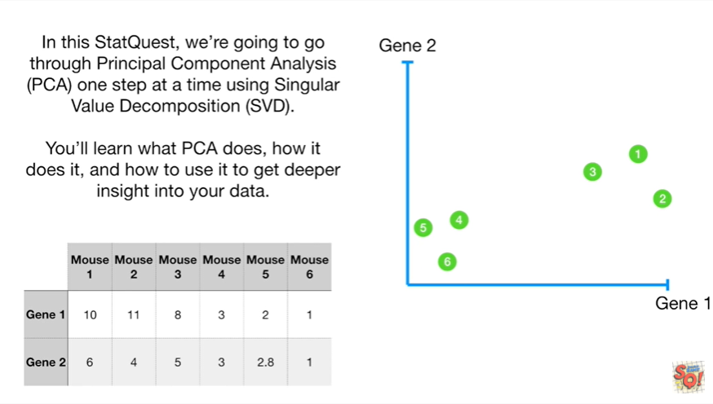

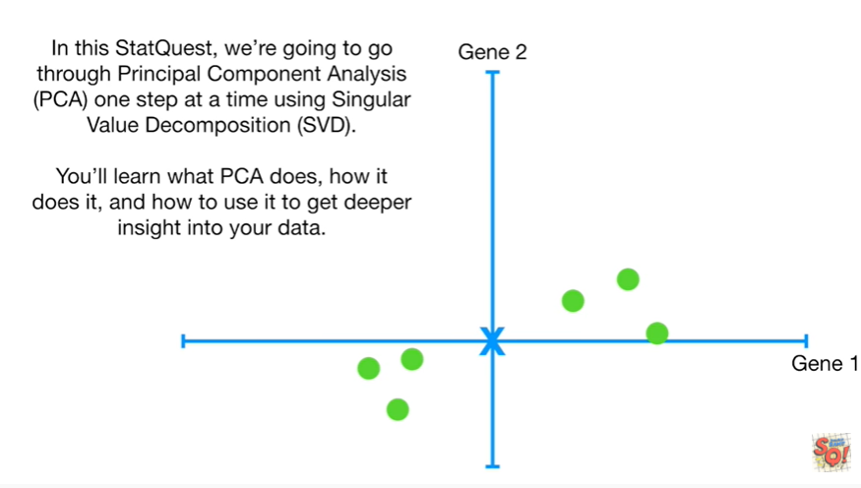

One step at a time using singular value decomposition SVD .

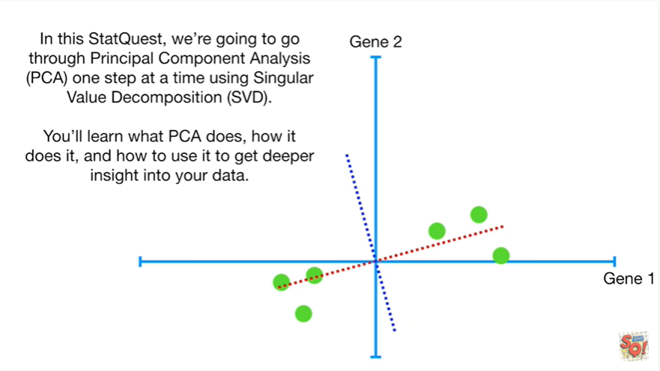

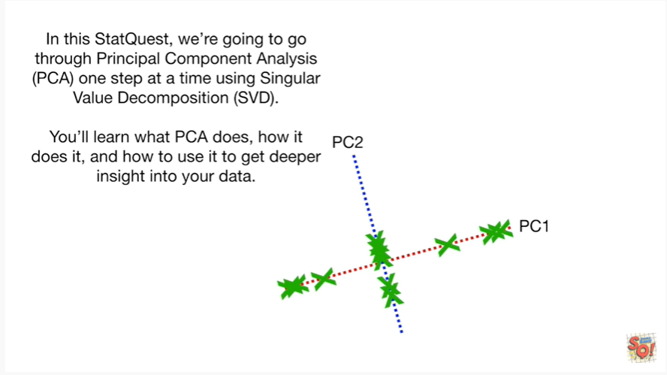

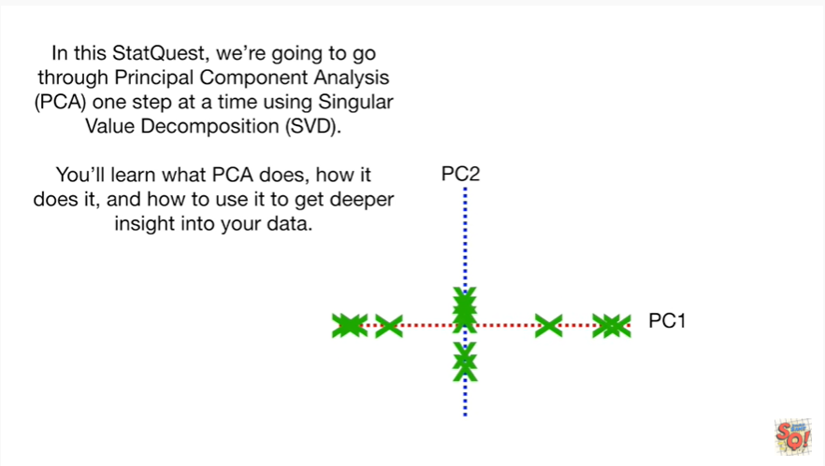

You'll learn about what PCA does, how it does it and how to use it to get deeper insight into your data.

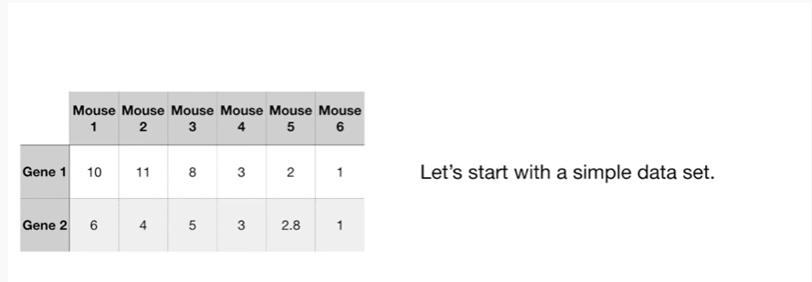

Let's start with a simple dataset.

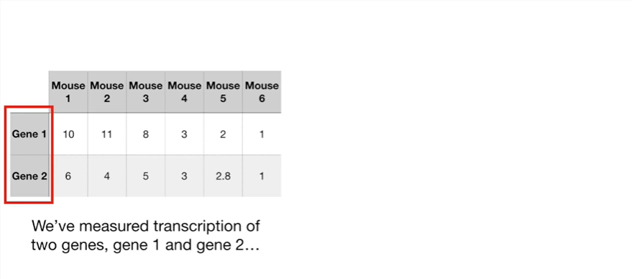

We've measured the transcription of two genes gene 1 and gene 2

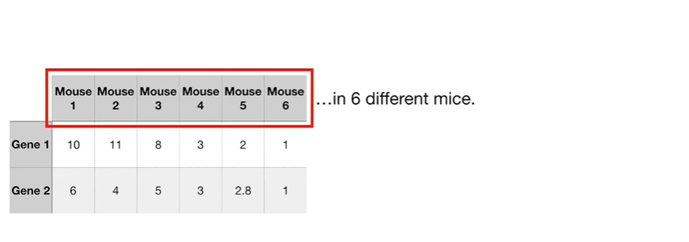

in 6 different mice.

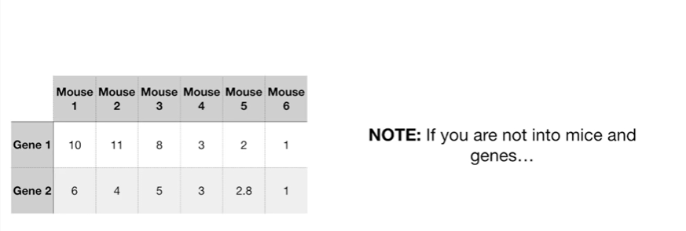

Note if you're not into mice and genes

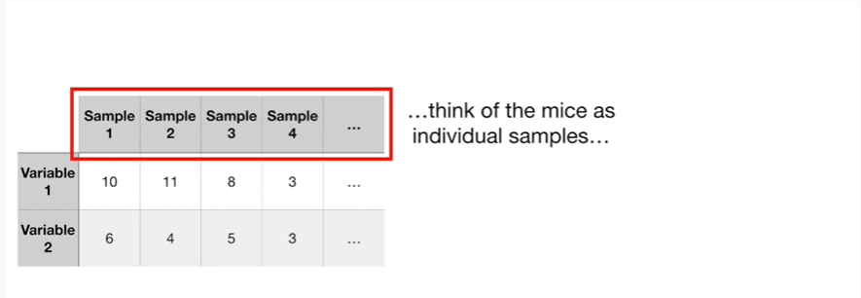

think of the mice as individual samples



and the genes as variables that we measure for each sample.

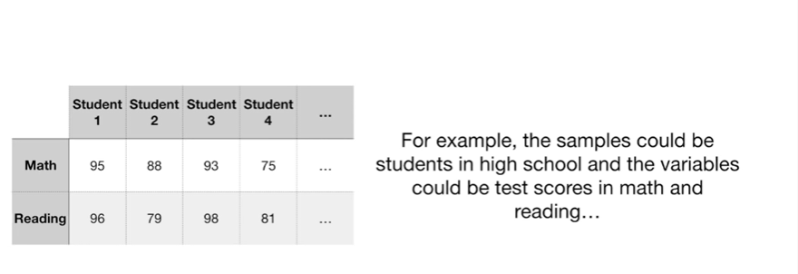

For example the samples could be students in high school and the variables could be test scores in math and reading



or the samples could be businesses and the variables could be market capitalization and the number of employees.

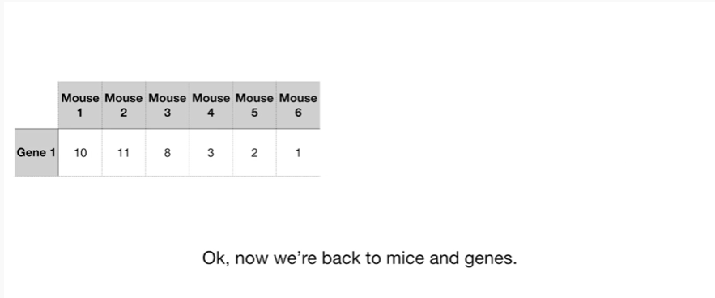

Ok now we're back to mice and genes because I'm a geneticist and I work in a genetics department.

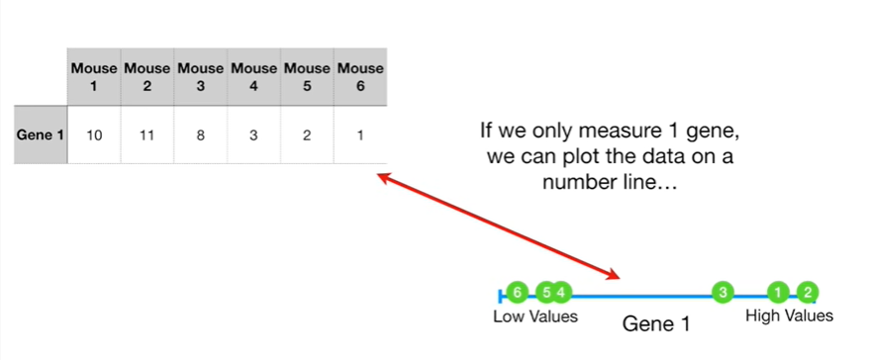

If we only measure one gene we can plot the data on a number line

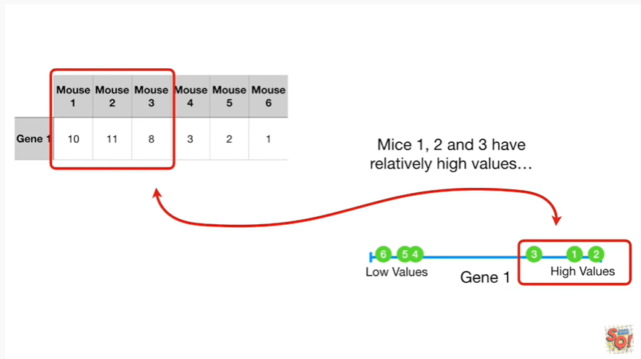

mice 1 2 & 3 have relatively high values

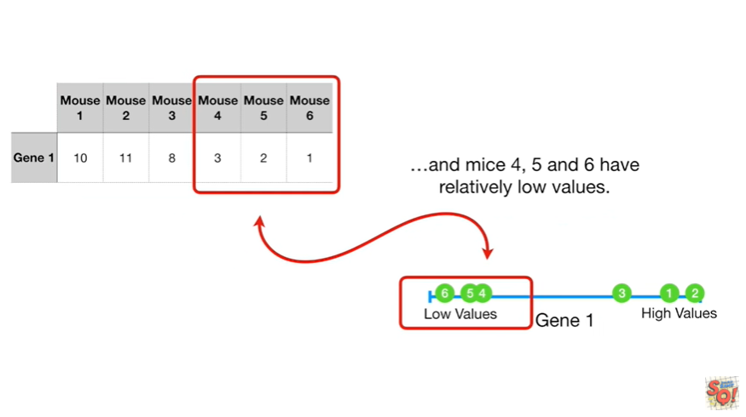

and mice 4 5 & 6 have relatively low values.

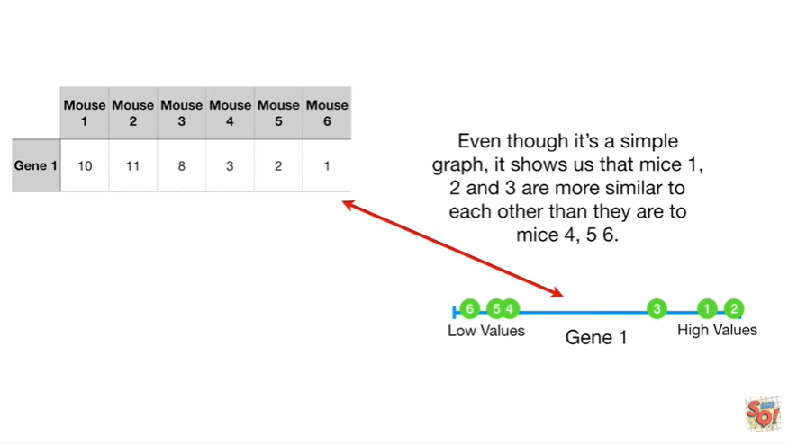

Even though it's a simple graph it shows us that mice 1 2 & 3 are more similar to each other than they are to mice 4 5 & 6.

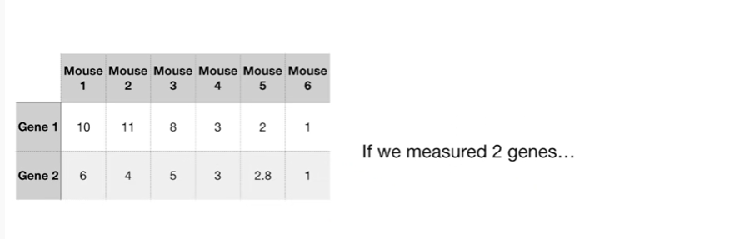

If we measured two genes

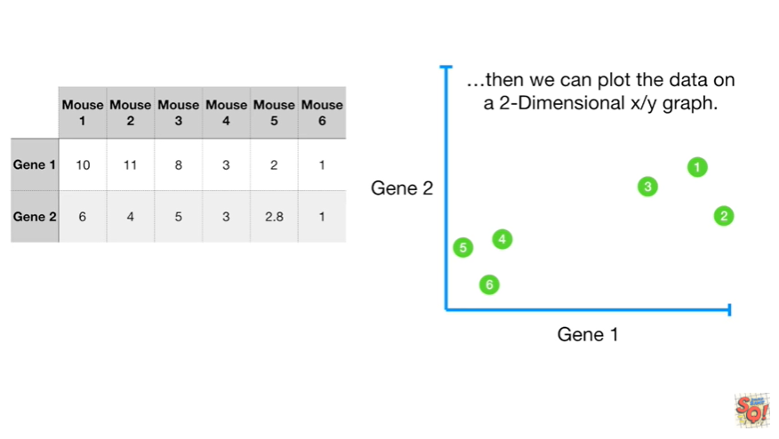

then we can plot the data on a two-dimensional XY graph

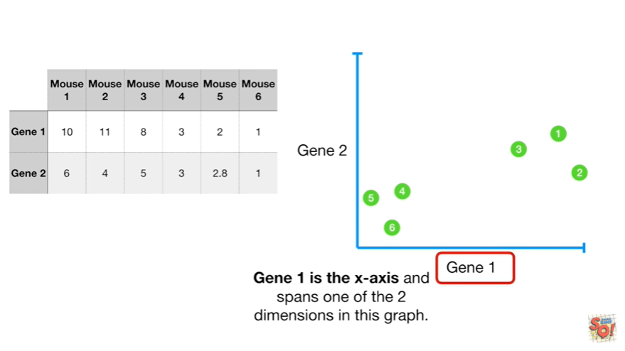

Gene 1 is the x-axis and spans one of the two dimensions in this graph.

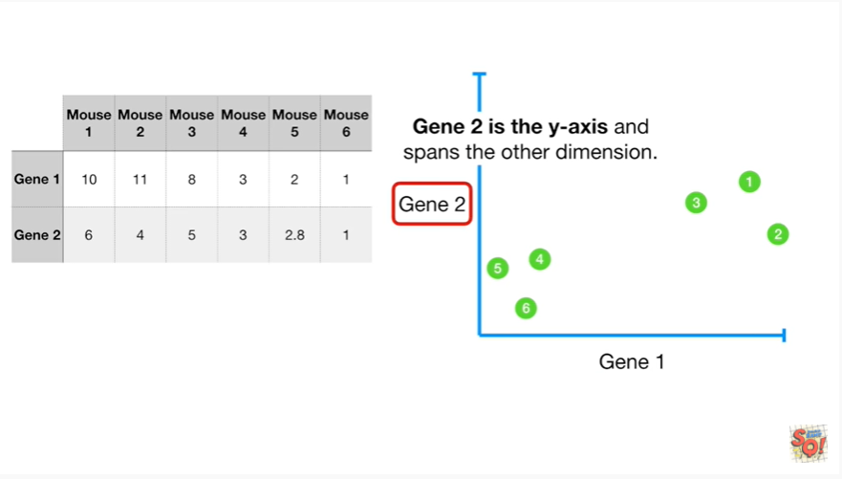

Gene2 is the y-axis and spans the other dimension.

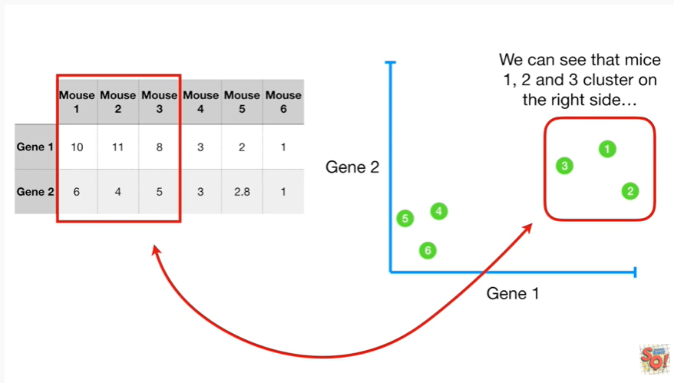

We can see that mice 1 2 & 3 cluster on the right side

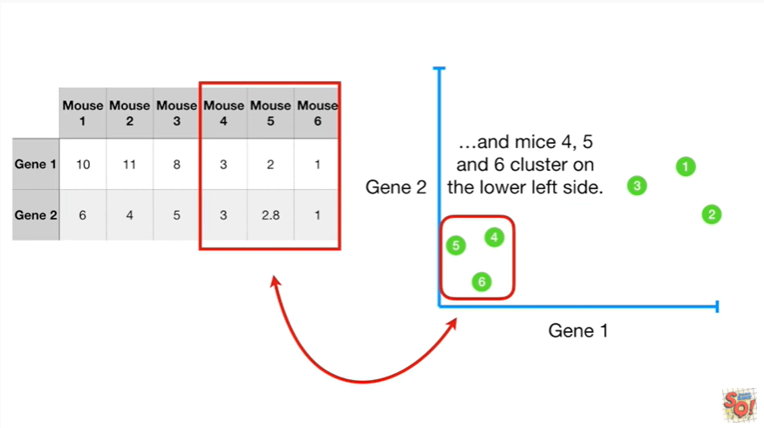

and mice 4 5 & 6 cluster on the lower left-hand side.

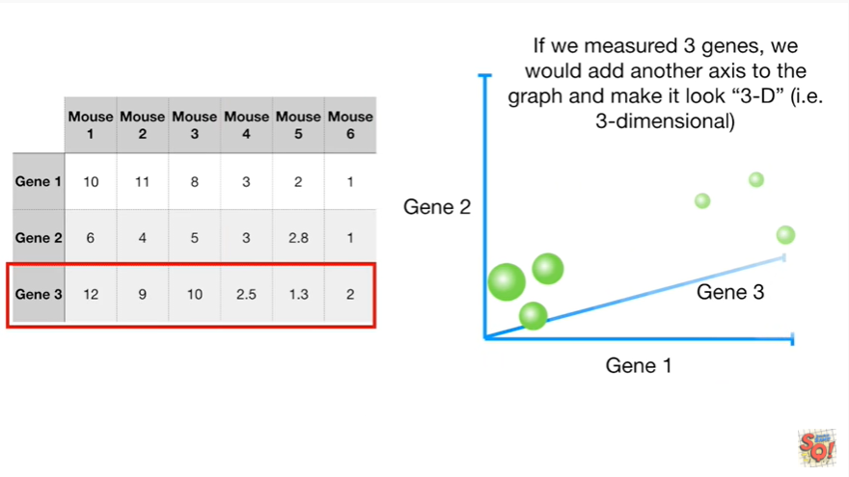

If we measured three genes we would add another axis to the graph and make it look 3d ie three dimensional.

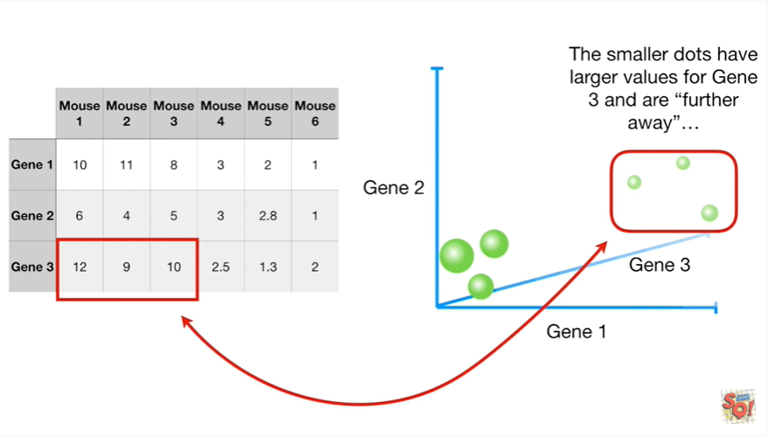

The smaller dots have larger values for gene three and are further away

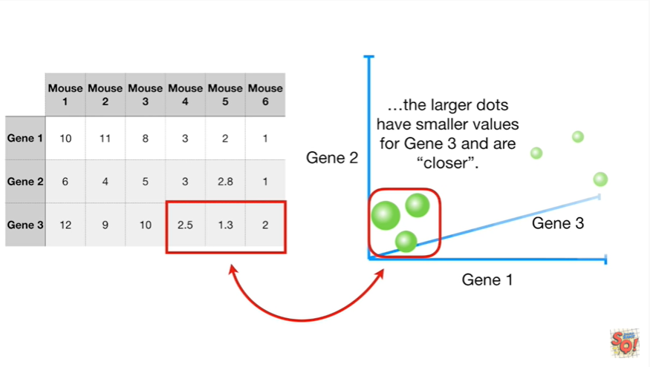

the larger dots have smaller values for gene three and are closer.

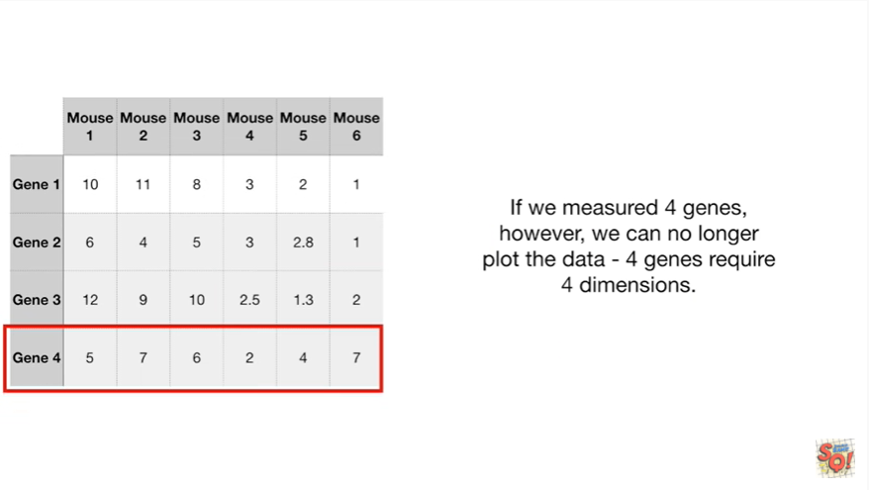

If we measured for jeans however we can no longer plot the data for jeans require four dimensions.

Waah Wahh !

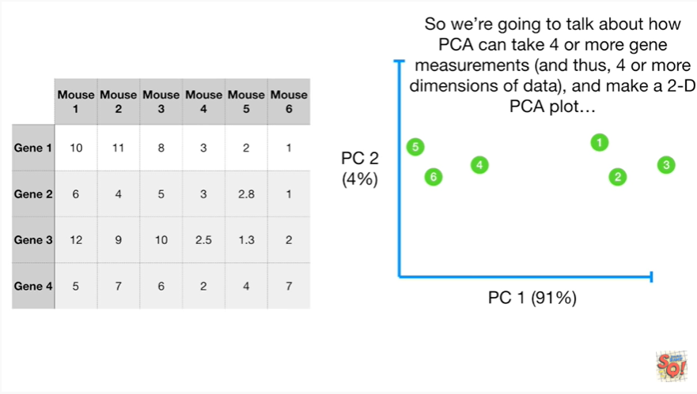

So we're going to talk about how PCA can take four or more Jean measurements and thus four or more dimensions of data and make a two dimensional PCA plot.

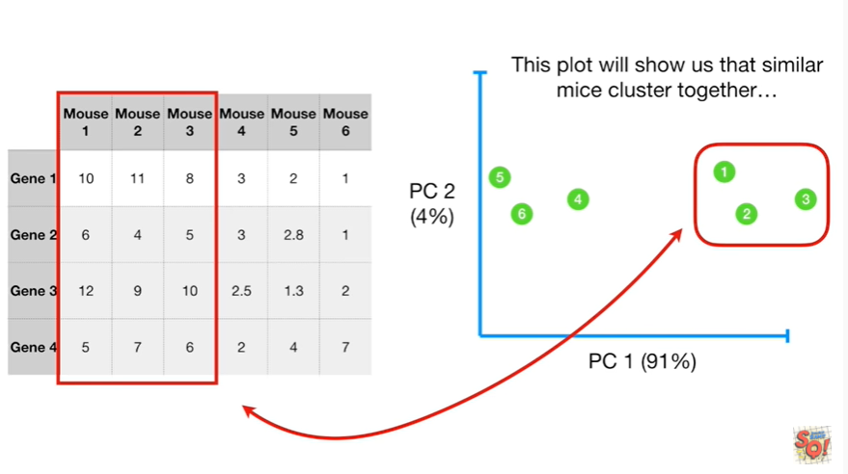

This plot will show us that similar mice cluster together.

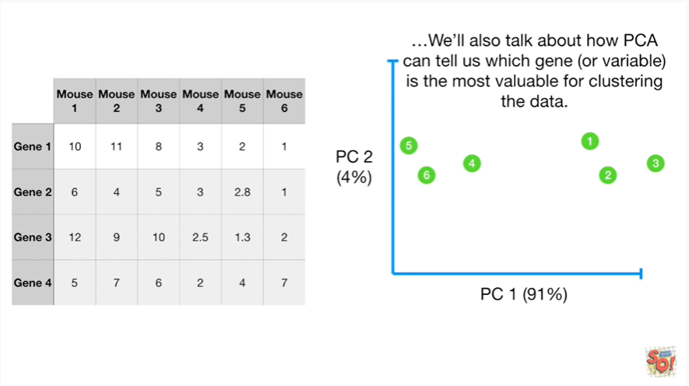

We'll also talk about how PCA can tell us which gene or variable is the most valuable for clustering the data.

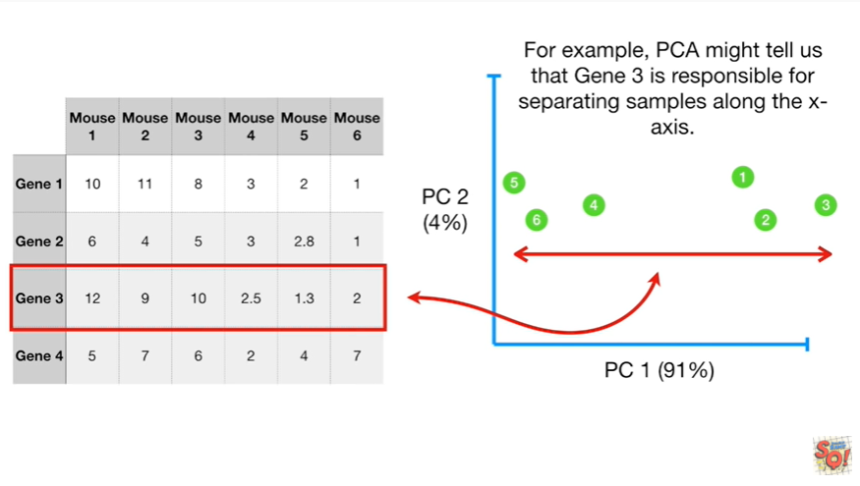

For example PCA might tell us that gene 3 is responsible for separating samples along the x axis.

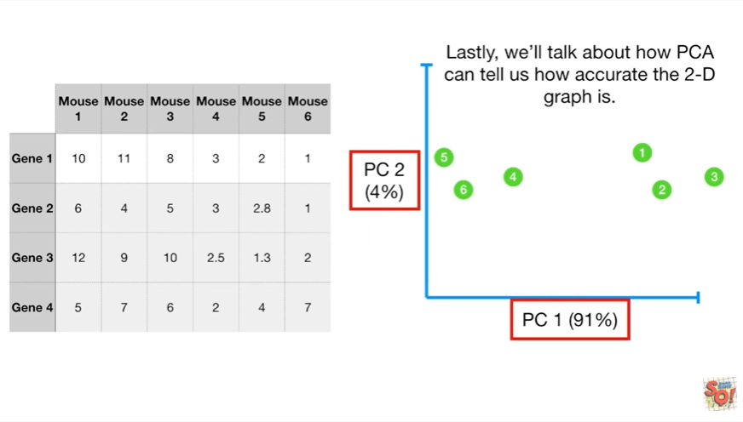

Lastly we'll talk about how PCA can tell us how accurate the 2d graph is.

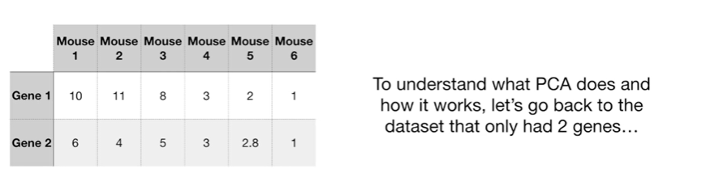

To understand what PCA does and how it works let's go back to the dataset that only had two genes.

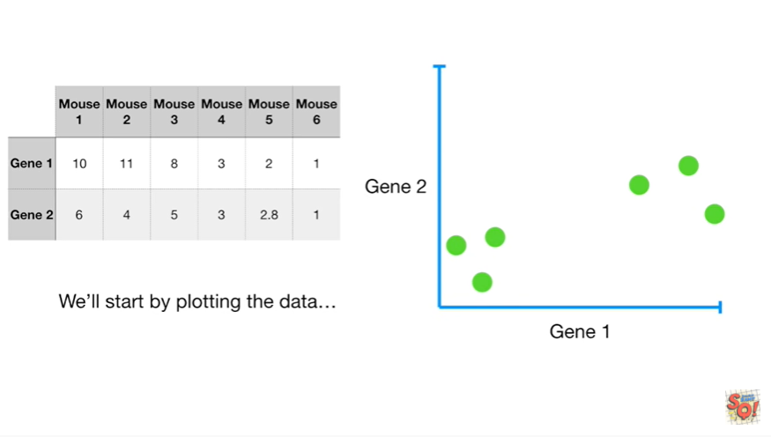

We'll start by plotting the data.

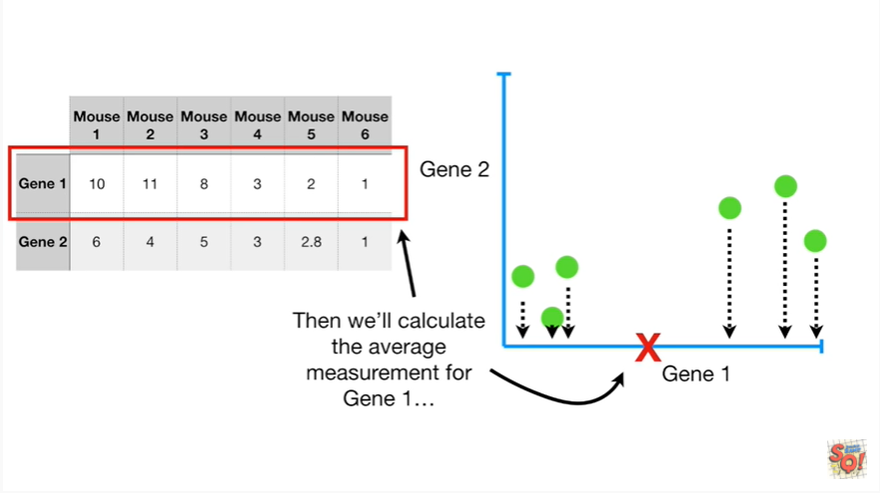

Then we'll calculate the average measurement for gene 1

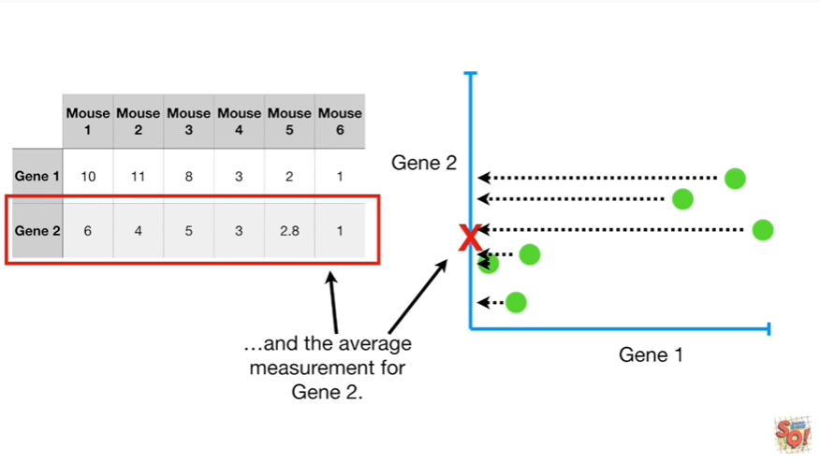

and the average measurement for gene 2.

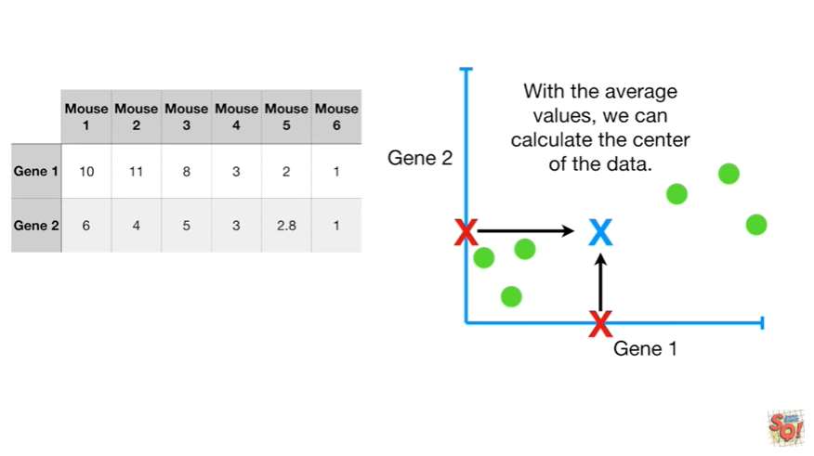

With the average values we can calculate the center of the data.

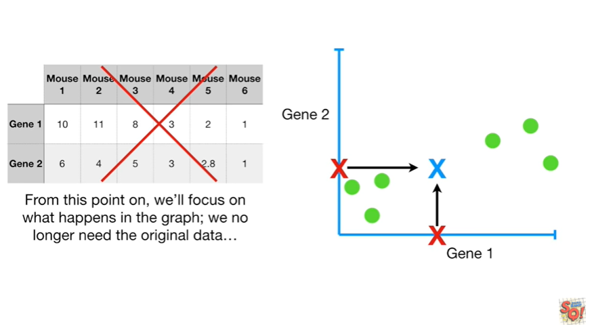

From this point on we'll focus on what happens in the graph we no longer need the original data.

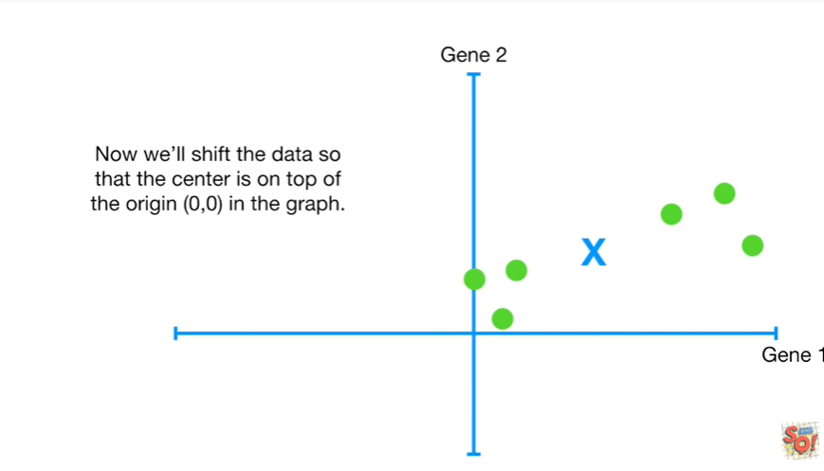

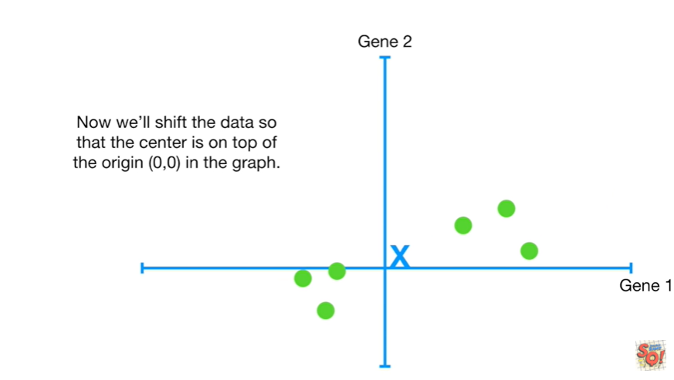

Now we'll shift the data so that the center is on top of the origin in the graph.

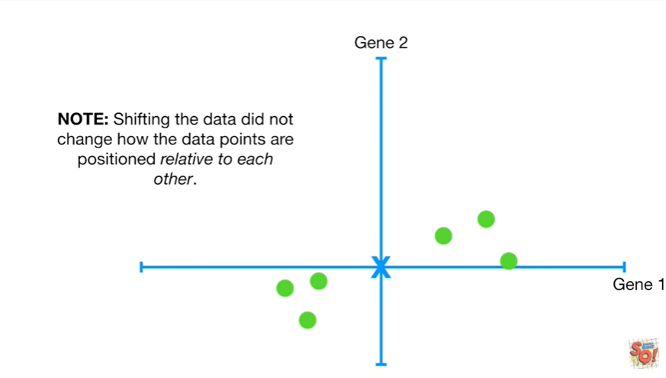

Note : shifting the data did not change how the data points are positioned relative to each other.

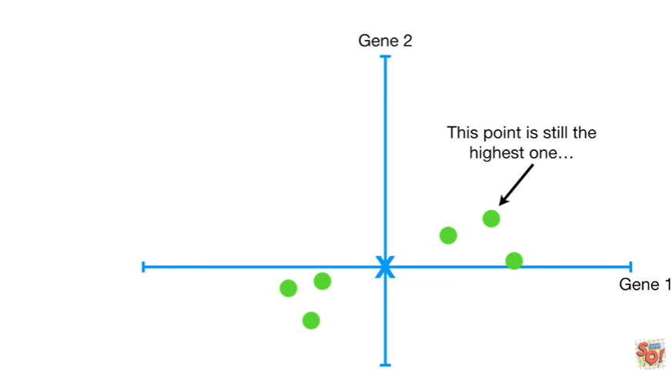

This point is still the highest one

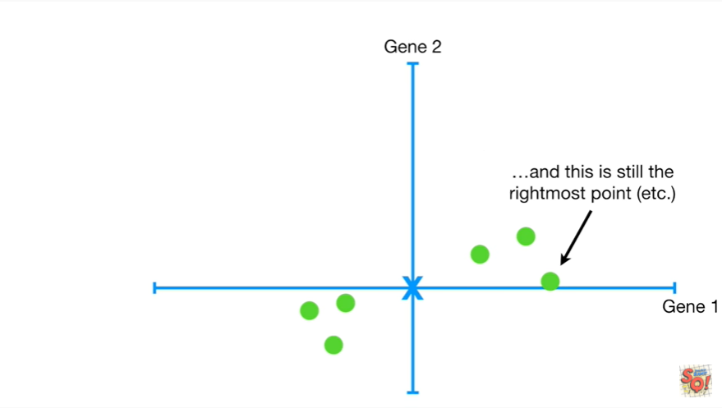

and this is still the rightmost point etc.

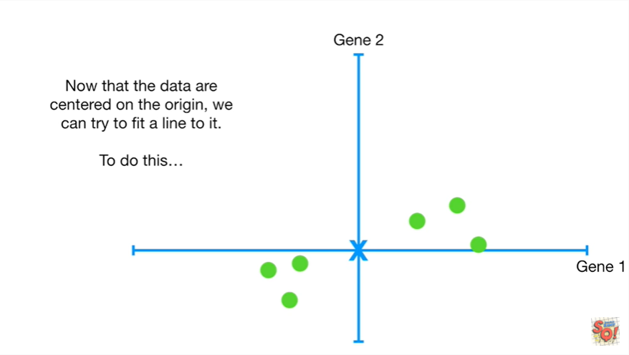

Now that the data are centered on the origin we can try to fit a line to it.

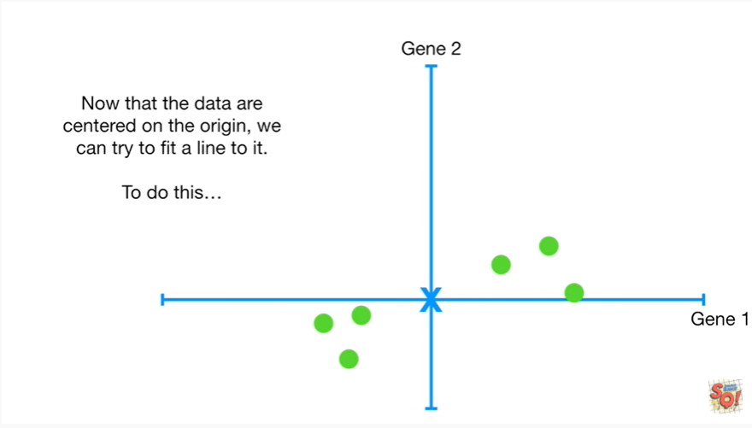

To do this

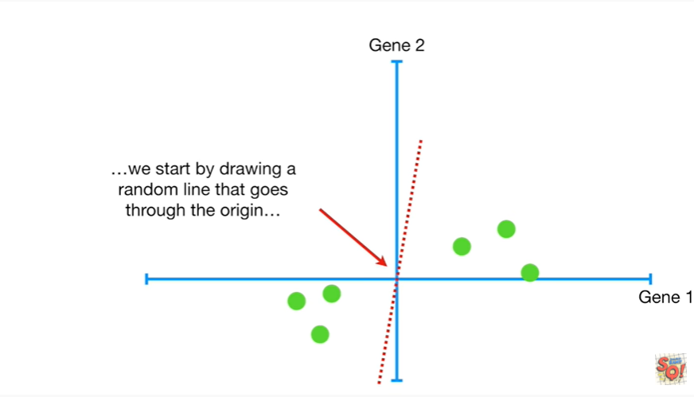

we start by drawing a random line that goes through the origin

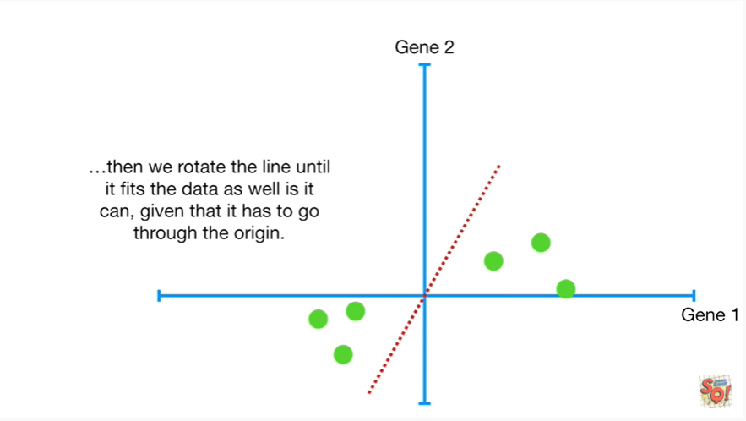

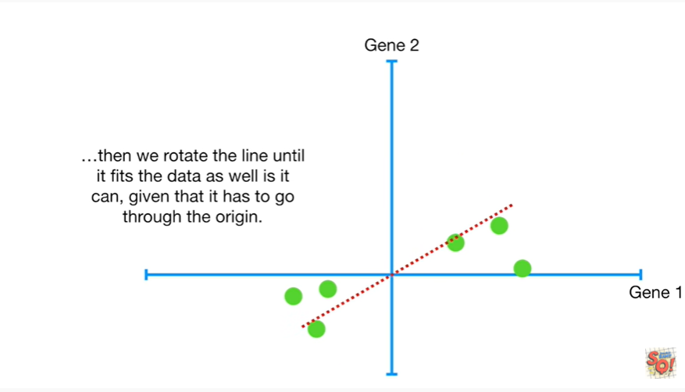

then we rotate the line until it fits the data as well as it can given that it has to go through the origin.

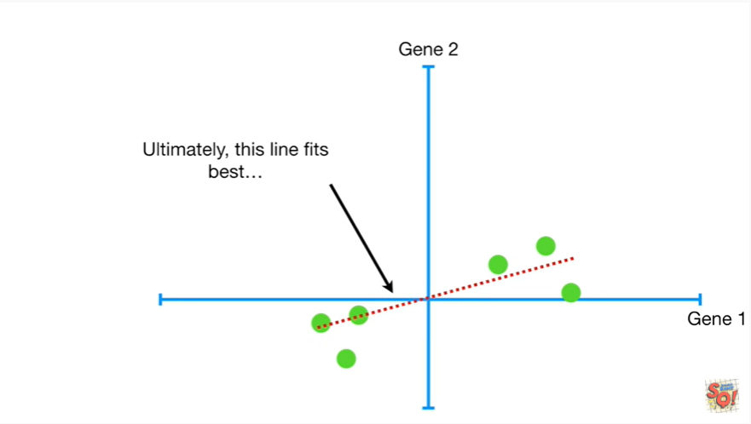

Ultimately this line fits best

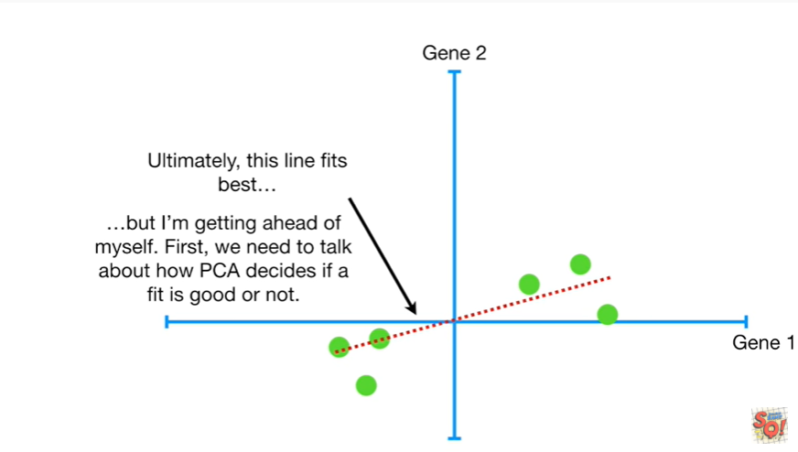

but I'm getting ahead of myself.

First we need to talk about how PCA decides if a fit is good or not.

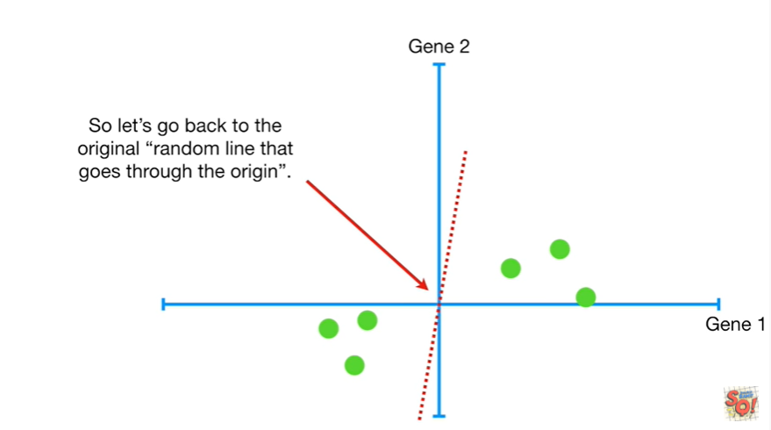

So let's go back to the original random line that goes through the origin.

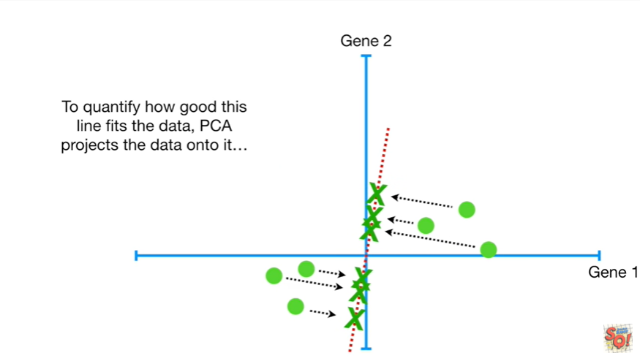

To quantify how good this line fits the data PCA projects the data onto it

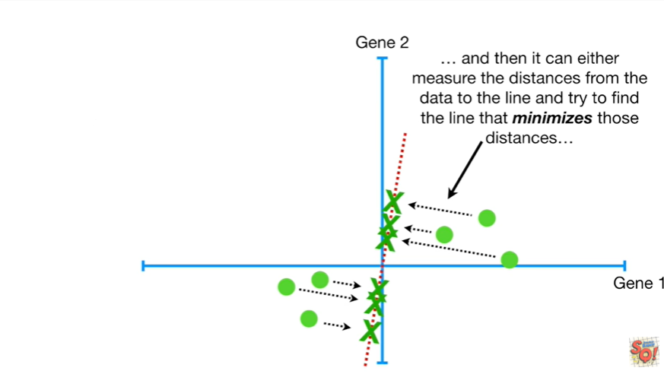

and then it can either measure the distances from the data to the line and try to find the line that minimizes those distances

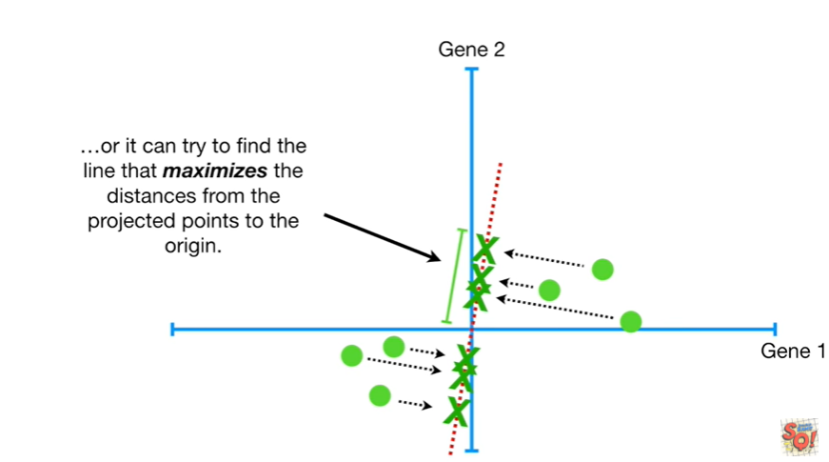

or it can try to find the line that maximizes the distances from the projected points to the origin.

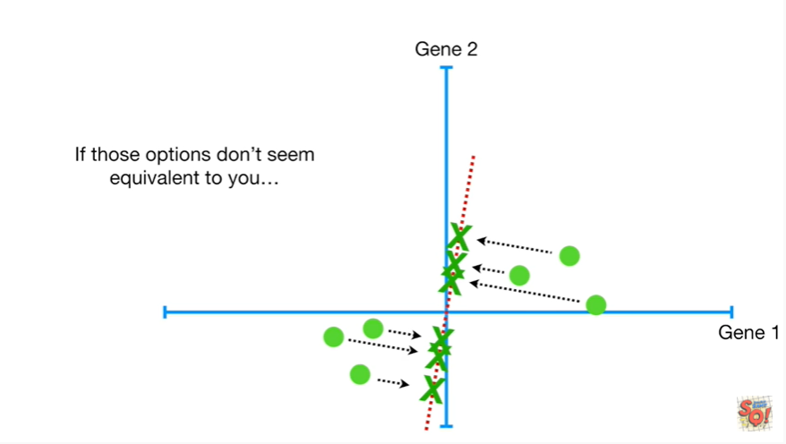

If those options don't seem equivalent to you

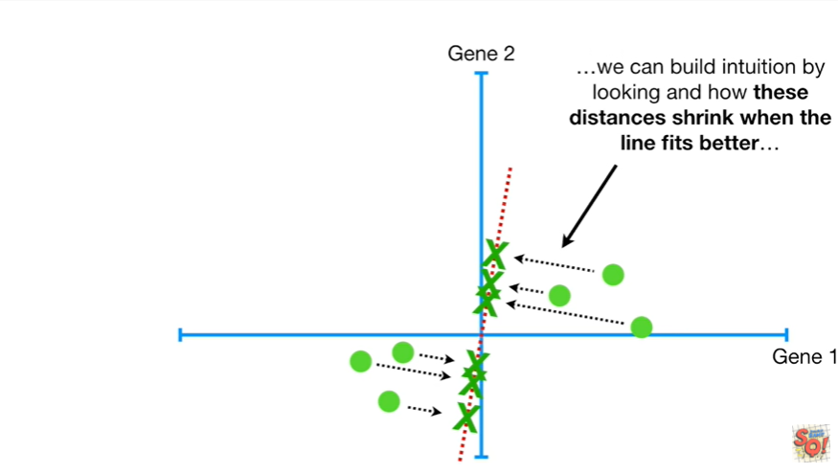

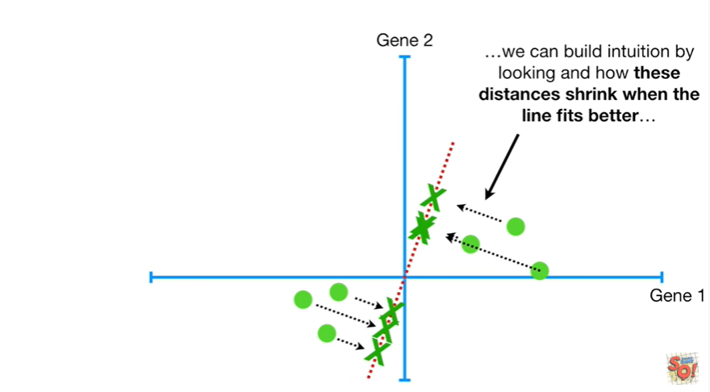

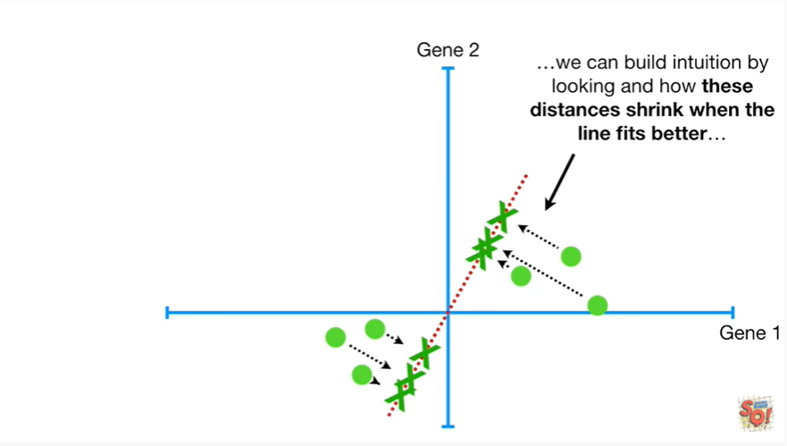

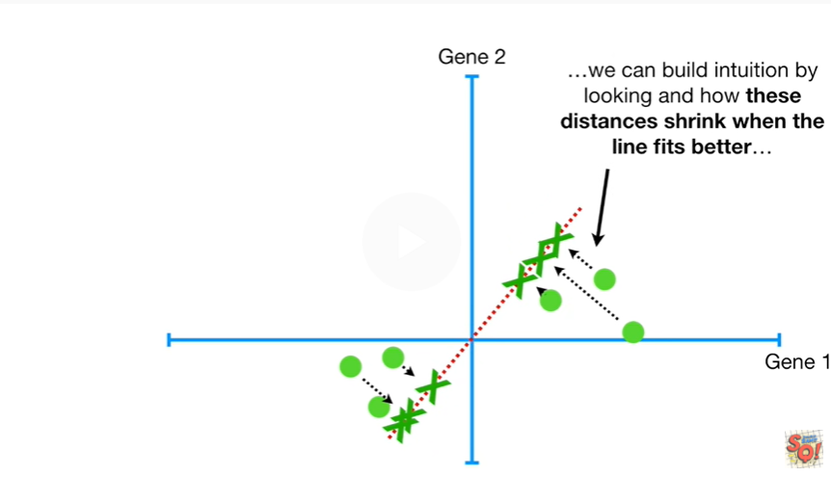

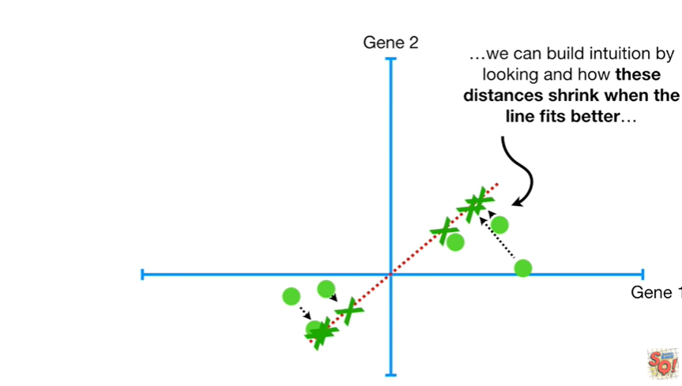

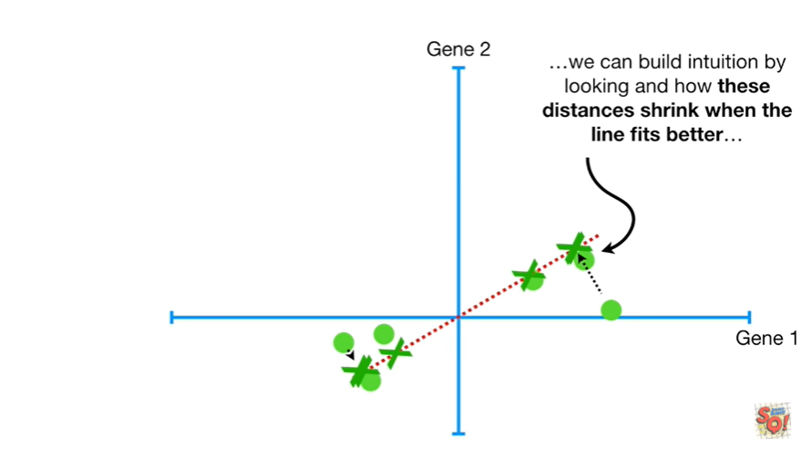

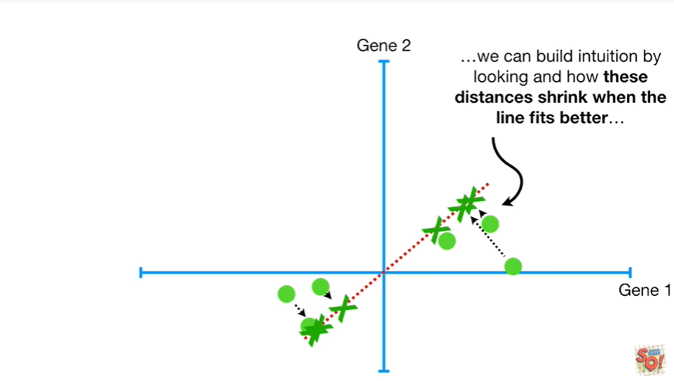

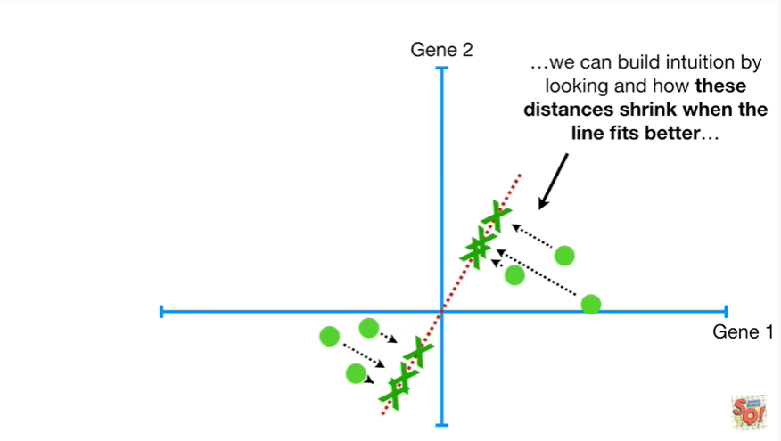

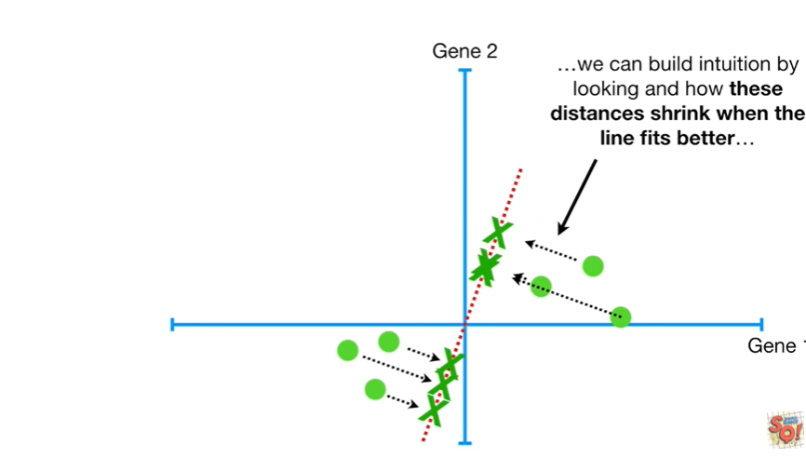

we can build intuition by looking at how these distances shrink when the line fits better

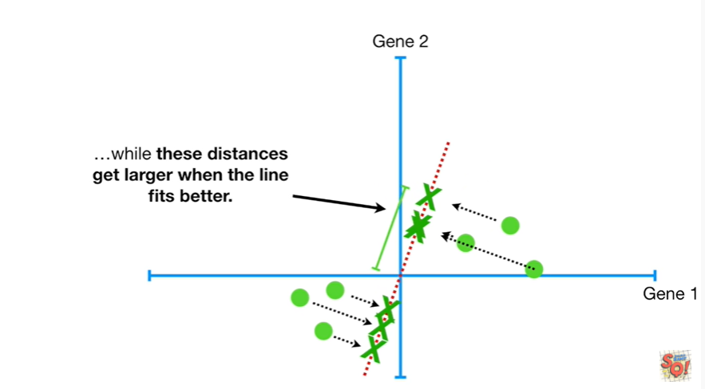

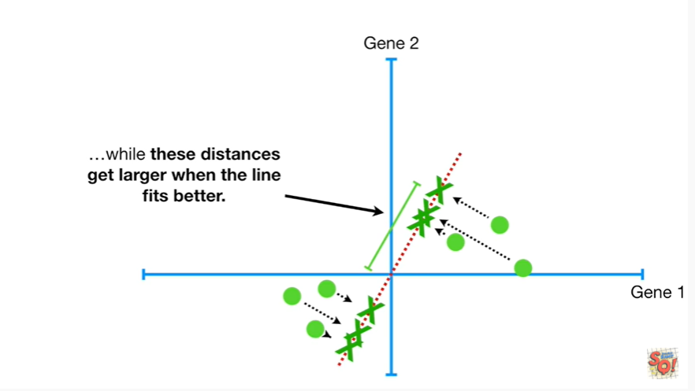

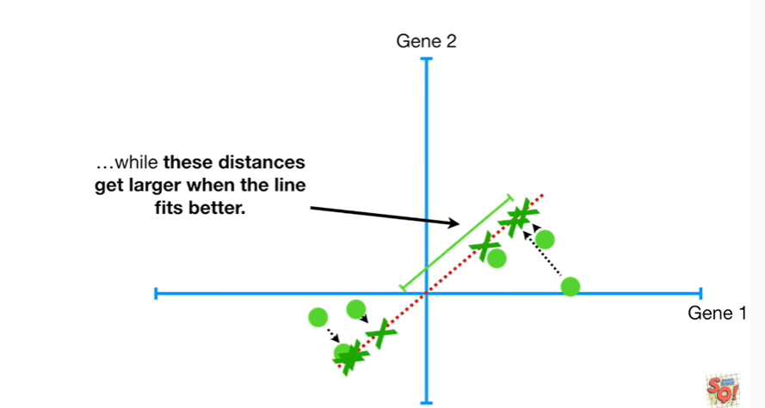

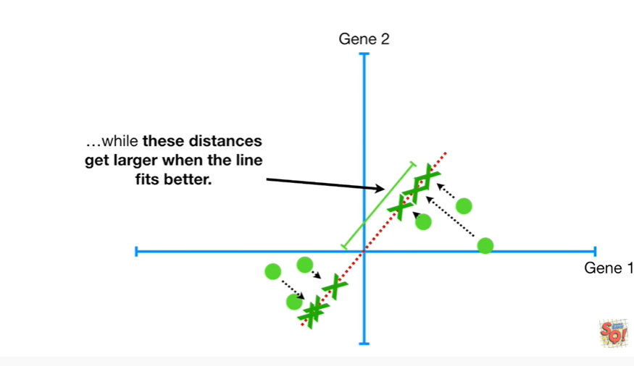

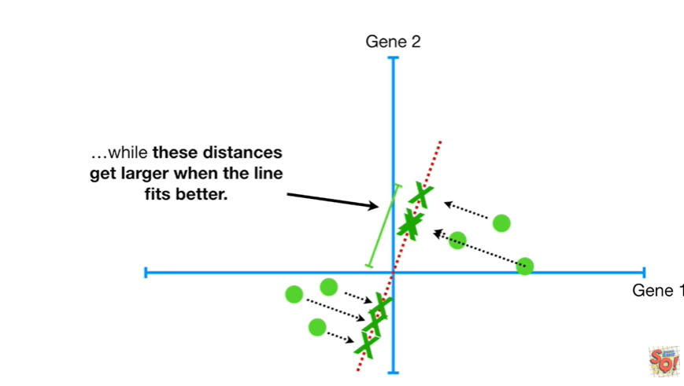

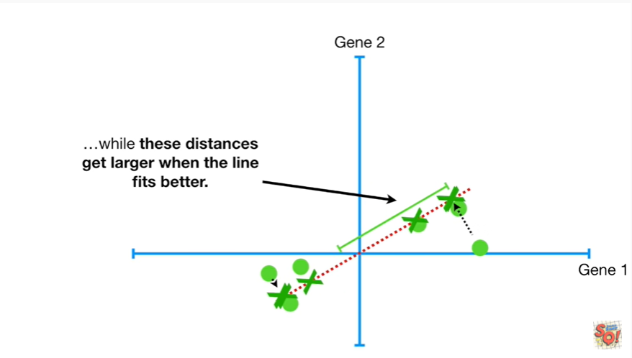

while these distances get larger when the line fits better.

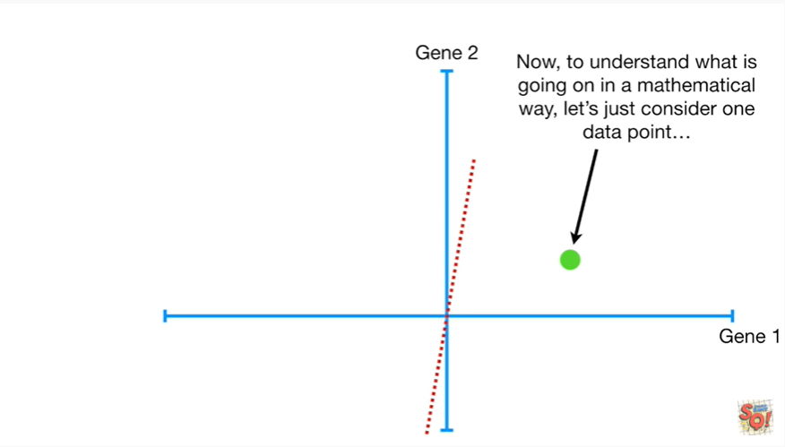

Now to understand what is going on in a mathematical way let's just consider one data point

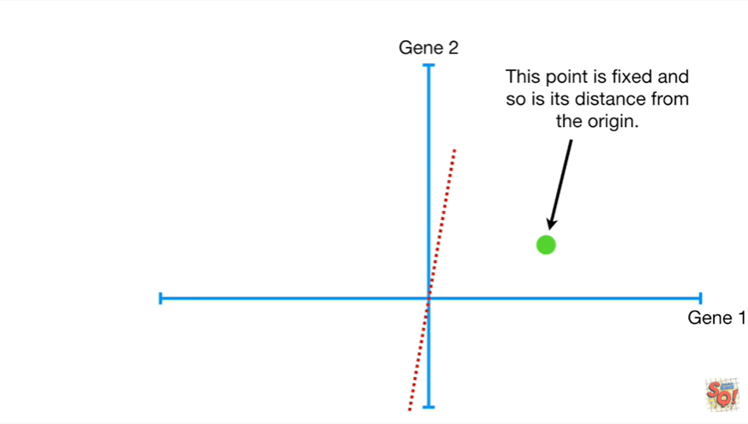

This point is fixed and so is its distance from the origin.

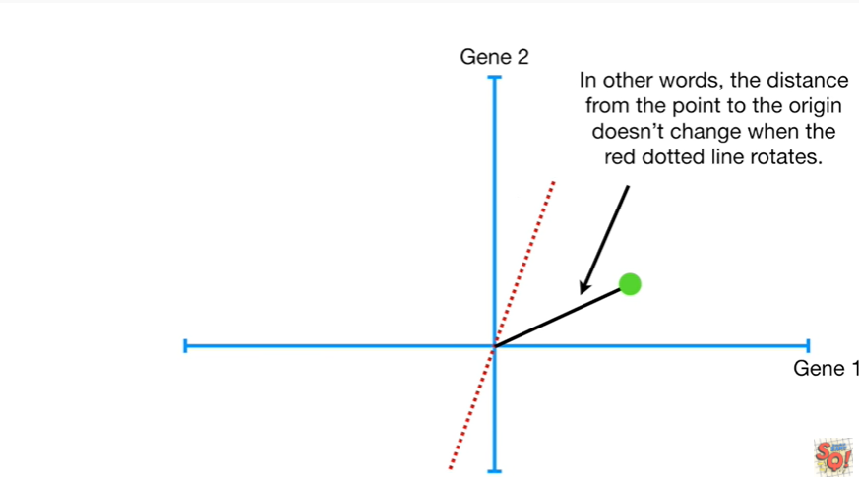

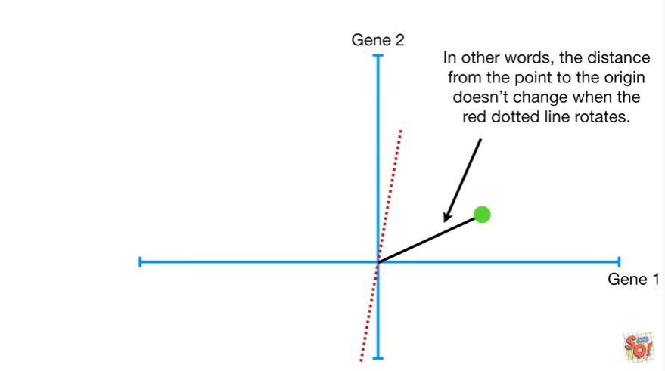

In other words the distance from the point to the origin doesn't change when the red dotted line rotates.

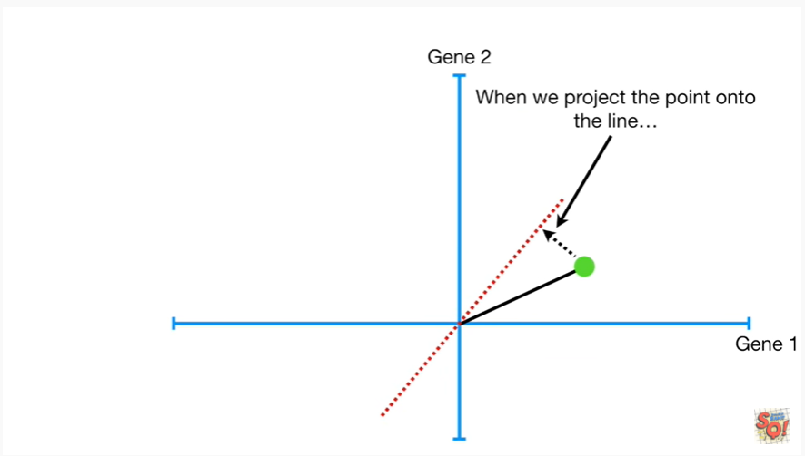

When we project the point onto the line

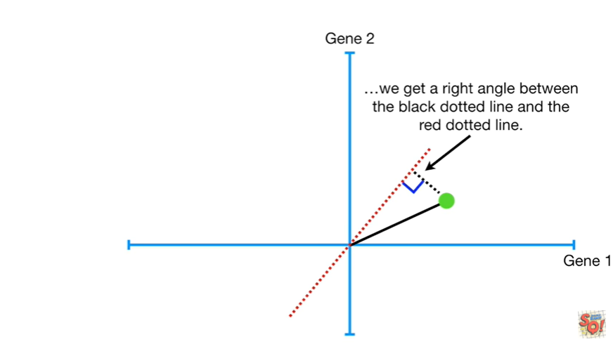

we get a right angle between the black dotted line and the red dotted line.

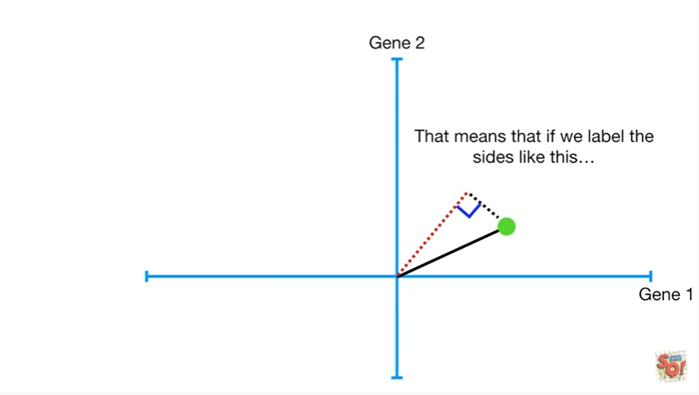

That means that if we label the sides like this

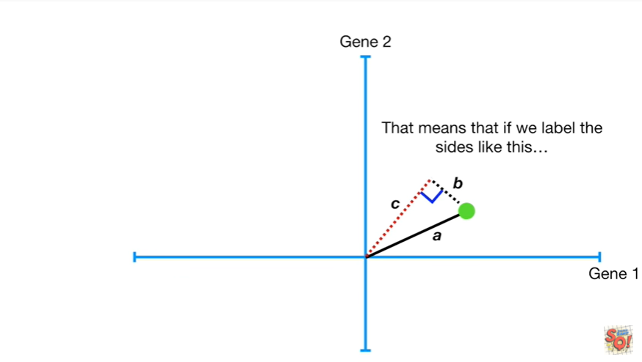

a b and c

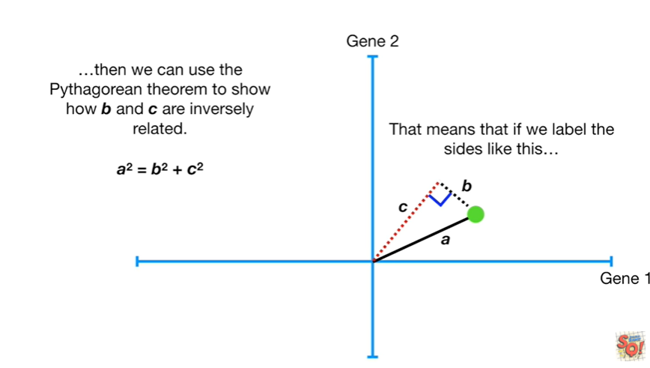

then we can use the Pythagorean theorem to show how B and C are inversely related.

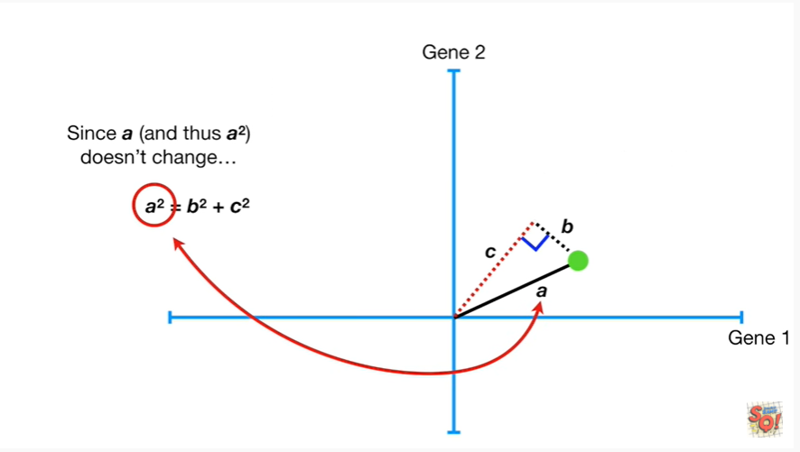

Since a and thus a squared doesn't change

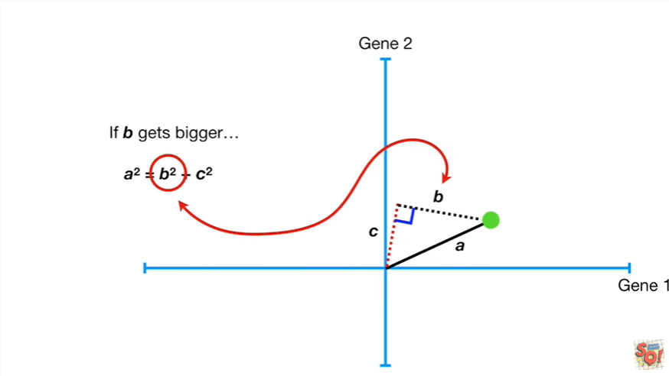

if B gets bigger

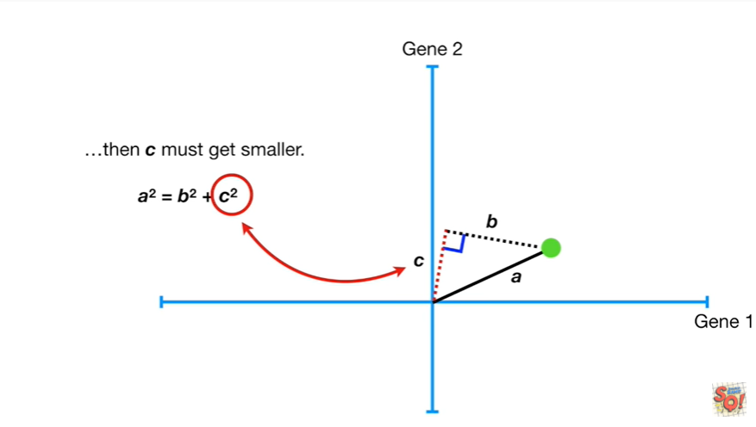

then C must get smaller.

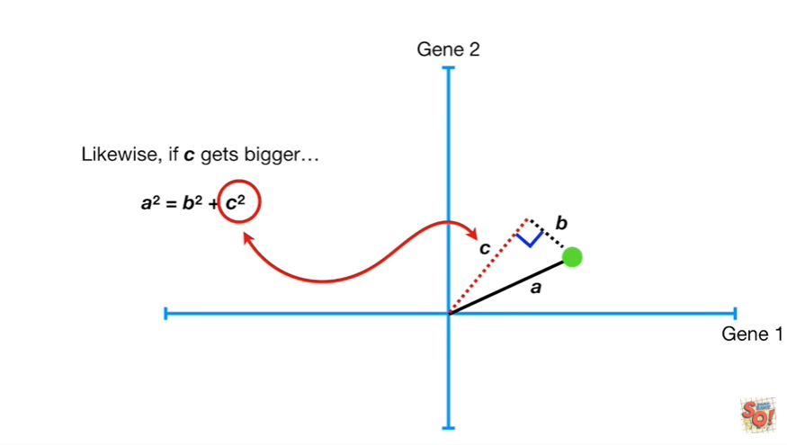

Likewise if C gets bigger

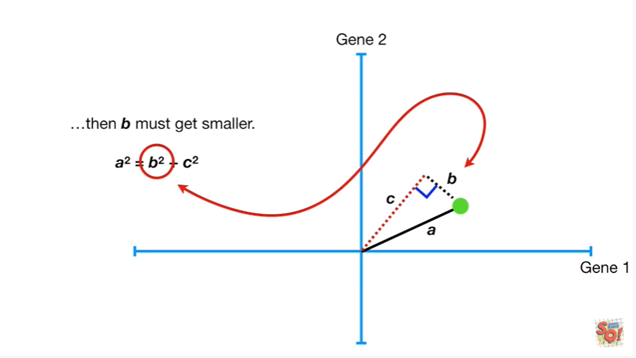

then B must get smaller.

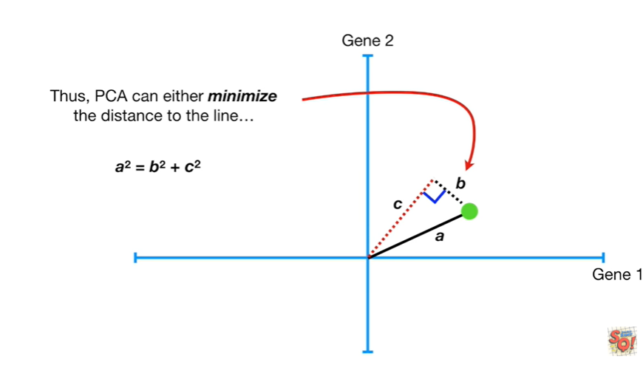

Thus PCA can either minimize the distance to the line

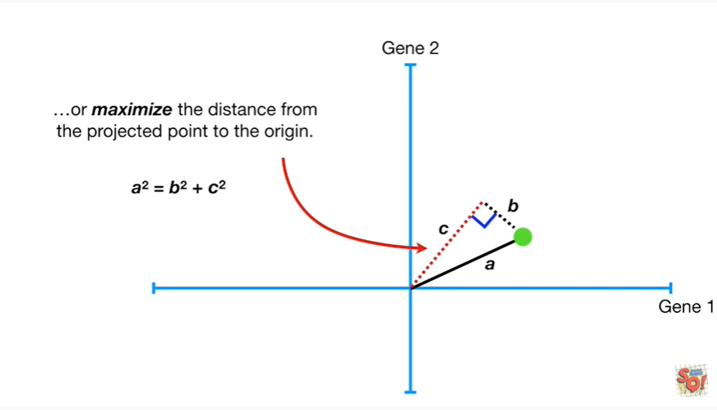

or maximize the distance from the projected point to the origin.

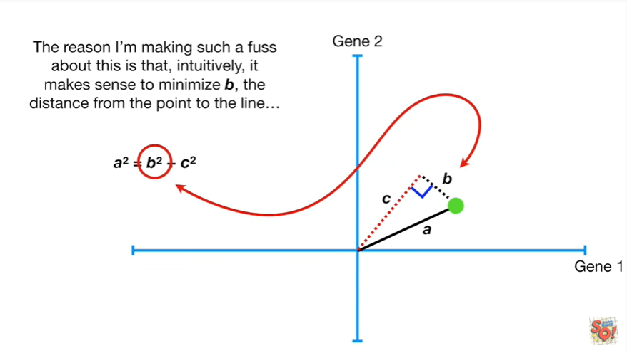

The reason I'm making such a fuss about this is that intuitively it makes sense to minimize B and the distance from the point to the line

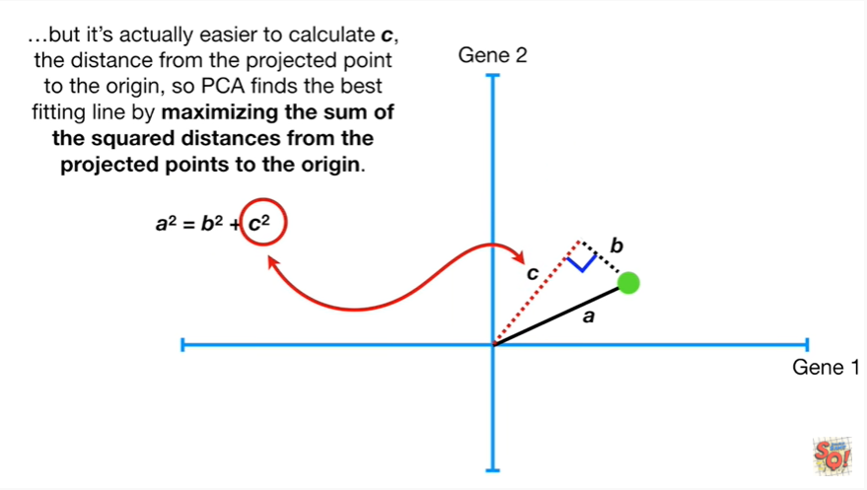

but it's actually easier to calculate C the distance from the projected point to the origin so PCA finds the best fitting line by maximizing the sum of the squared distances from the projected points to the origin.

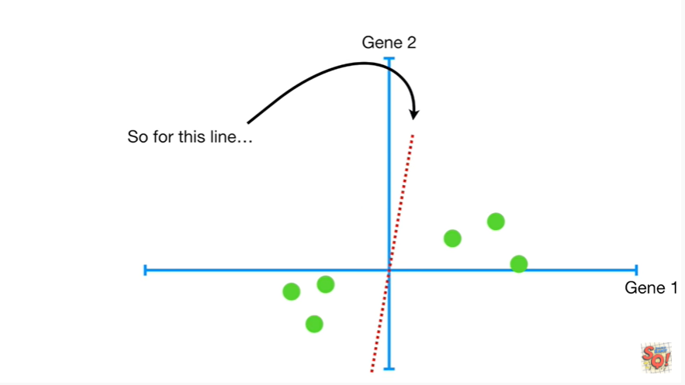

So for this line

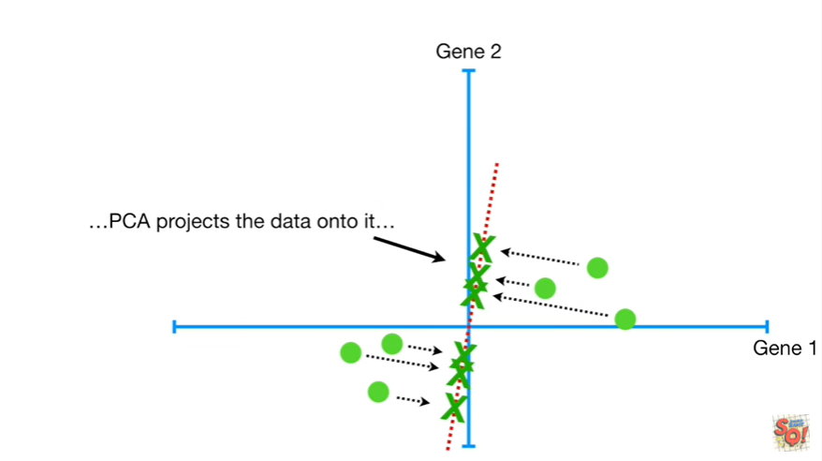

PCA projects the data onto it

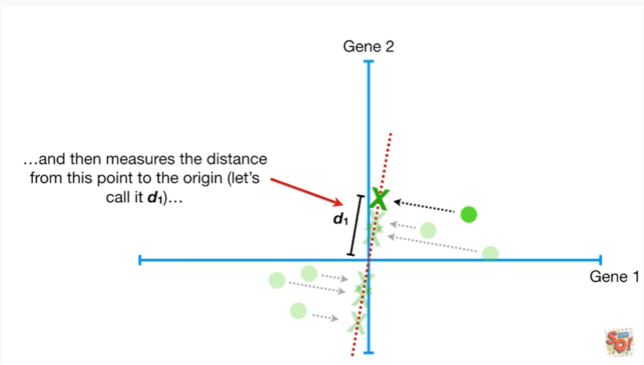

and then measures the distance from this point to the origin let's call it d sub1.

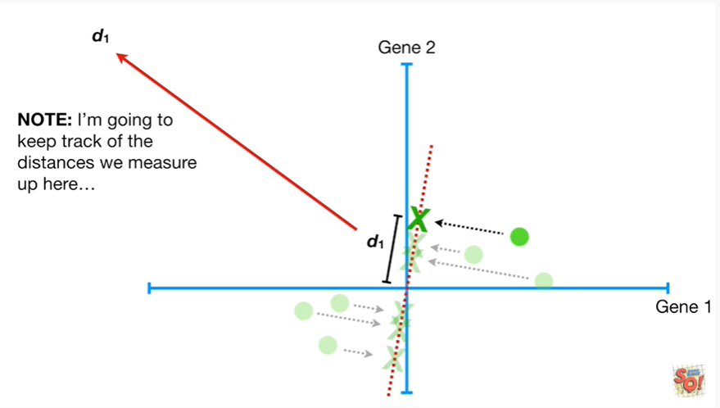

Note : I'm going to keep track of the distance as we measure up here

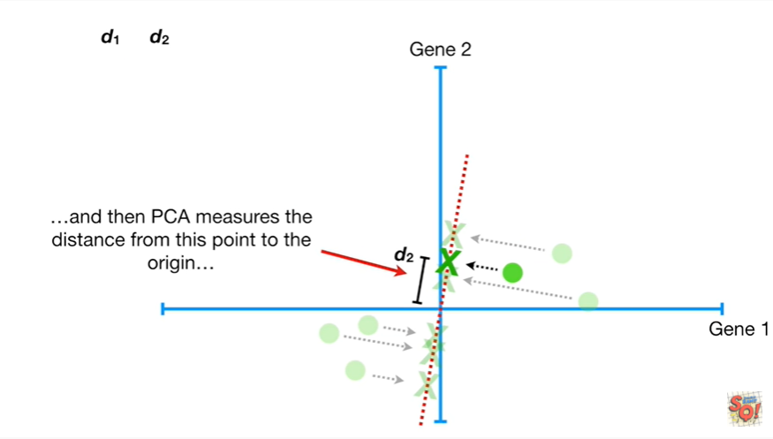

and then PCA measures the distance from this point to the origin.

We'll call that d2

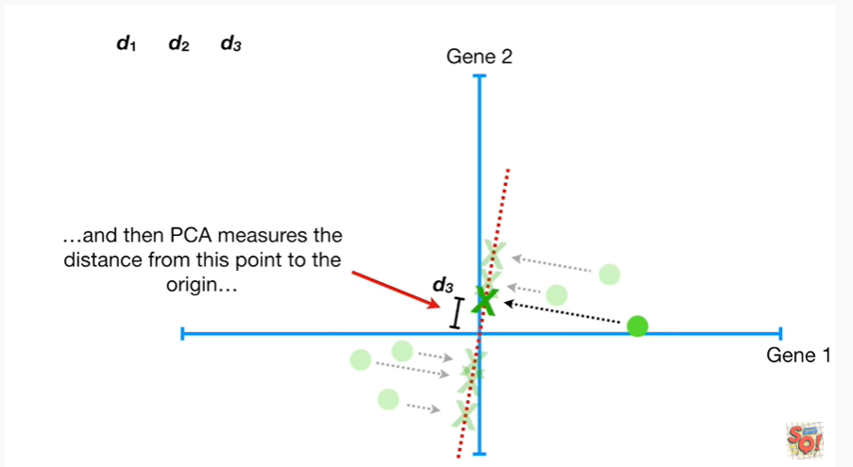

then it measures d3

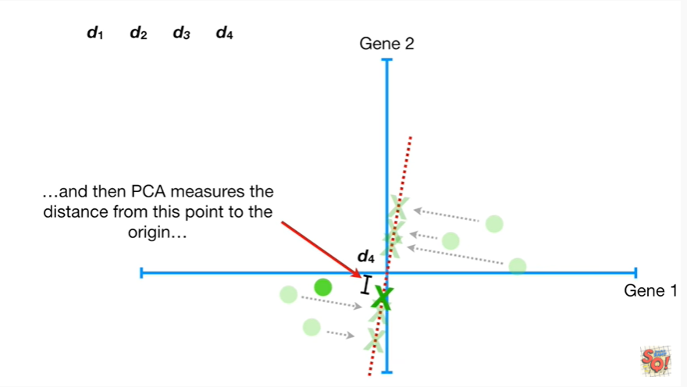

d4

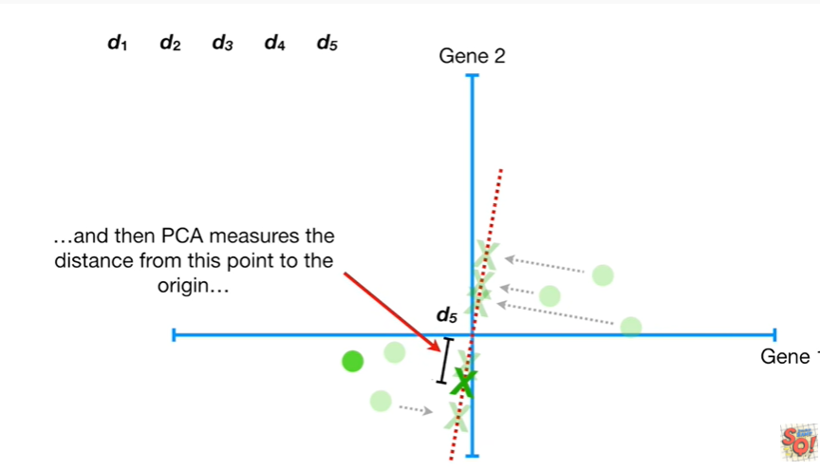

d5

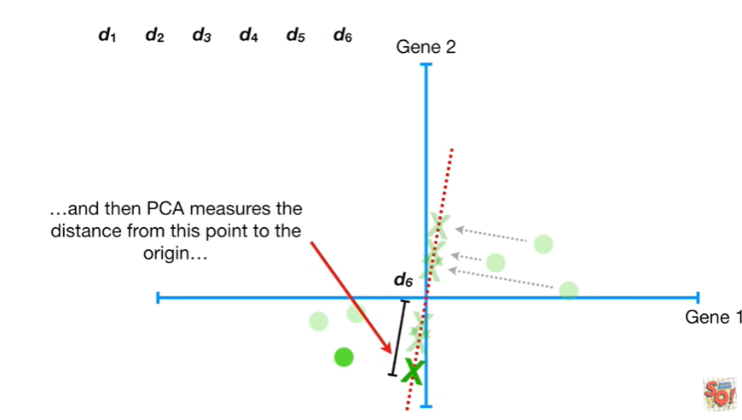

and d6.

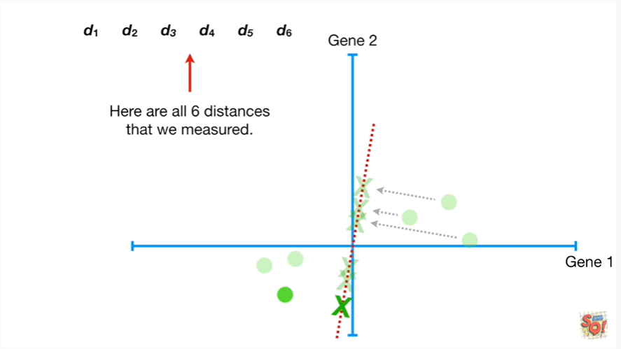

Here are all six distances that we measured.

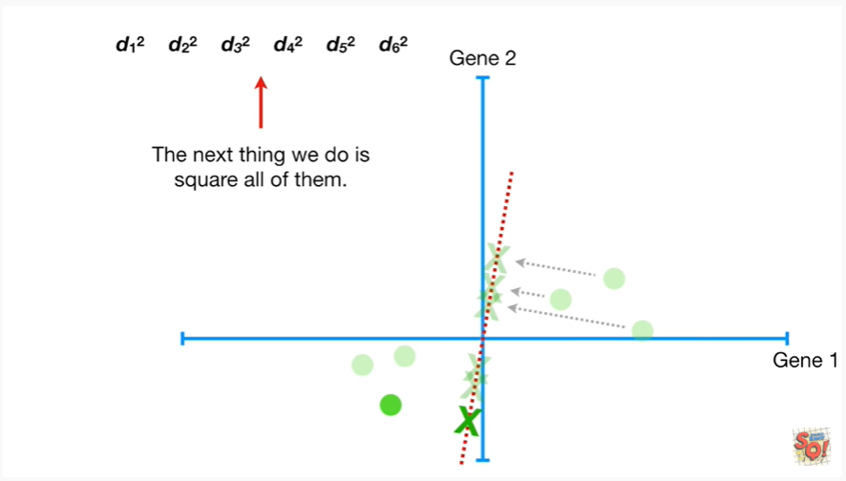

The next thing we do is Square all of them.

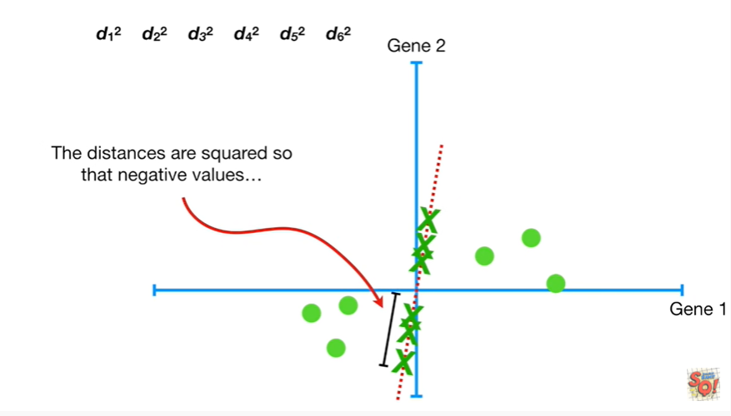

The distances are squared so that negative values

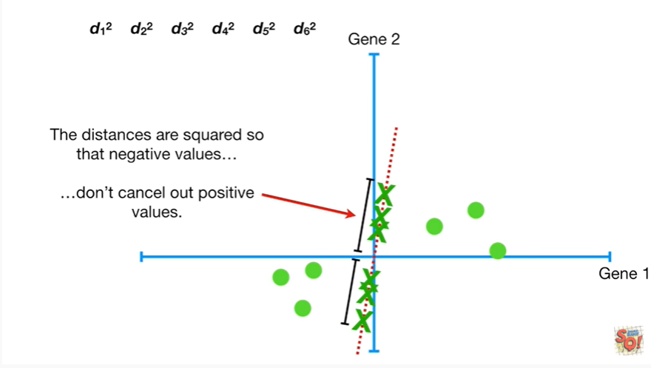

don't cancel out positive values.

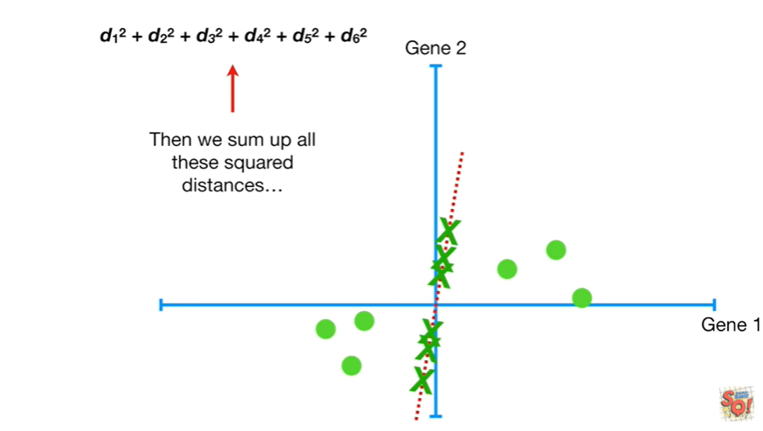

Then we sum up all these squared distances

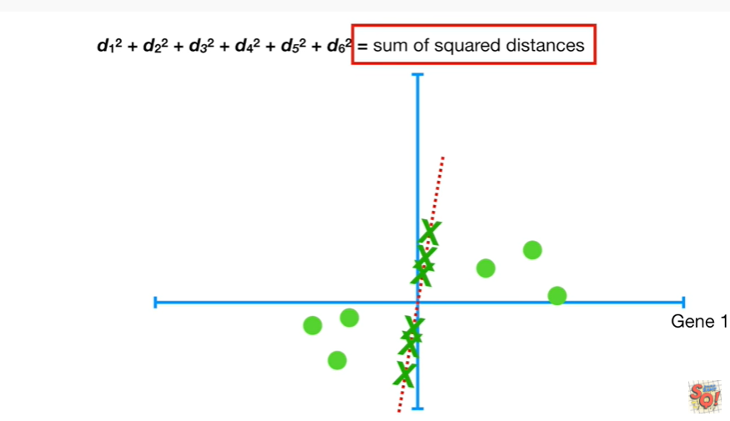

and that equals the sum of the squared distances

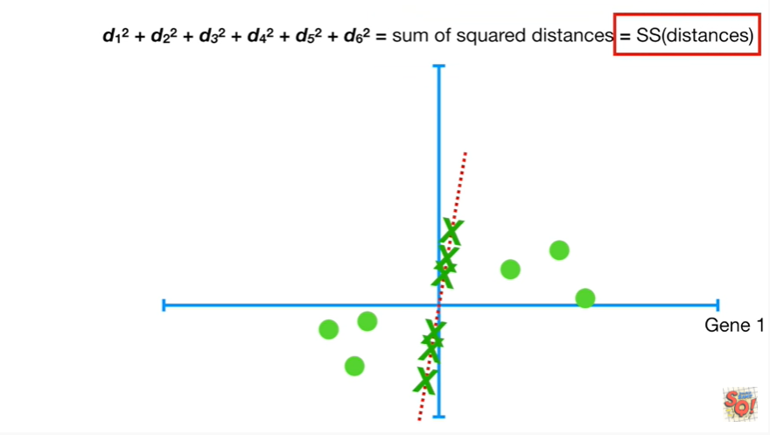

for short we'll call this SS distances for sum of squared distances.

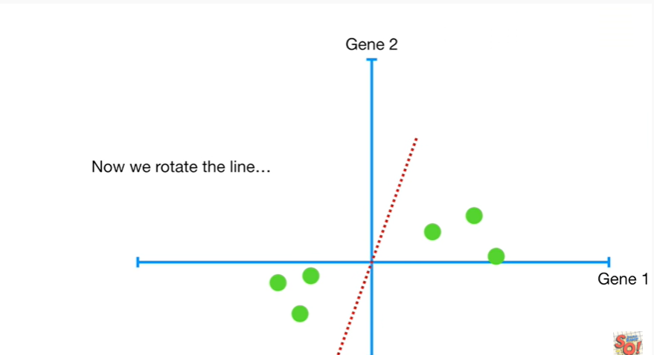

Now we rotate the line

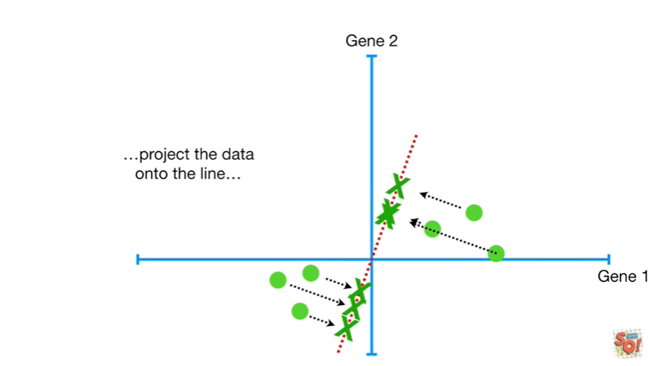

project the data onto the line

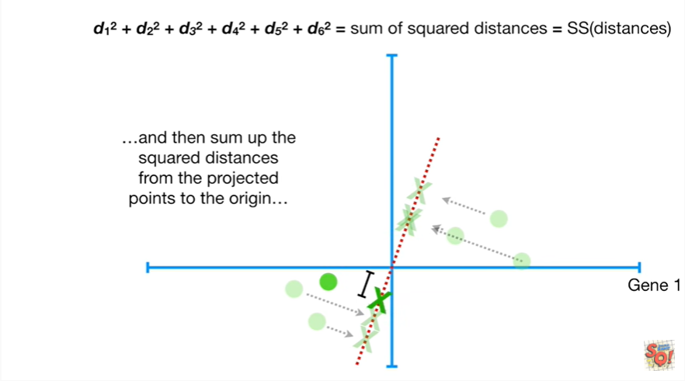

and then sum up the squared distances from the projected points to the origin

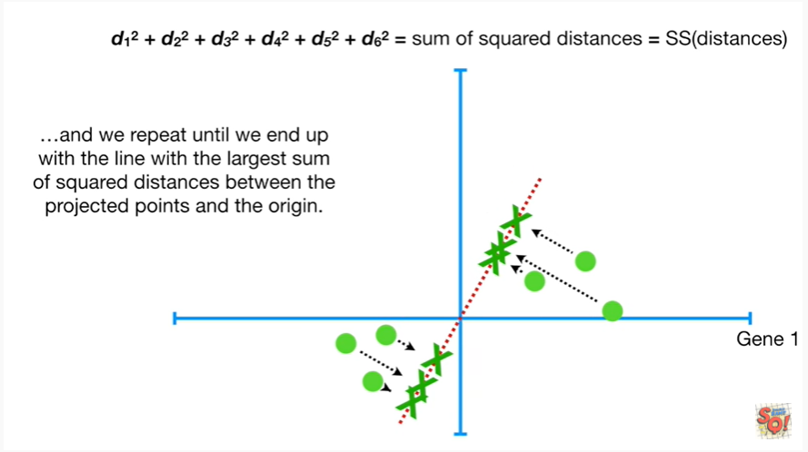

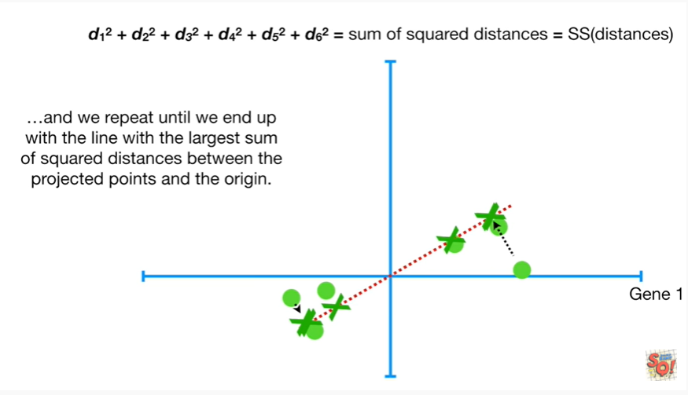

and we repeat until we end up with the line with the largest sum of square distances between the projected points and the origin.

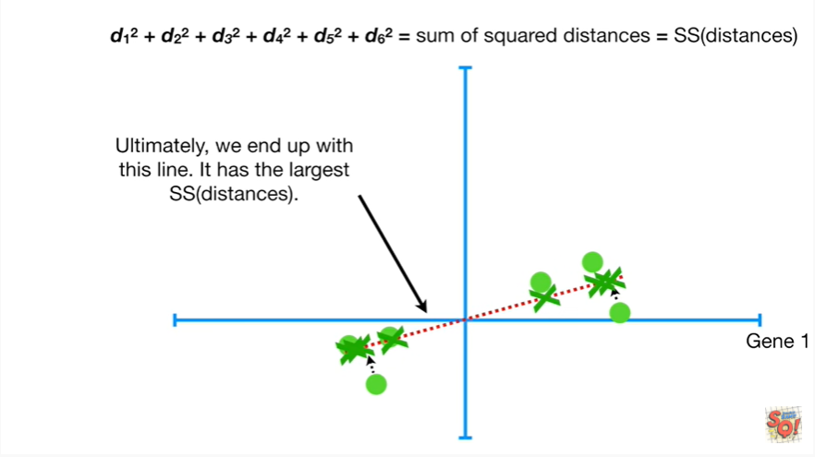

Ultimately we end up with this line it has the largest sum of squared distances.

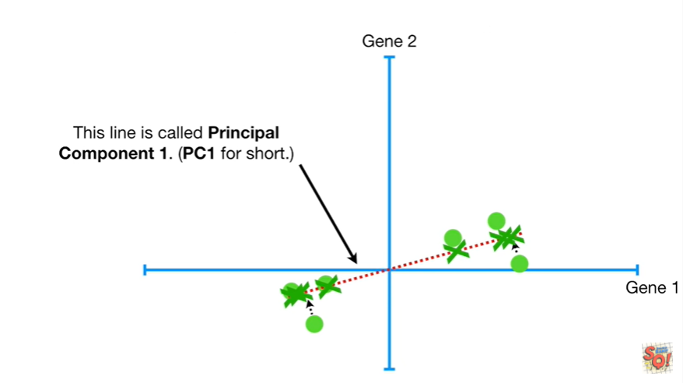

This line is called principal component 1 or PC1 for short.

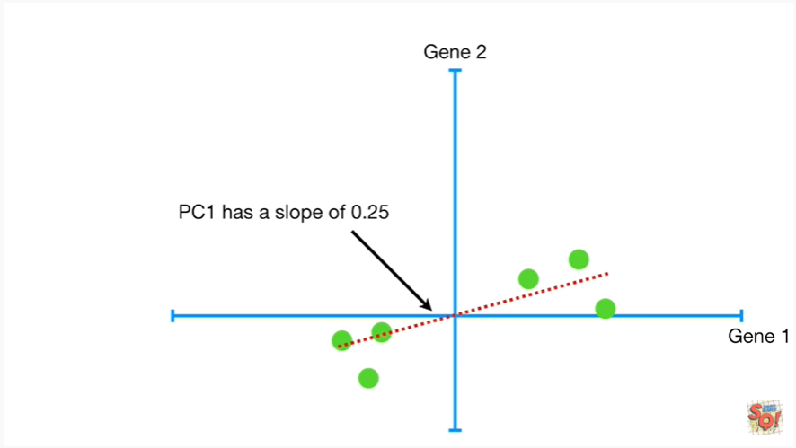

PC1 has a slope of 0.25.

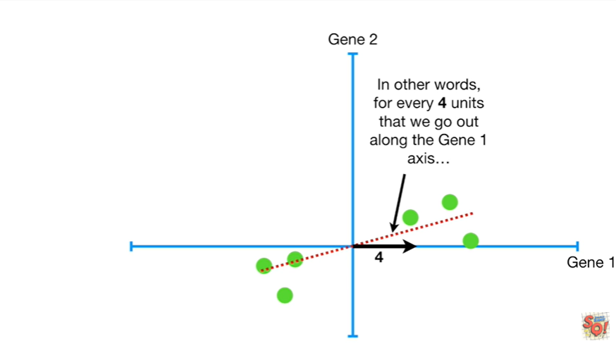

In other words for every four units that we go out along the gene 1 axis

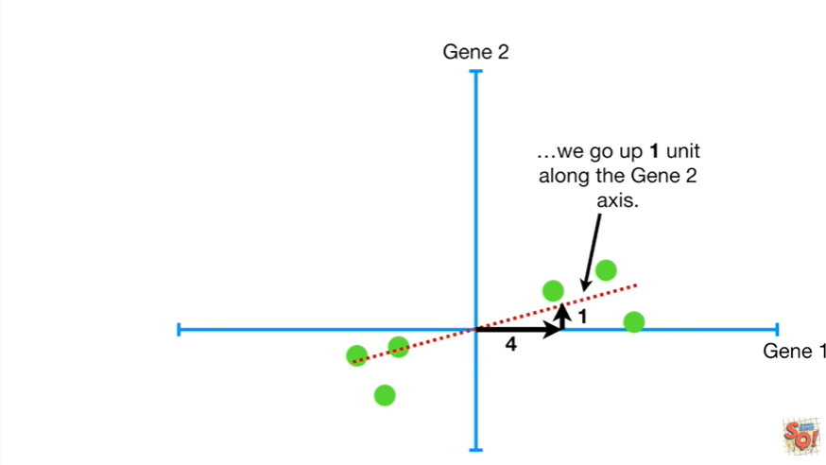

we go up one unit along the gene2 axis.

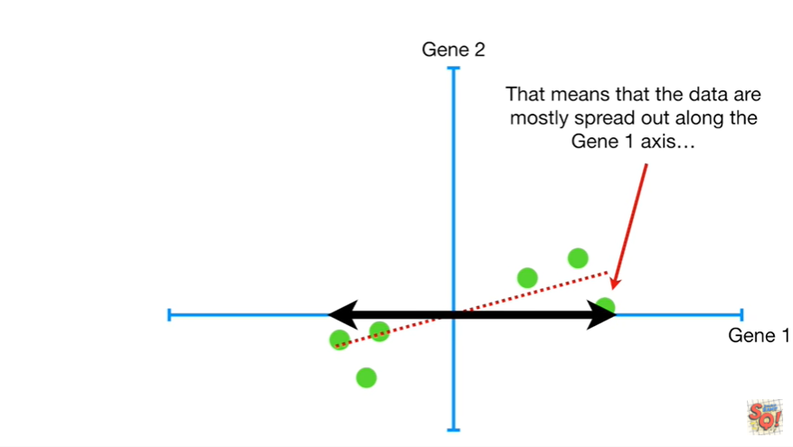

That means that the data are mostly spread out along the gene 1 axis

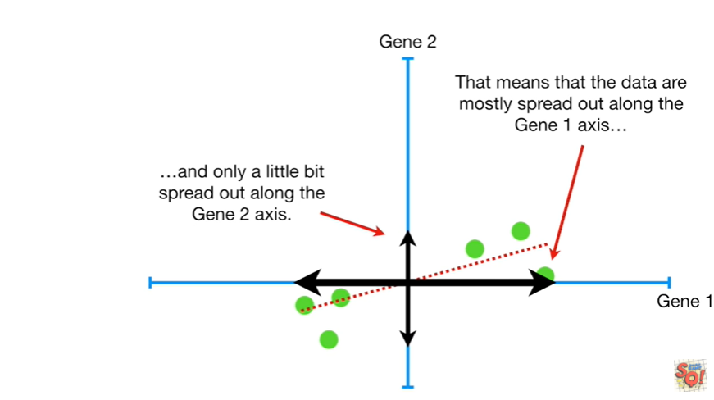

and only a little bit spread out along the gene2 axis.

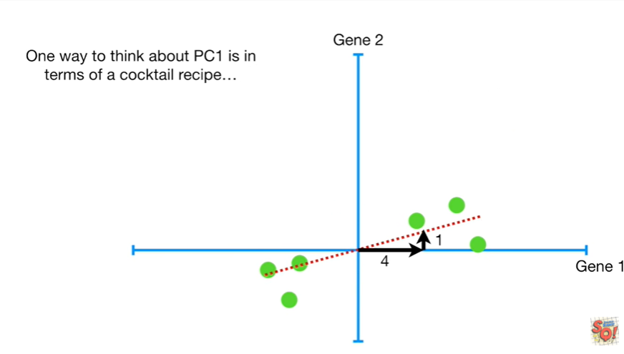

One way to think about PC1 is in terms of a cocktail recipe.

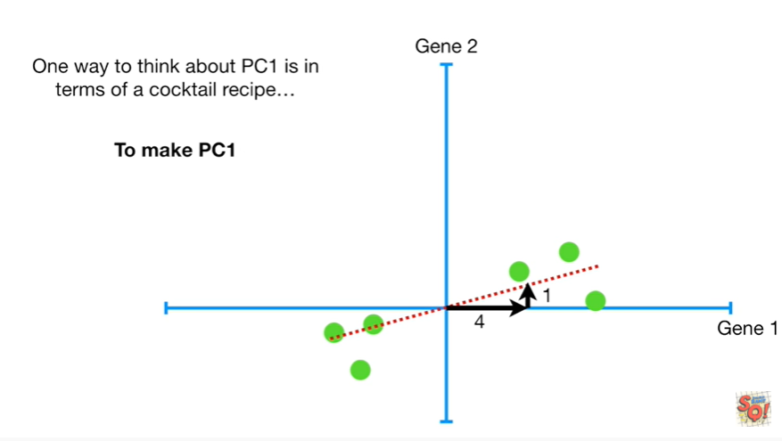

To make PC1 mix four parts gene1

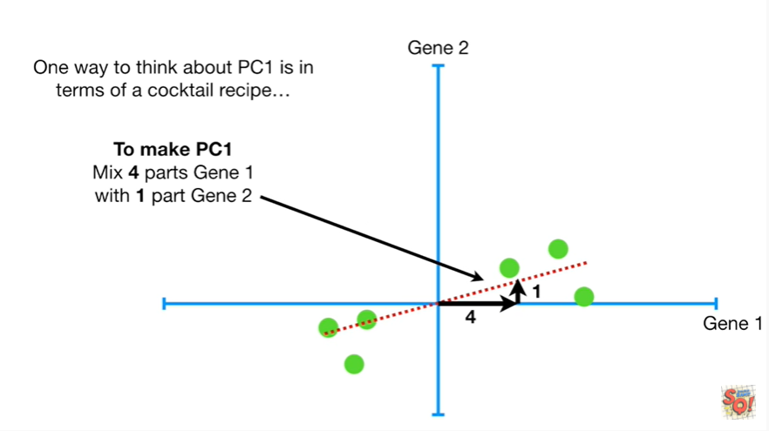

with one part gene2.

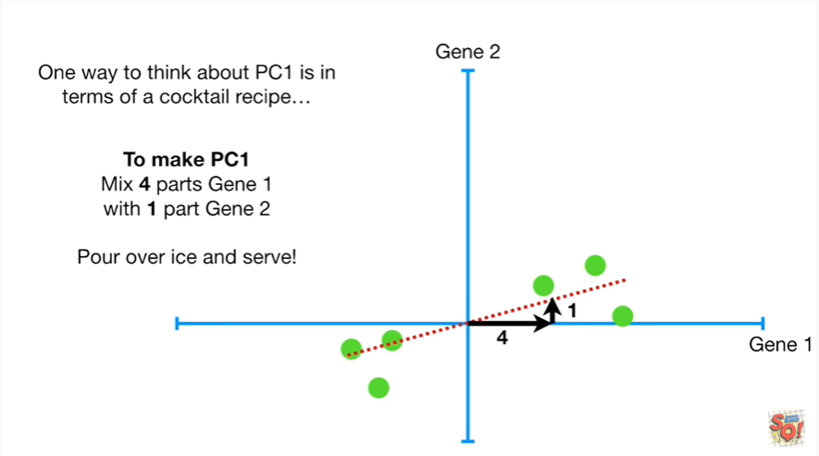

Pour over ice and serve !

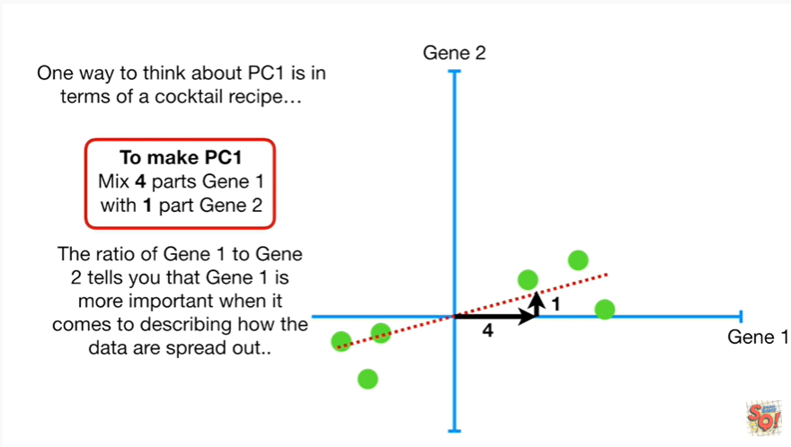

The ratio of gene 1 to gene 2 tells you that gene 1 is more important when it comes to describing how the data are spread out.

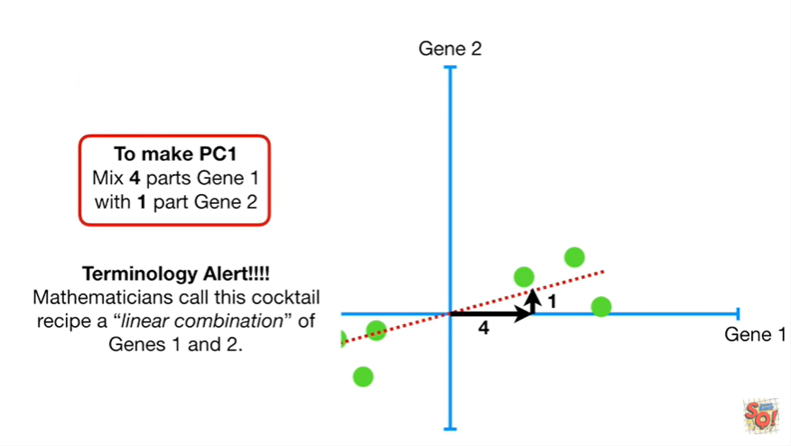

Oh No terminology alert !!!!

Mathematicians call this cocktail recipe a linear combination of genes 1 & 2.

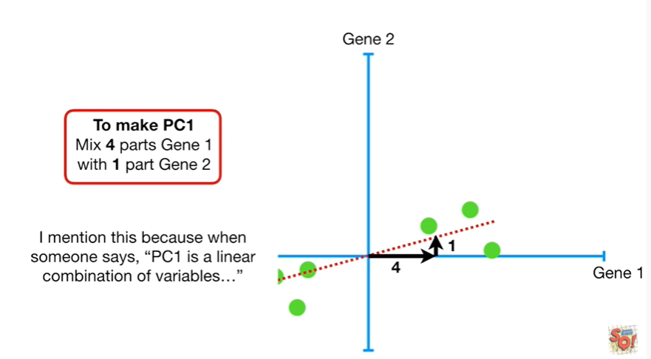

I mention this because when someone says PC 1 is a linear combination of variables

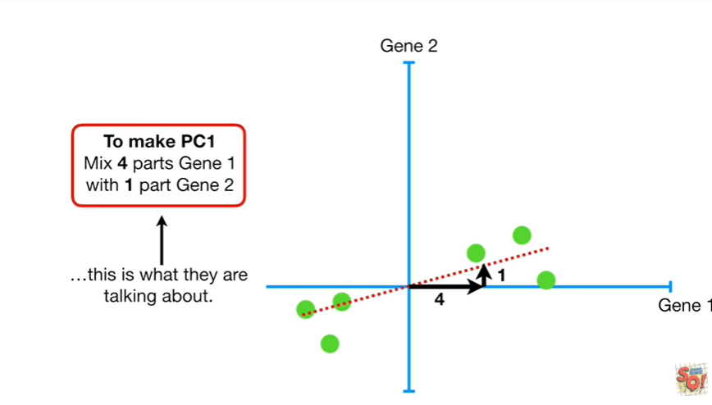

this is what they're talking about.

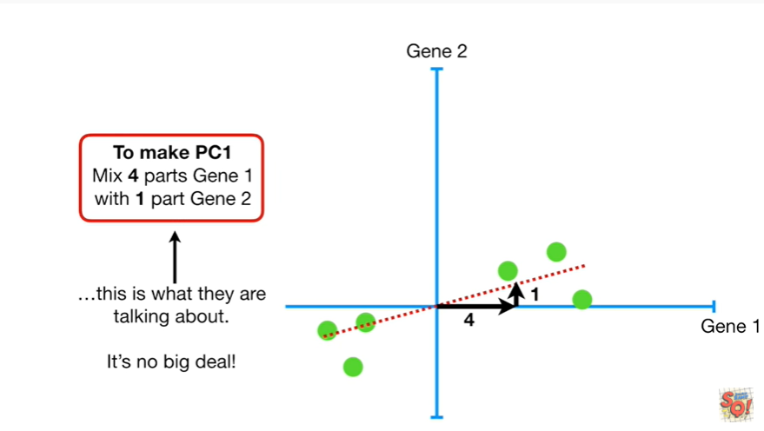

It's no big deal.

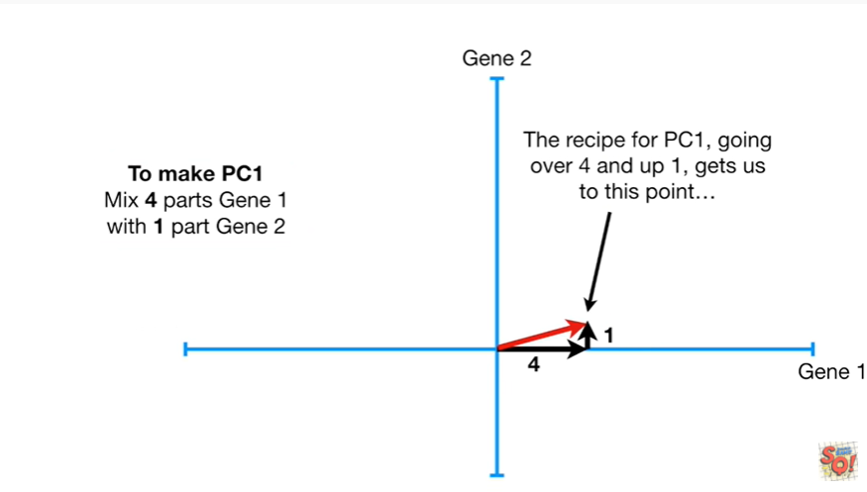

The recipe for PC1 going over 4 and up 1 gets us to this point.

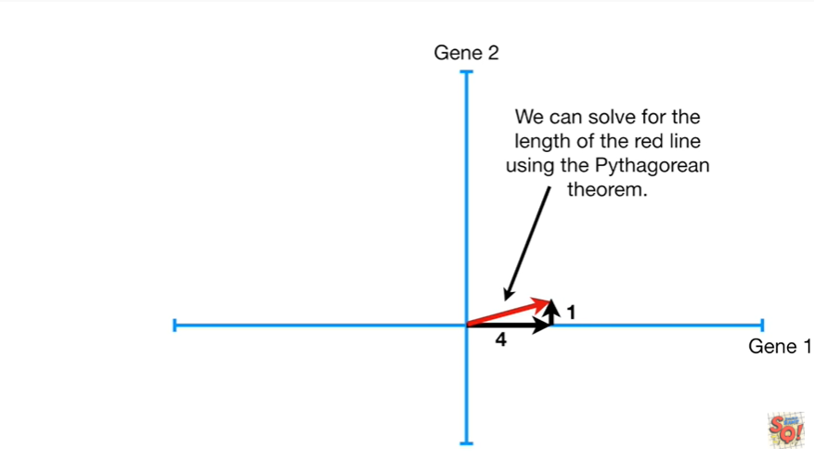

We can solve for the length of the red line using the Pythagorean theorem.

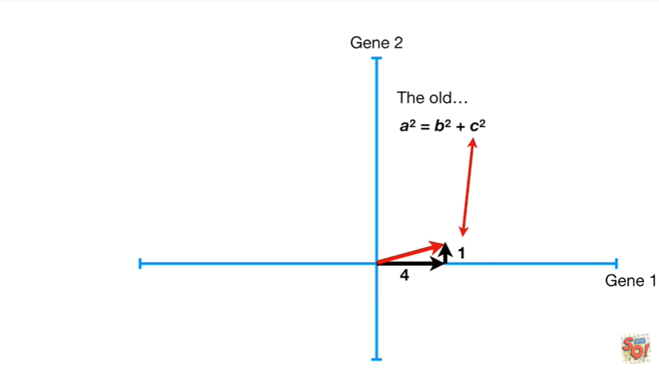

The old a squared equals B squared plus C squared.

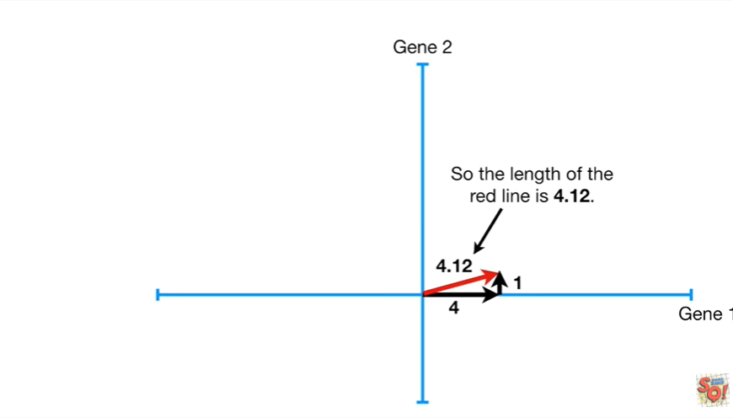

Plugging in the numbers gives us a equals four point one two.

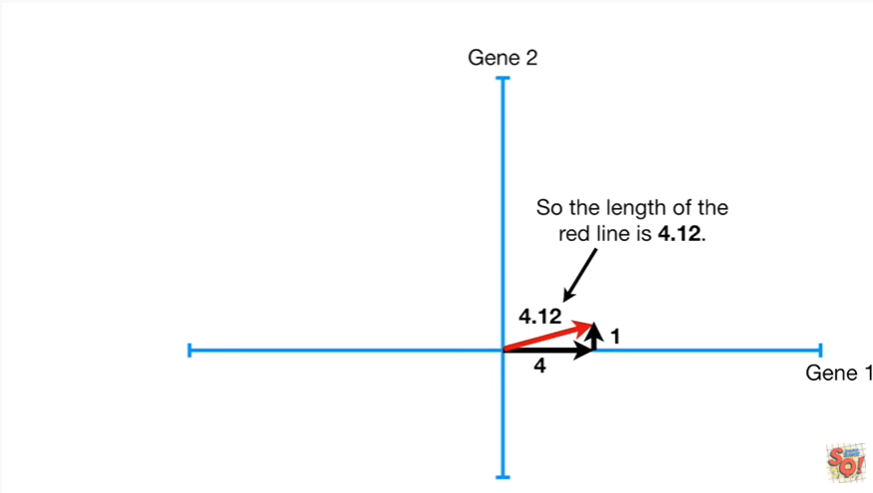

So the length of the red line is four point one two.

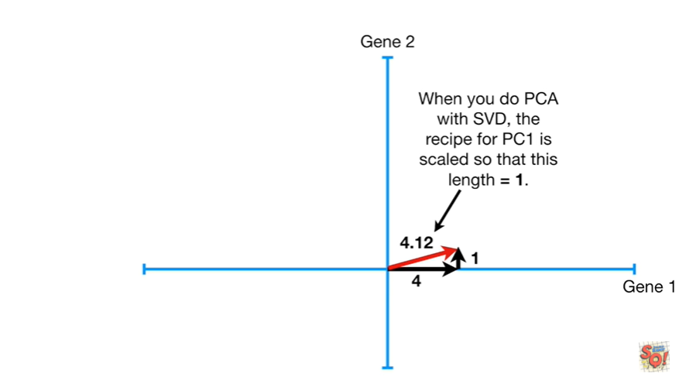

When you do pca with SVD the recipe for PC1 is scaled so that this length equals one.

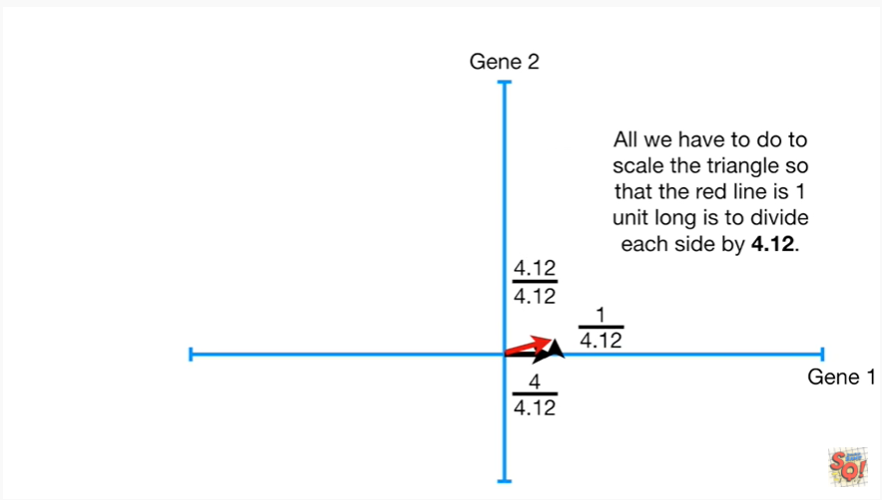

All we have to do to scale the triangle so that the red line is one unit long is to divide each side by four point one two.

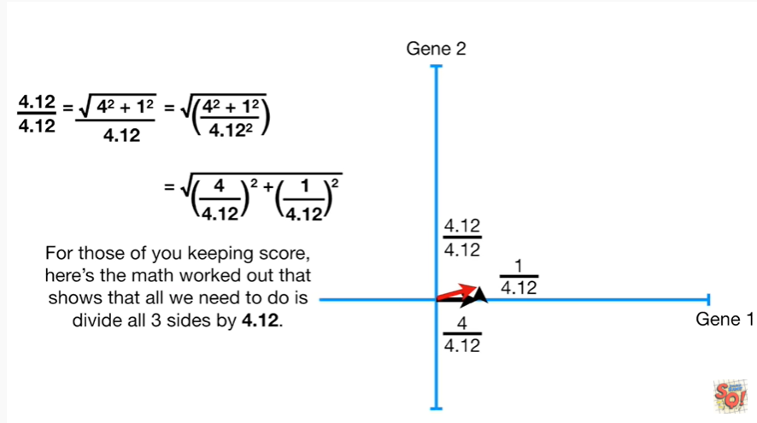

For those of you keeping score here's the math worked out that shows that all we need to do is divide all three sides by four point one two.

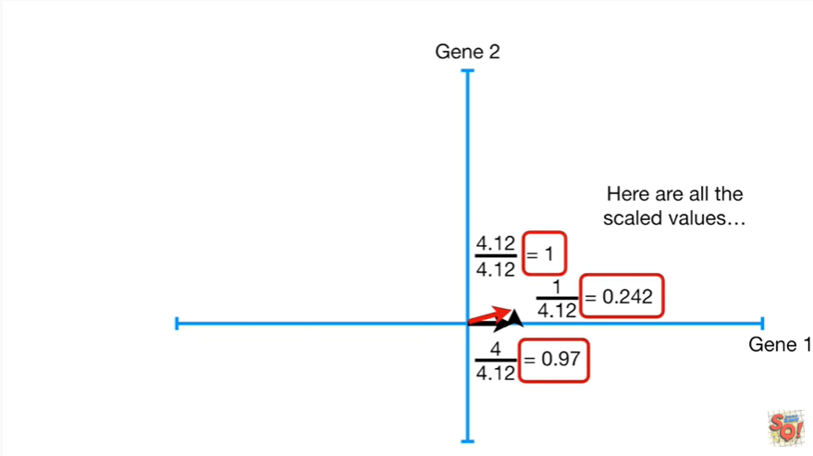

Here are the scaled values.

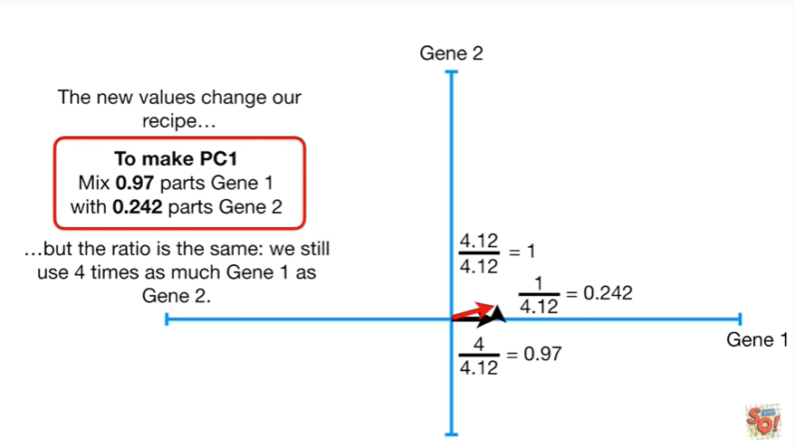

The new values change our recipe but the ratio is the same : we still use four times as much gene 1 as gene 2.

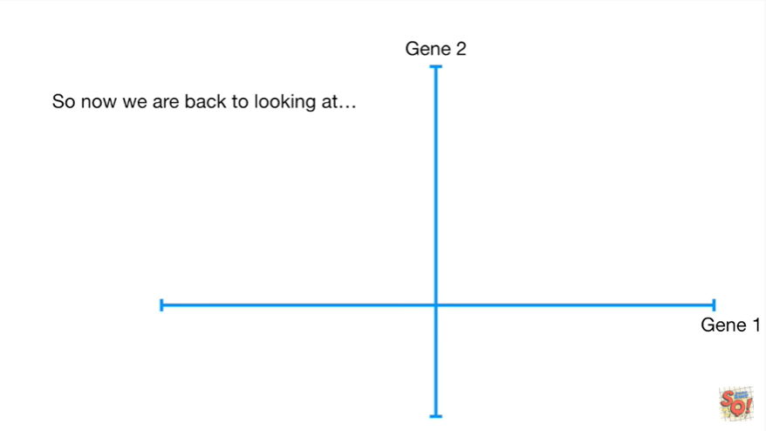

So now we are back to looking at

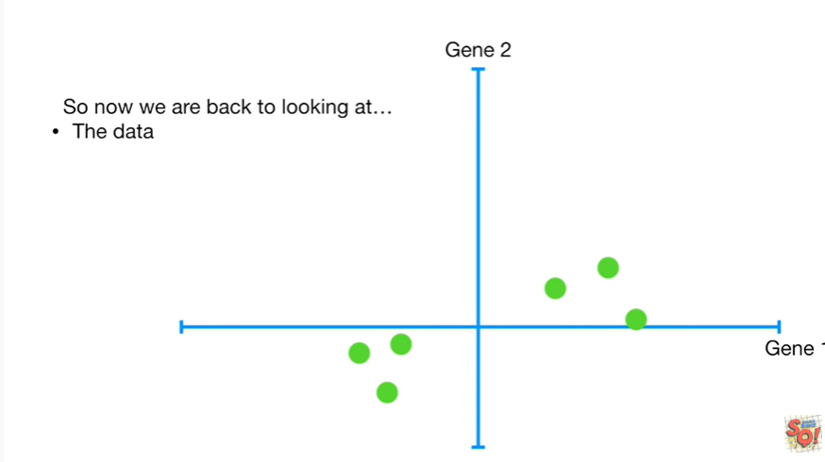

the data

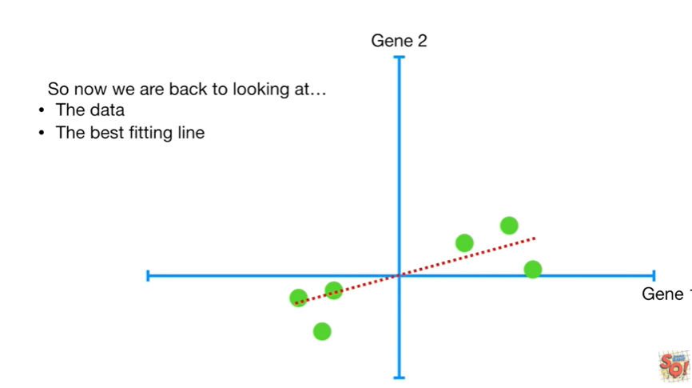

the best fitting line

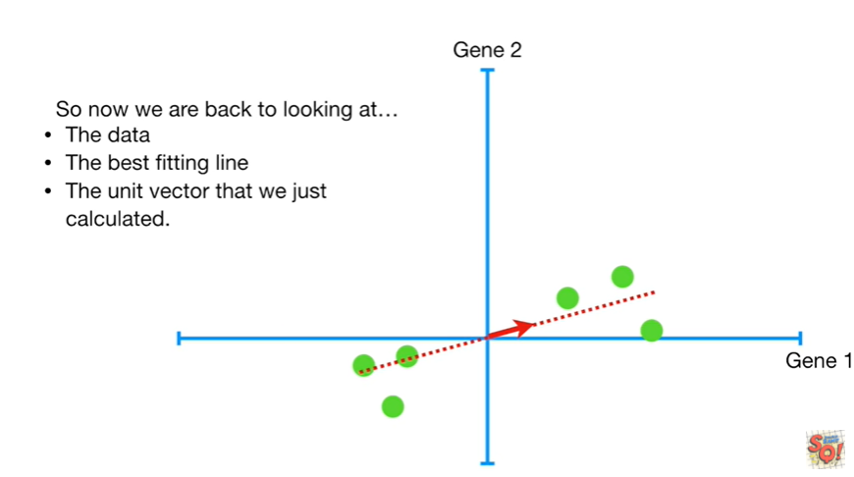

and the unit vector that we just calculated.

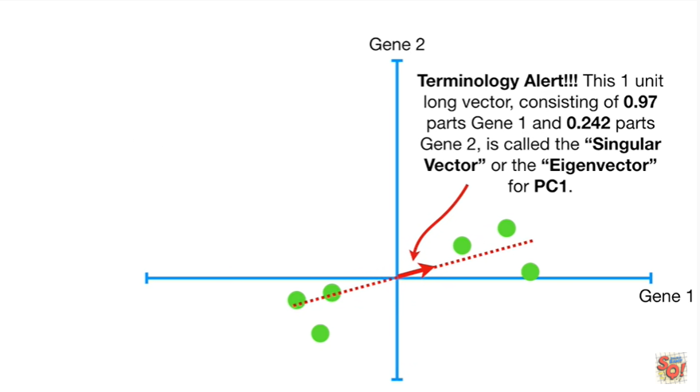

Oh no another terminology alert !!!

This one unit long vector consisting of 0.97 parts gene one and 0.242 parts gene 2 is called the singular vector or the eigenvector for PC1.

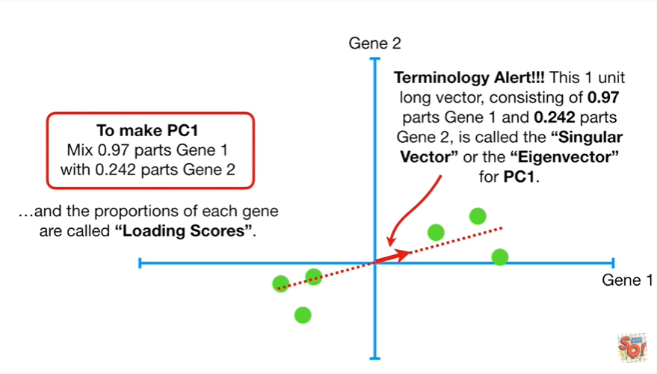

And the proportions of each gene are called loading scores.

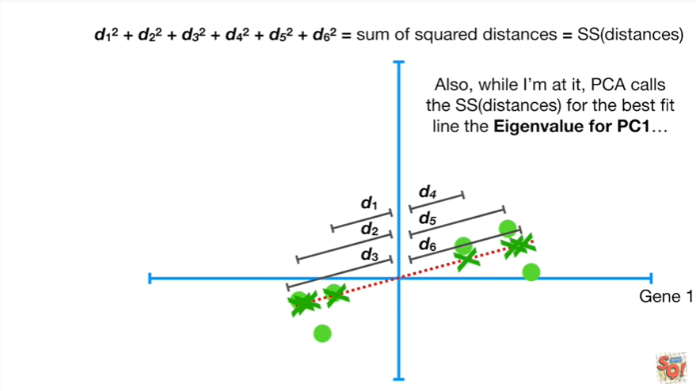

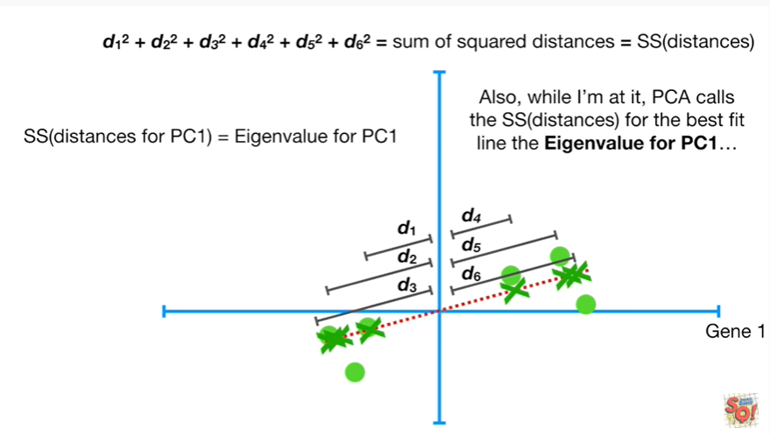

Also while I'm at it pca calls the sums of squares of the distances for the best fit line the eigenvalue for pc 1.

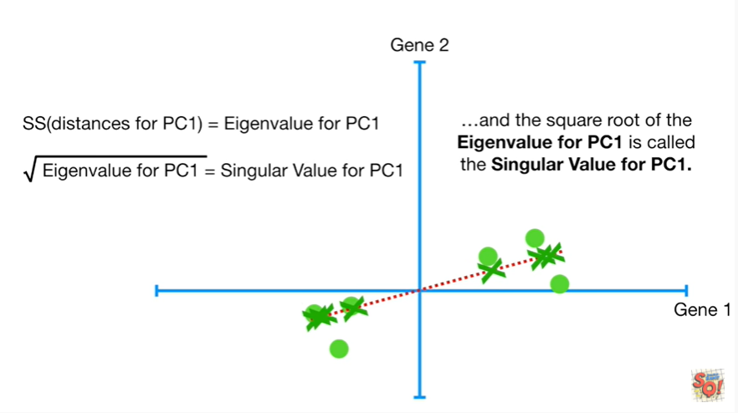

And the square root of the eigenvalue for PC1 is called the singular value for PC1.

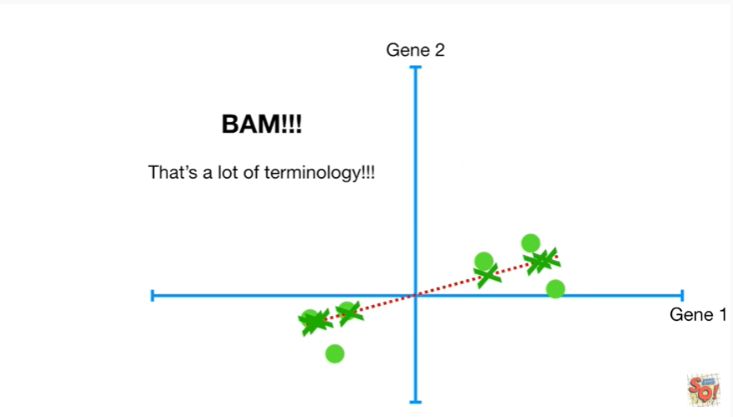

BAM !!!

That's a lot of terminology.

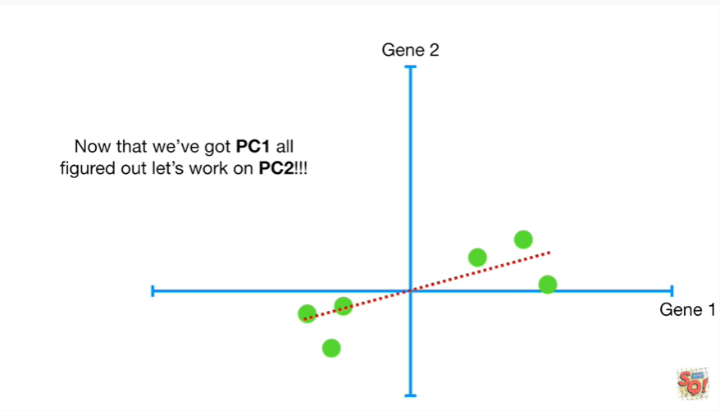

Now that we've got pc1 all figured out let's work on PC2 !!!

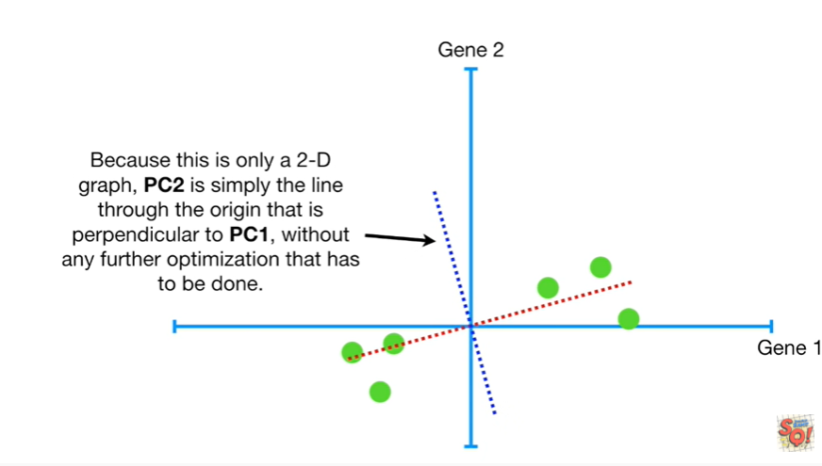

Because this is only a two-dimensional graph PC 2 is simply the line through the origin that is perpendicular to PC 1 without any further optimization that has to be done .

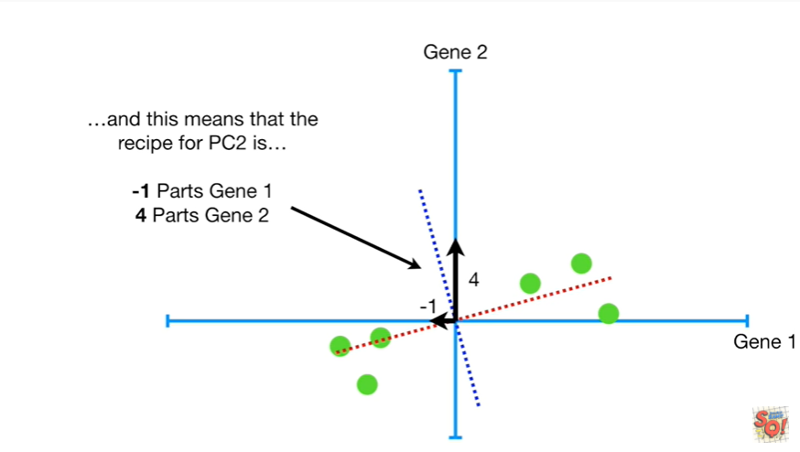

And this means that the recipe for PC 2 is negative 1 parts gene 1 to 4 parts gene 2.

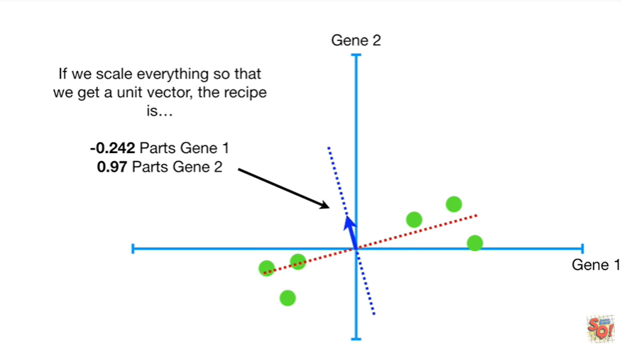

If we scale everything so that we get a unit vector the recipe is negative zero point two for two parts gene one and zero point nine seven parts gene 2.

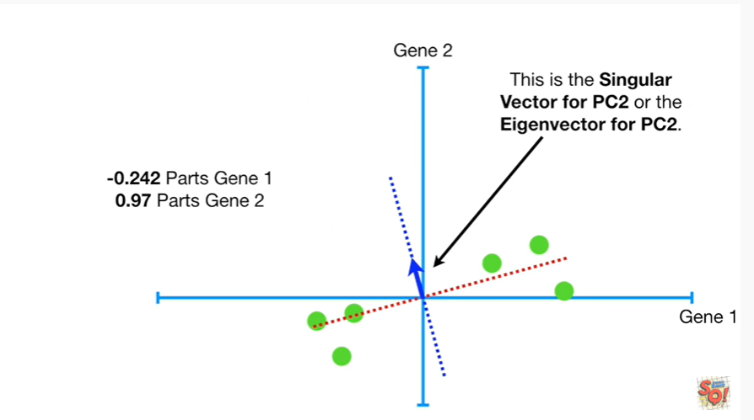

This is the singular vector for PC2 or the eigenvector for PC2.

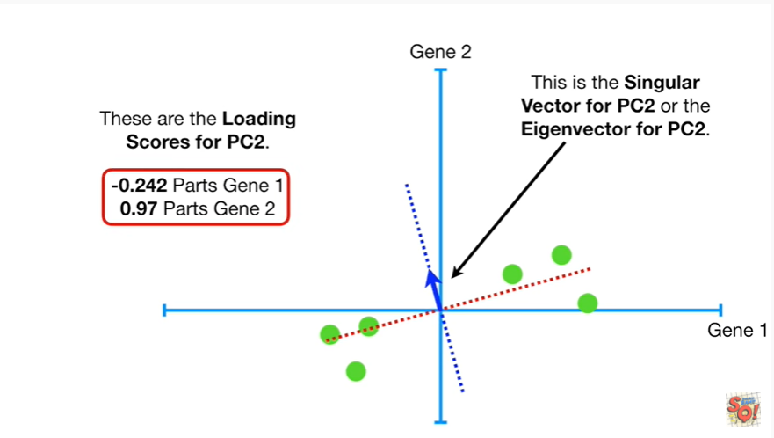

These are the loading scores for PC2.

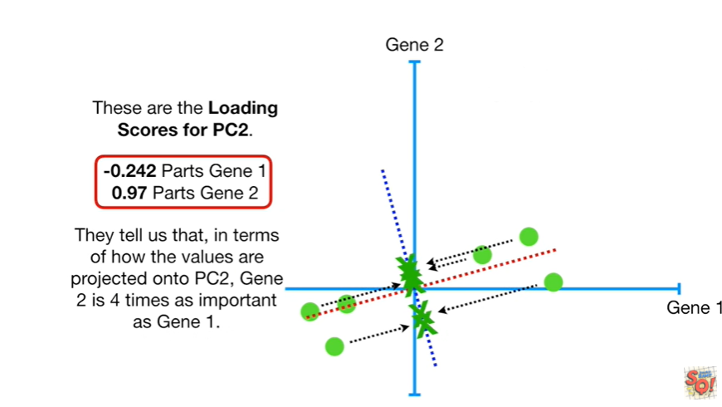

They tell us that in terms of how the values are projected onto PC2, gene 2 is four times as important as gene 1.

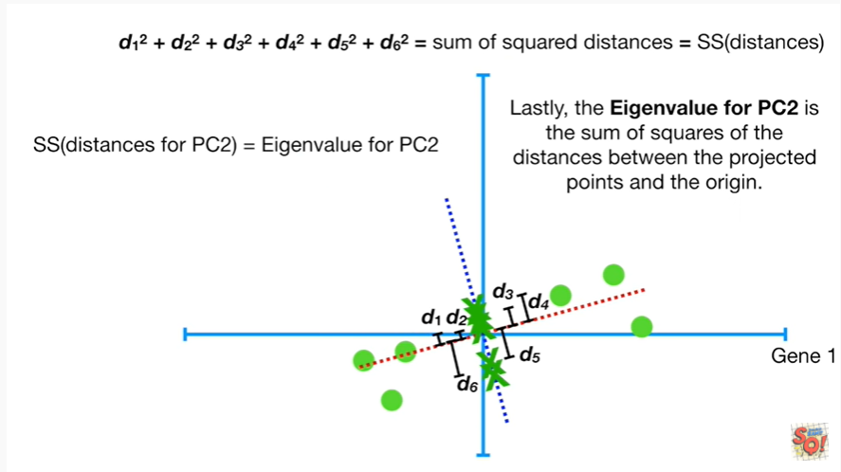

Lastly the eigenvalue for pc2 is the sum of squares of the distances between the projected points and the origin.

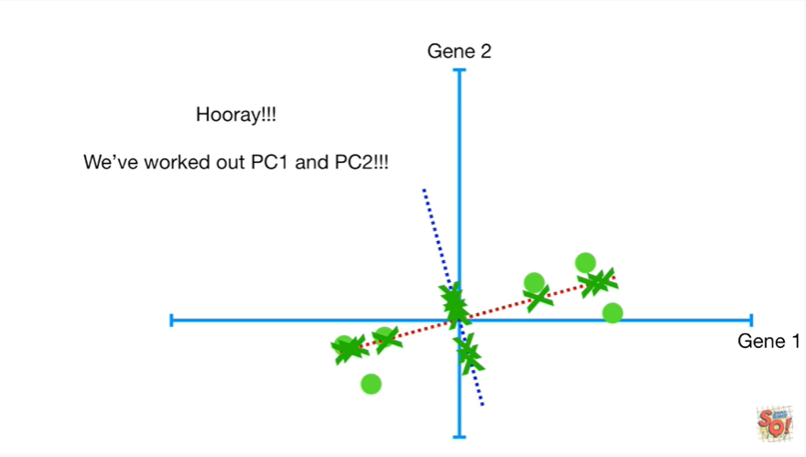

Hooray !!!

We've worked out pc1 & pc2 !!!

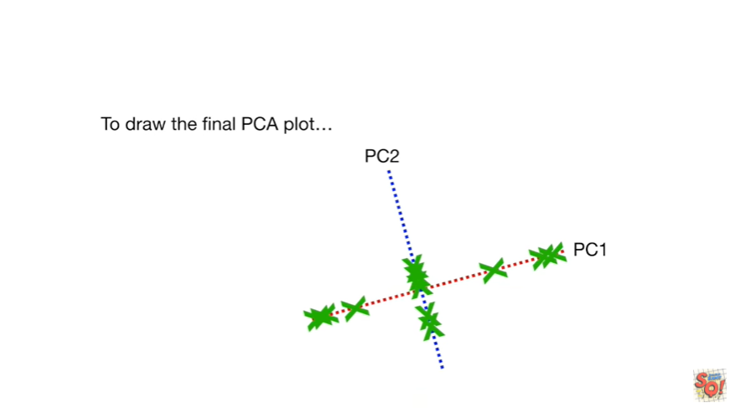

To draw the final PCA plot

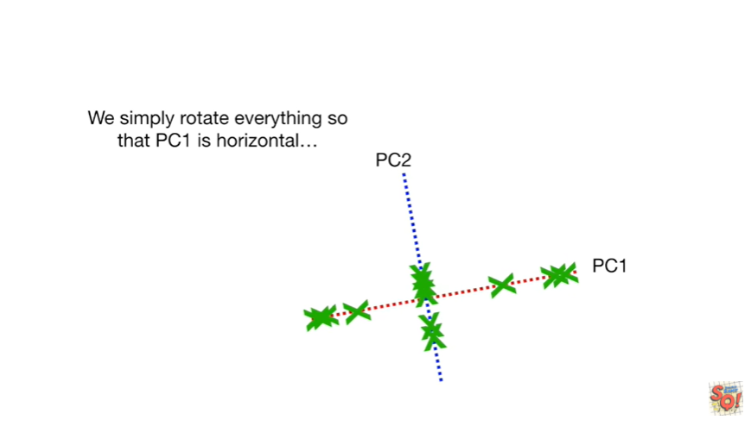

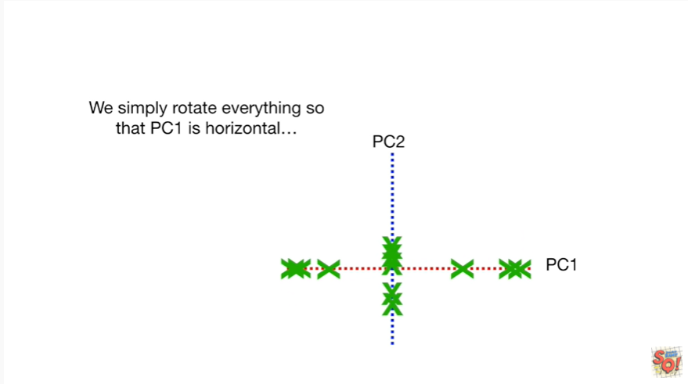

we simply rotate everything so that PC1 is horizontal

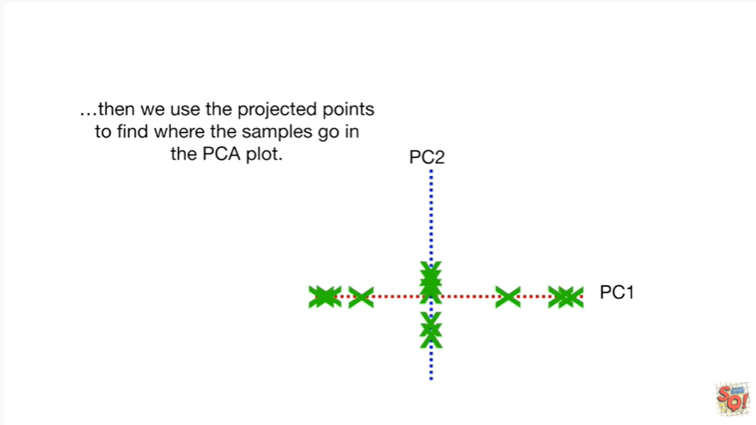

then we use the projected points to find where the samples go in the PCA plot.

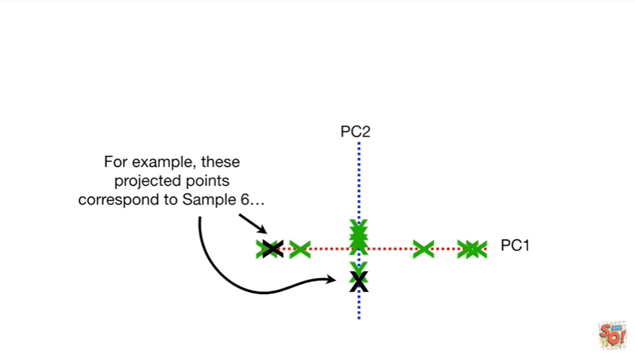

For example these projected points correspond a sample six

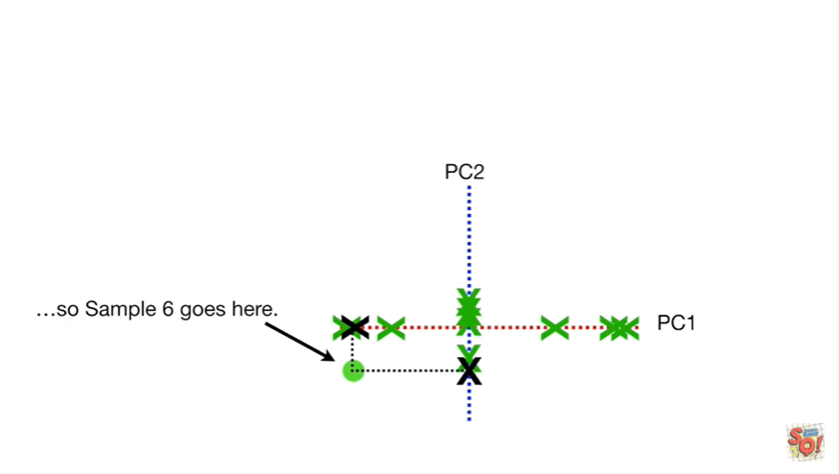

so sample six goes here

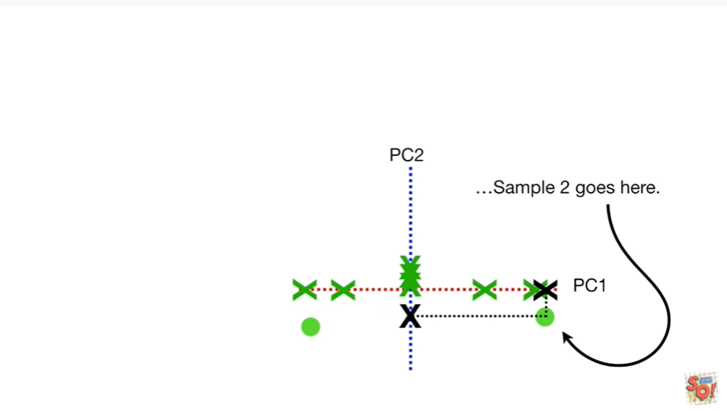

sample two goes here

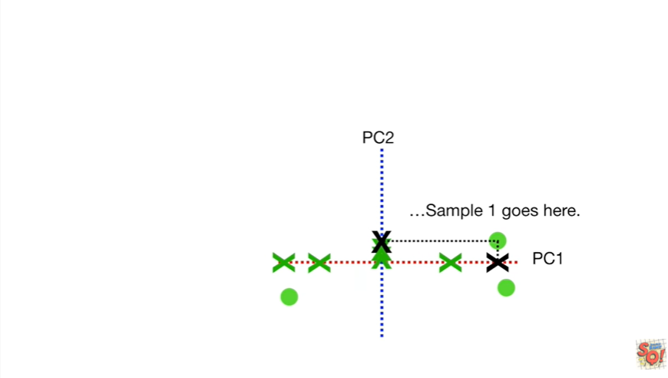

and sample one goes here

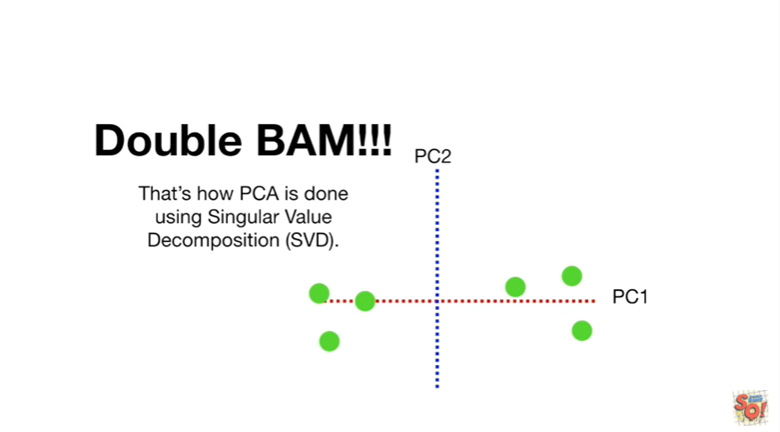

etc.

Double bam !!!

That's how PCA is done using singular value decomposition.

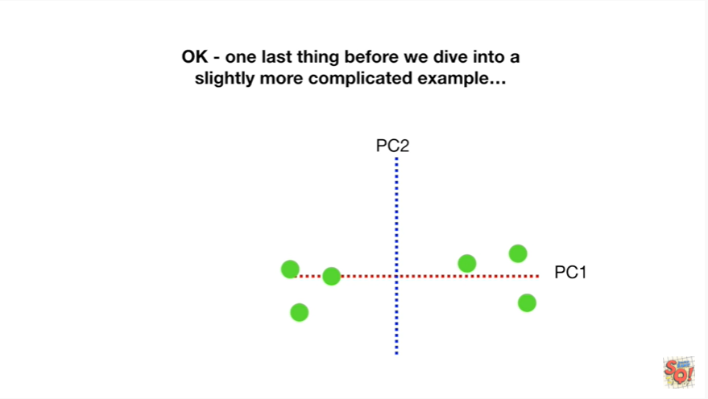

Okay one last thing before we dive into a slightly more complicated example.

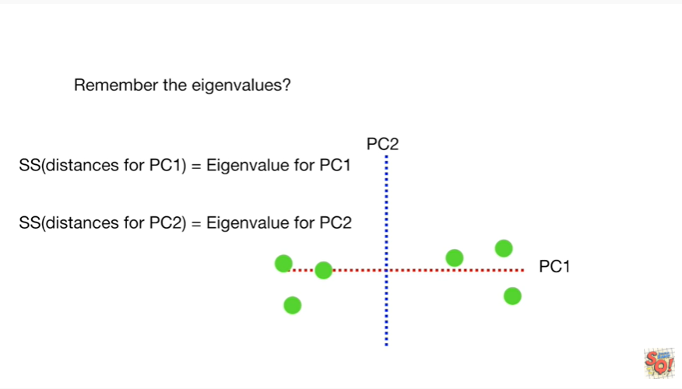

Remember the eigenvalues.

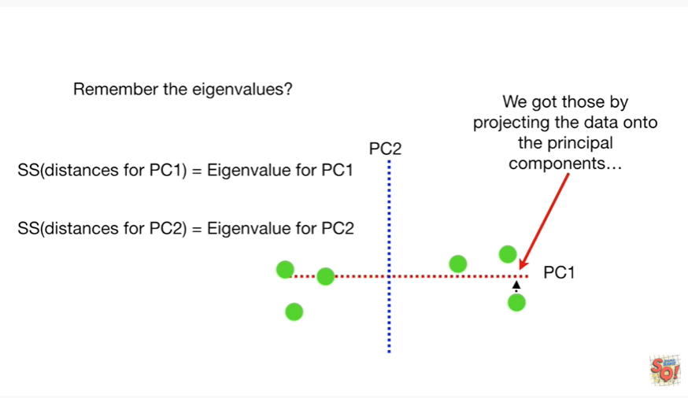

We got those by projecting the data onto the principal components

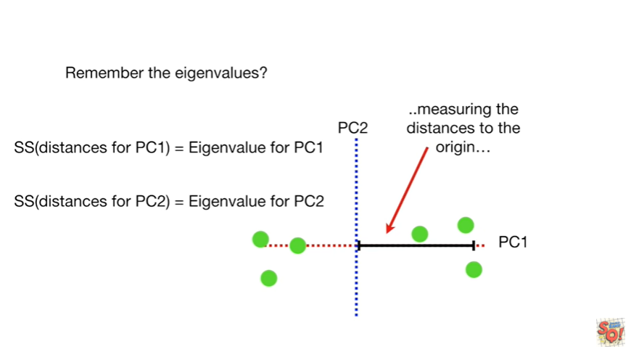

measuring the distances to the origin

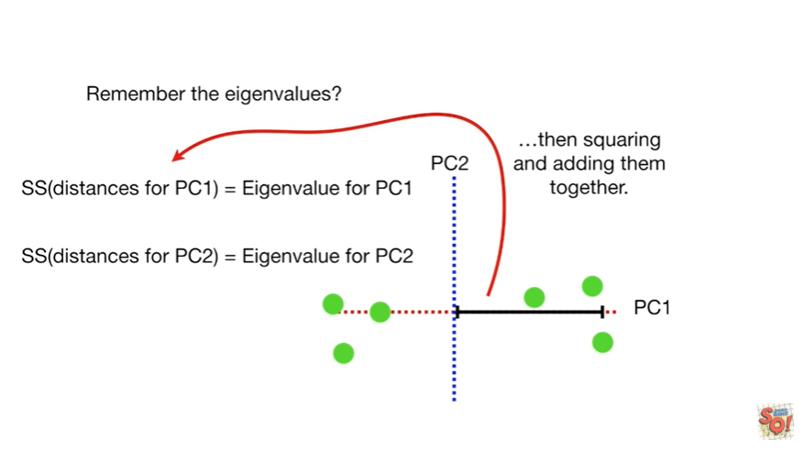

then squaring and adding them together.

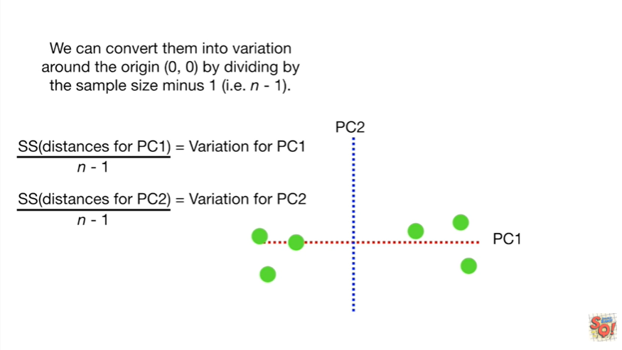

We can convert them into variation around the origin by dividing by the sample size minus 1.

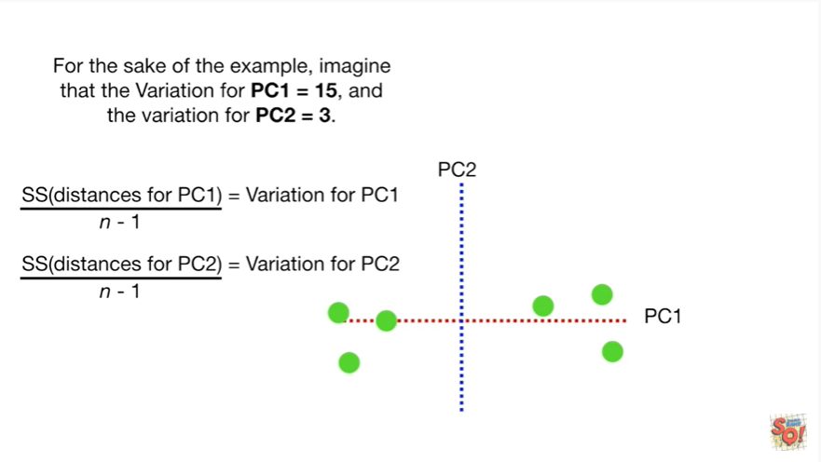

For the sake of this example imagine that the variation for pc1 equals 15 and the variation for pc2 equals 3.

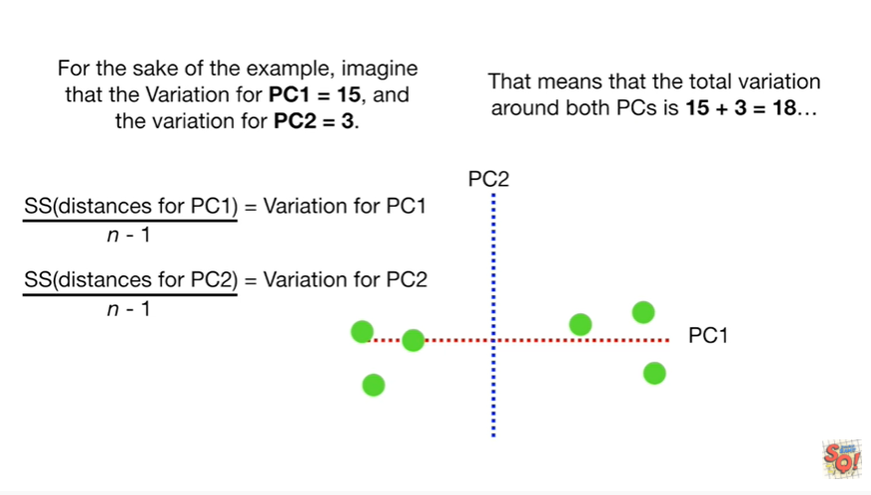

That means that the total variation around both pcs is 15 plus 3 equals 18

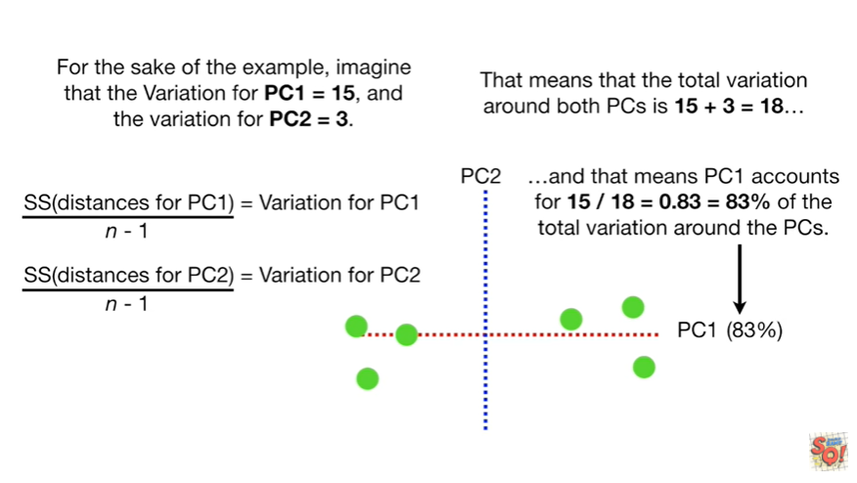

and that means PC 1 accounts for 15 divided by 18 equals zero point 83 or 83 percent of the total variation around the PCs.

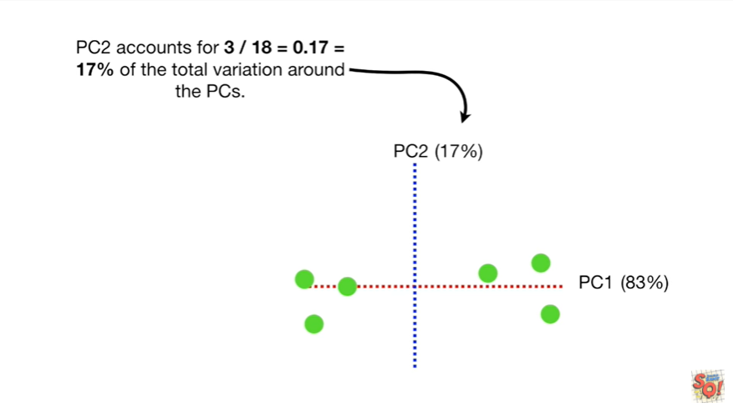

Pc2 accounts for 3/18 equals 17% of the total variation around the PCs.

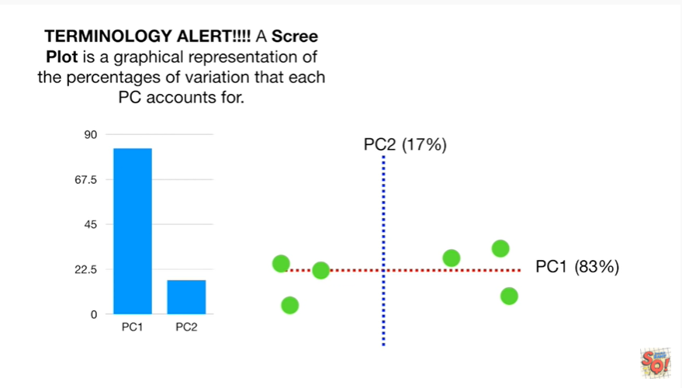

Oh no another terminology alert !!!

A scree plot is a graphical representation of the percentages of variation that each PC accounts for.

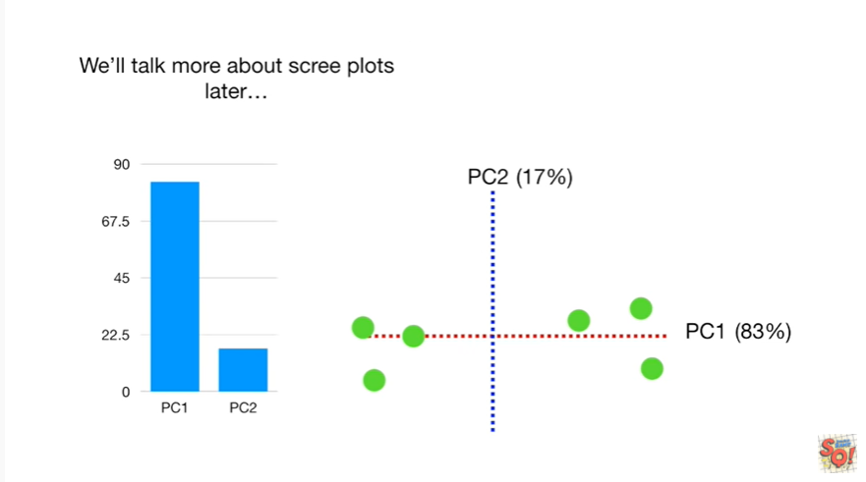

We'll talk more about scree plot Slater.

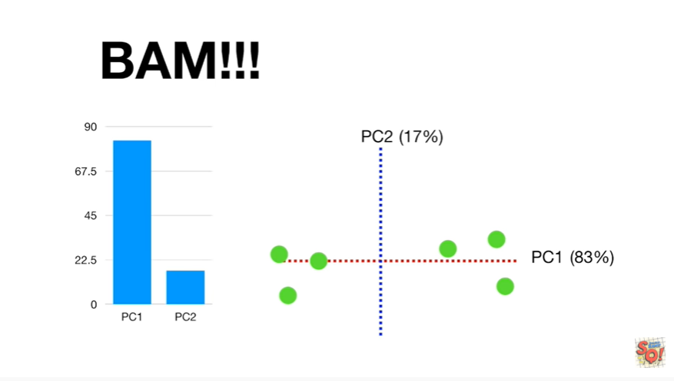

BAM !!!



Okay now let's quickly go through a slightly more complicated example.

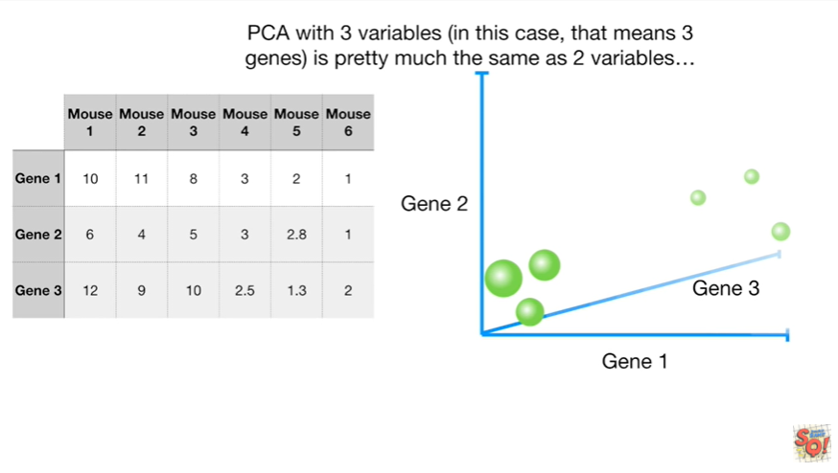

PCA with three variables in this case that means three genes is pretty much the same as two variables.

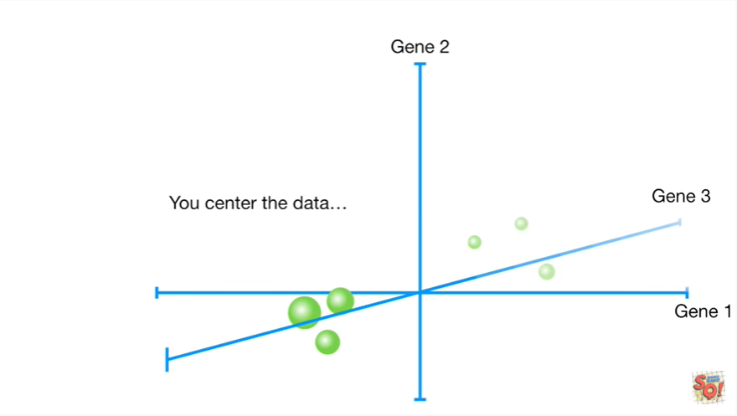

You center the data.

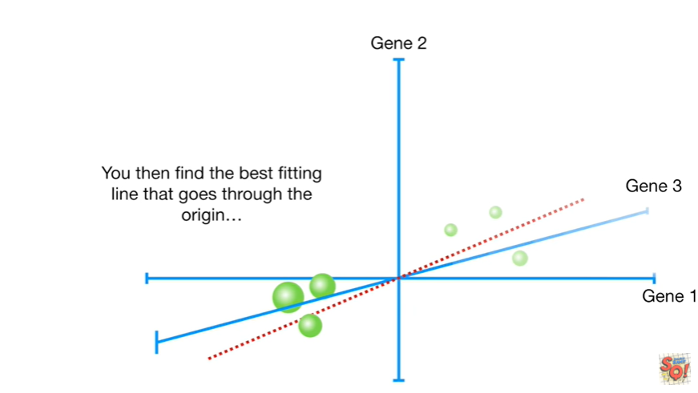

You then find the best fitting line that goes through the origin.

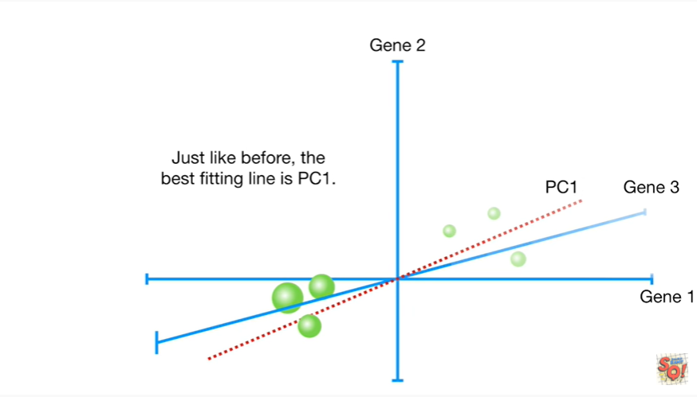

Just like before the best fitting line is PC1.

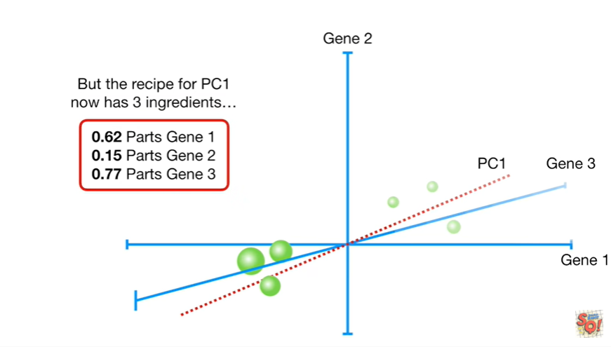

But the recipe for pc1 now has three ingredients.

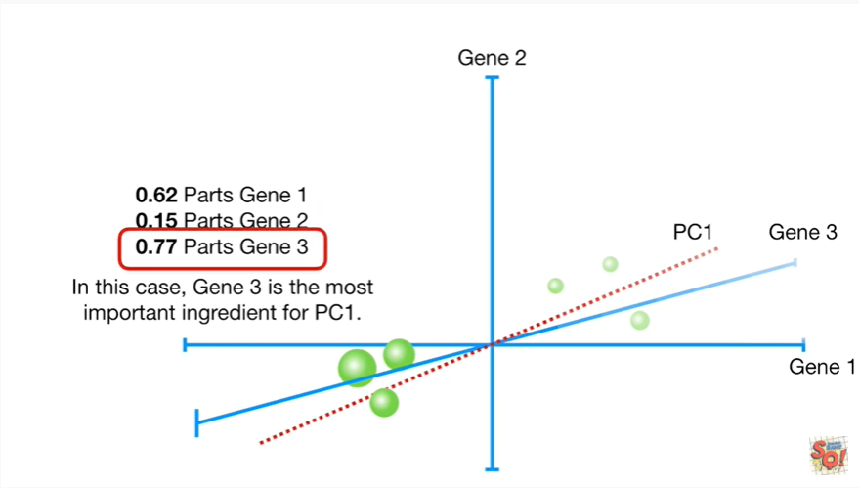

In this case Jean 3 is the most important ingredient for pc1.

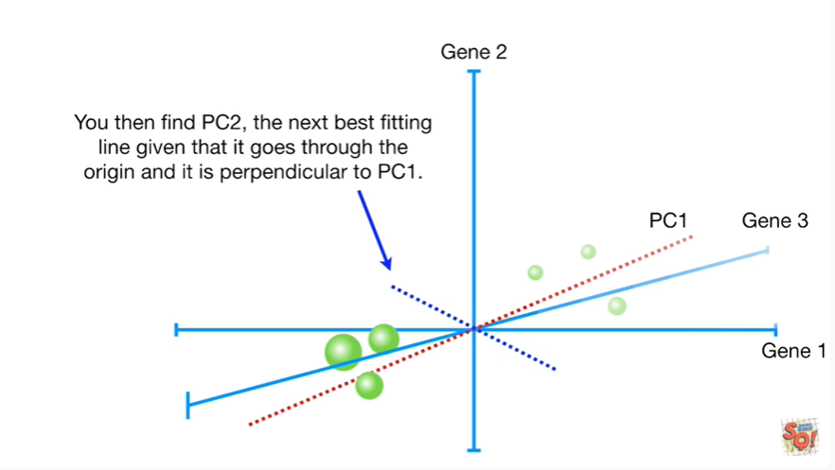

You then find pc2 the next best fitting line given that it goes through the origin and is perpendicular to PC1.

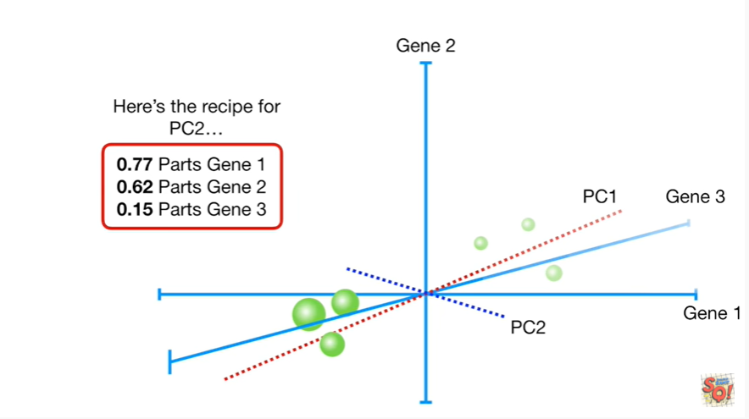

Here's the recipe for pc2.

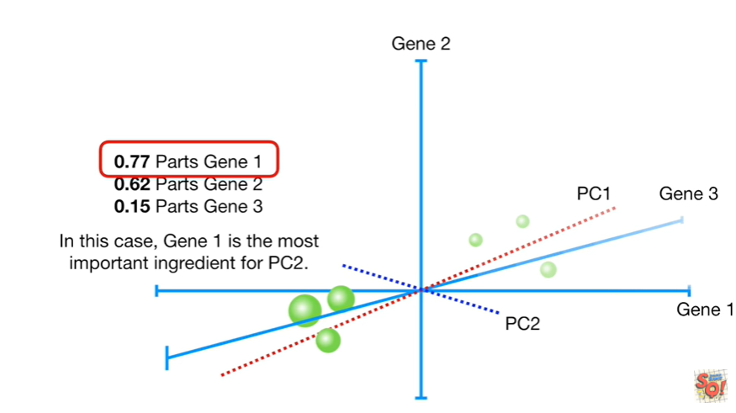

In this case gene one is the most important ingredient for PC2.

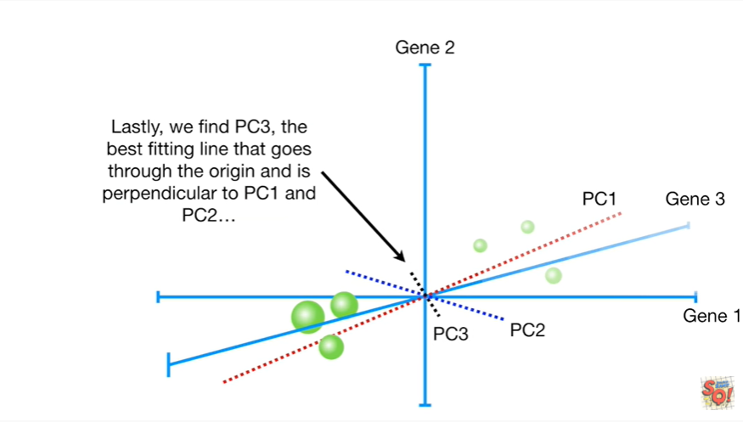

Lastly we find PC3, the best fitting line that goes through the origin and is perpendicular pc1 & pc2.

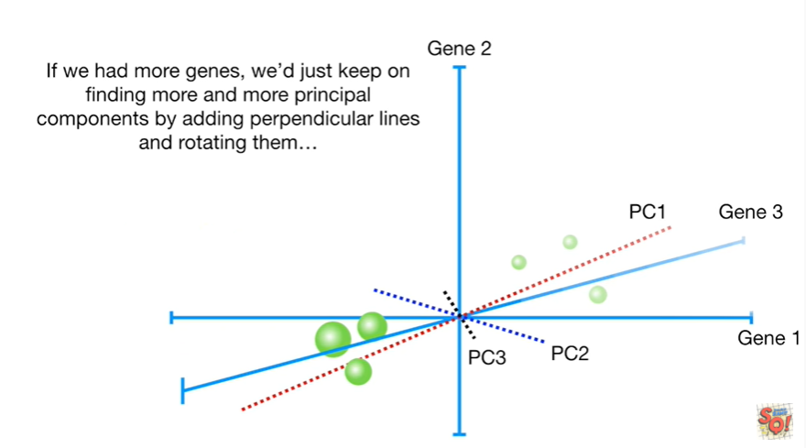

If we had more genes we just keep on finding more and more principal components by adding perpendicular lines and rotating them.

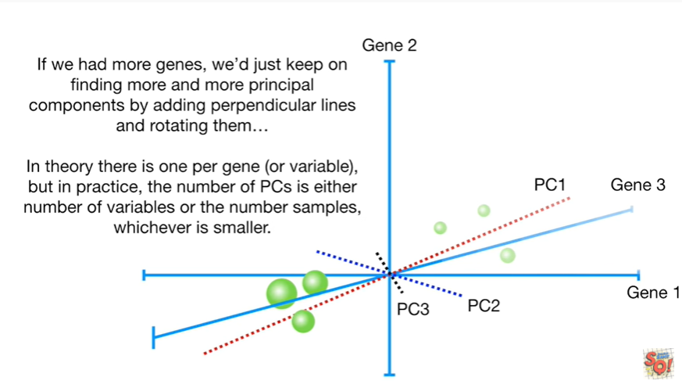

In theory there is one per gene or variable but in practice the number of PCs is either the number of variables or the number of samples whichever is smaller.

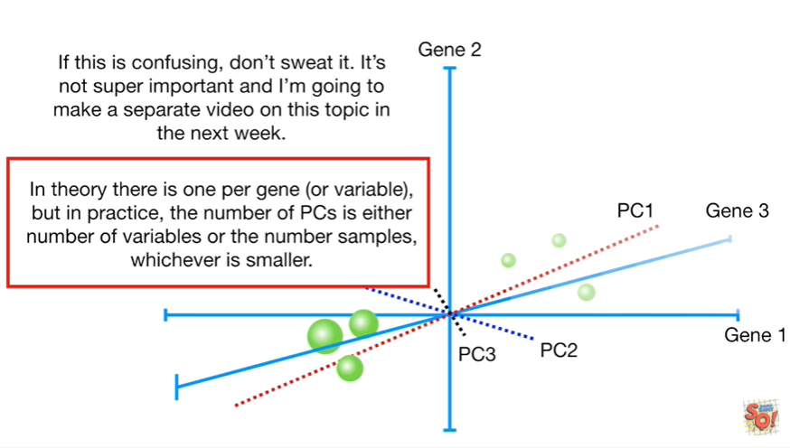

If this is confusing don't sweat it it's not super important and I'm going to make a separate video on this topic in the next week.

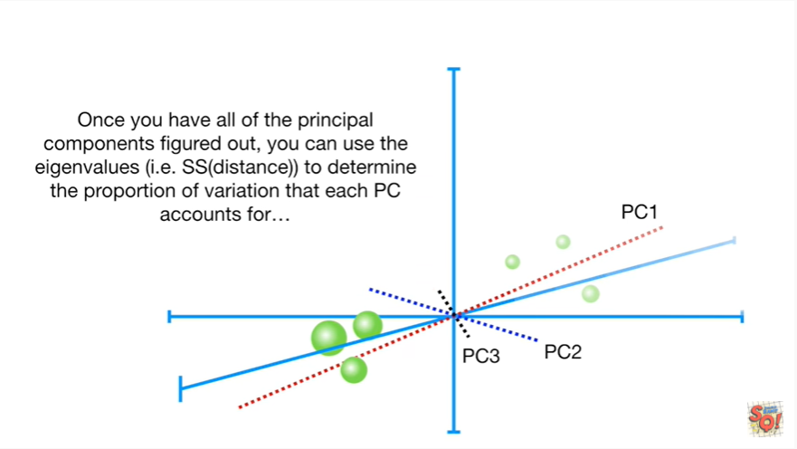

Once you have all the principal components figured out you can use the eigenvalues ie the sums of squares of the distances to determine the proportion of variation that each PC accounts for.

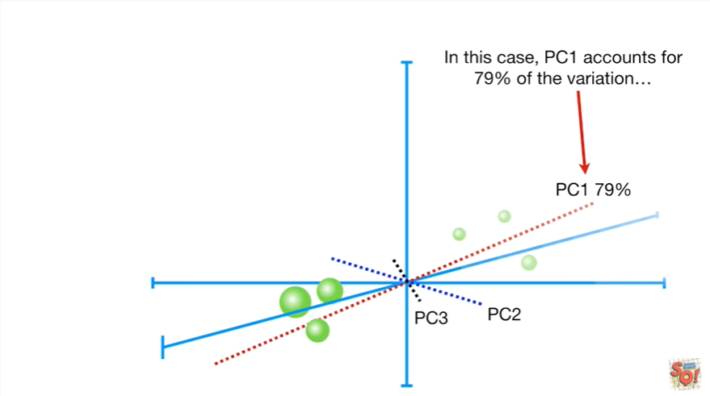

In this case PC1 accounts for 79 percent of the variation

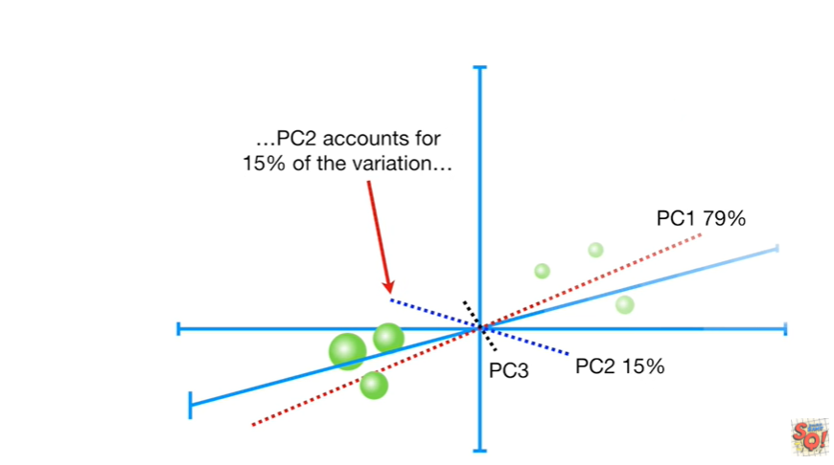

PC2 accounts for fifteen percent of the variation

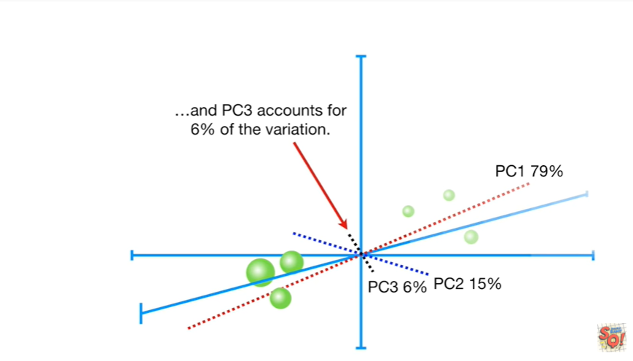

and PC3 accounts for six percent of the variation.

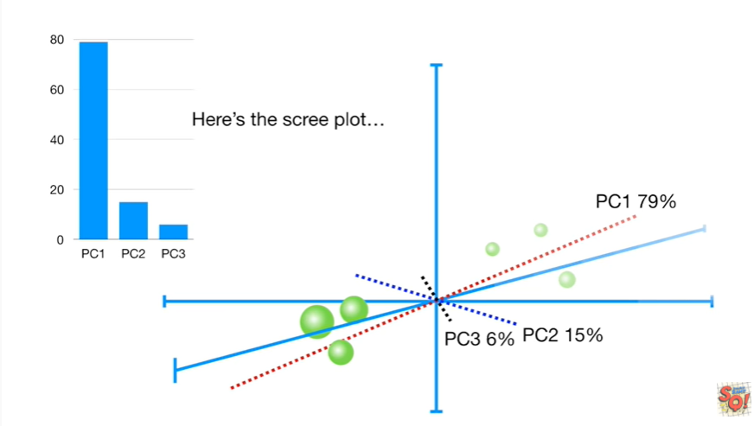

Here's the scree plot.

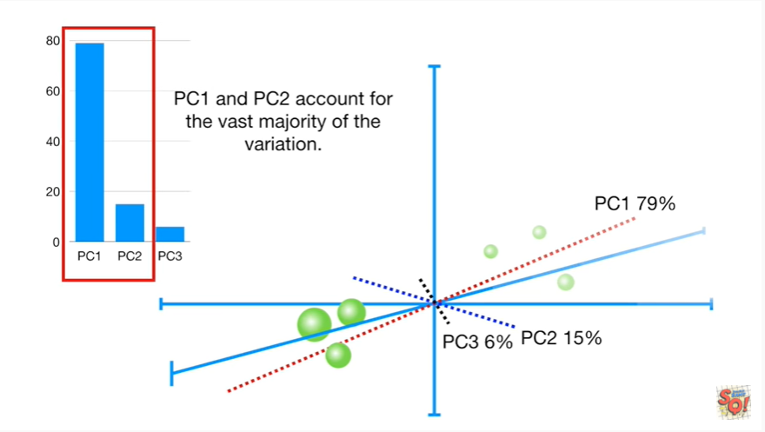

Pc1 & pc2 account for the vast majority of the variation.

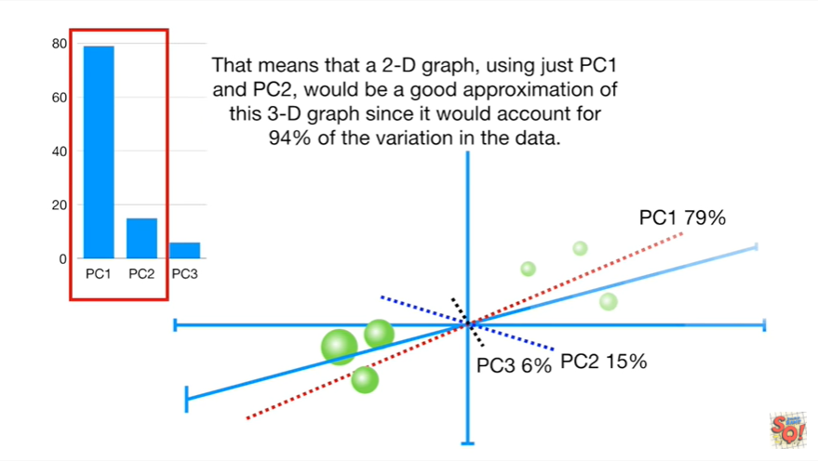

That means that a 2d graph using just pc1 & pc2, would be a good approximation of this 3d graph since it would account for 94% of the variation in the data.

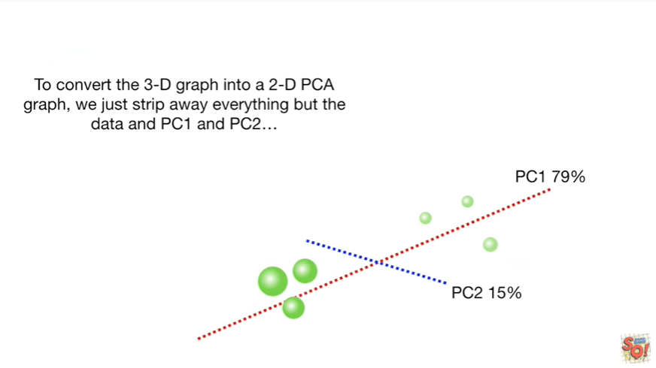

To convert the 3d graph into a two-dimensional PCA graph we just strip away everything but the data and pc1 & pc2.

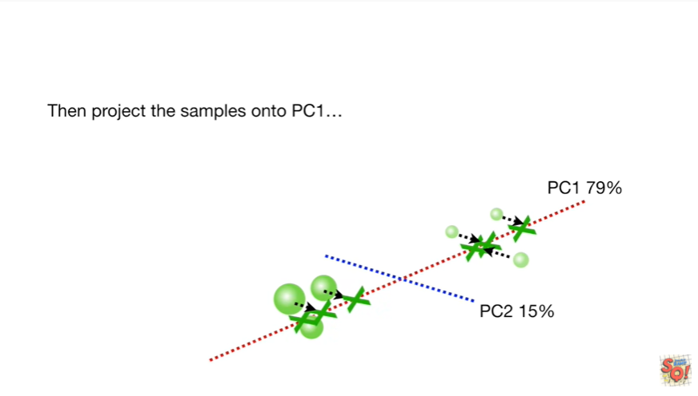

Then project the samples onto pc1

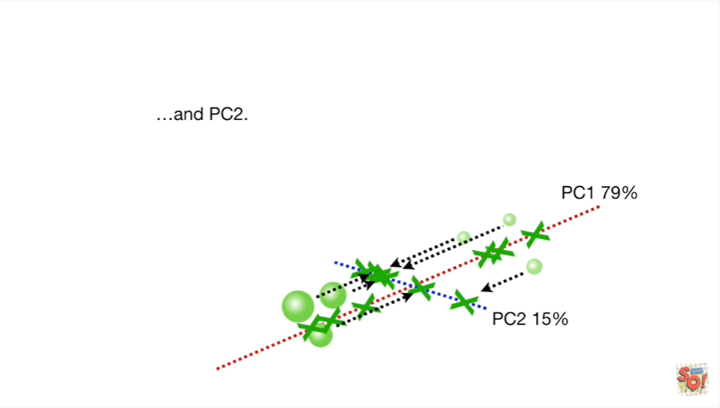

& pc2.

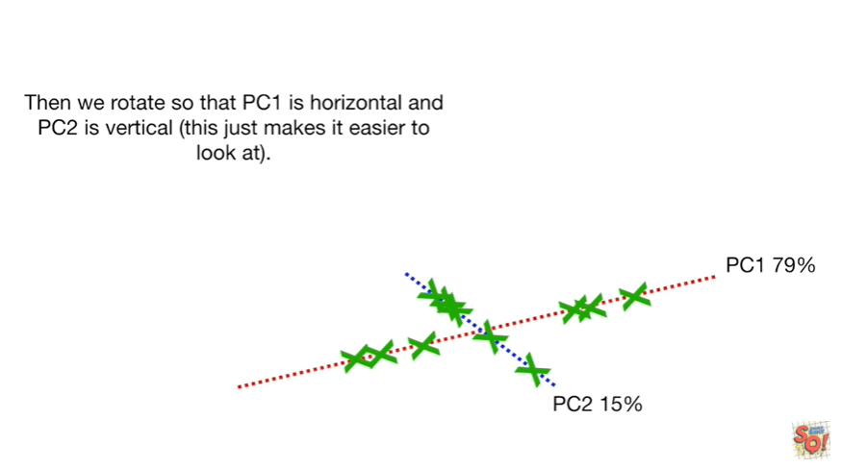

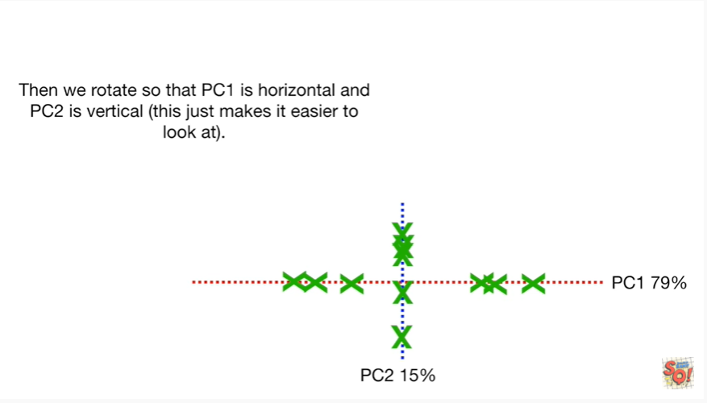

Then we rotate so that PC1 is horizontal in PC two is vertical this just makes it easier to look at.

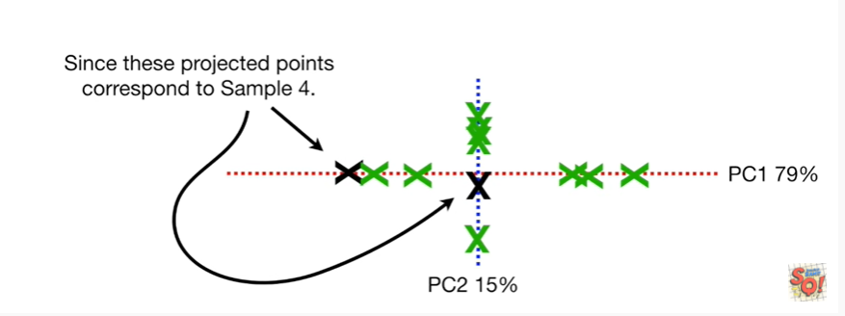

Since these projected points correspond a sample 4.

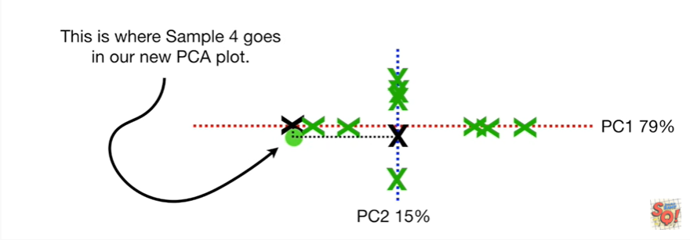

This is where sample 4 goes in our new PCA plot.

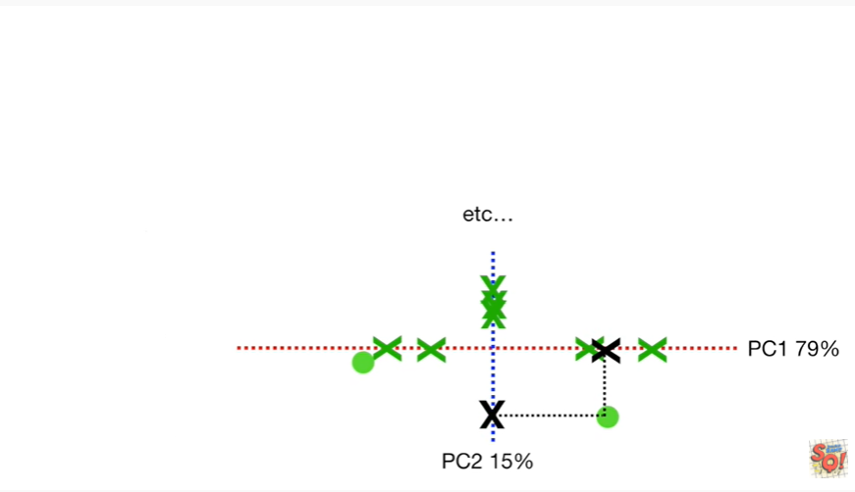

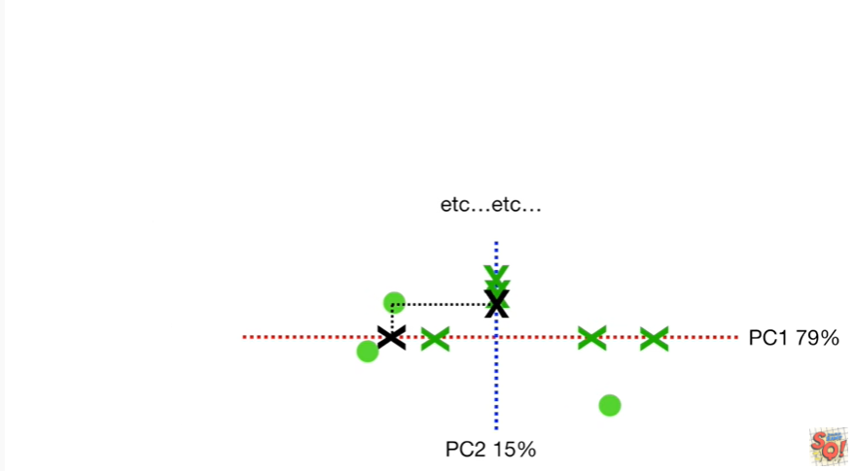

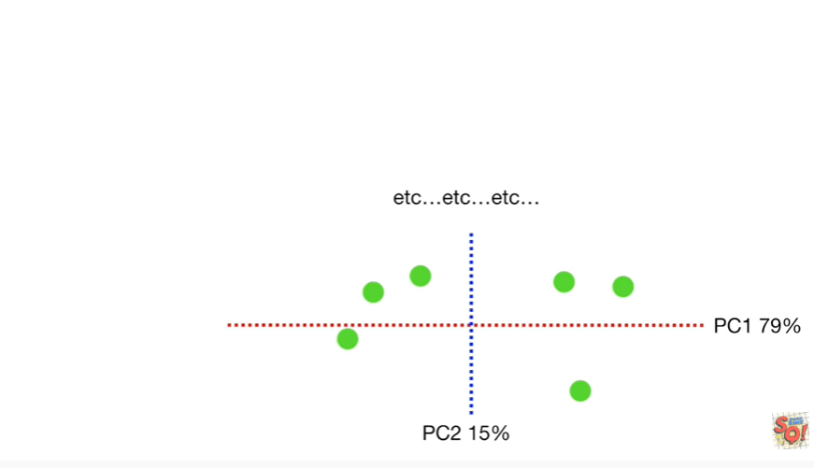

etc etc etc.

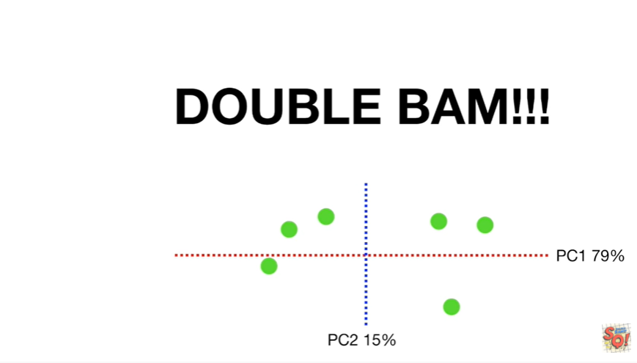

Double bam !!!

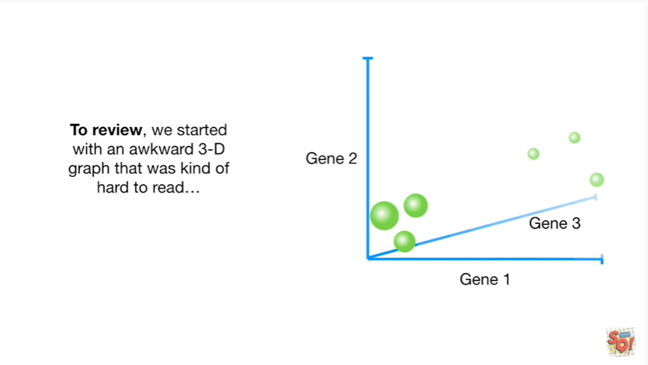

To review we started with an awkward 3d graph that was kind of hard to read

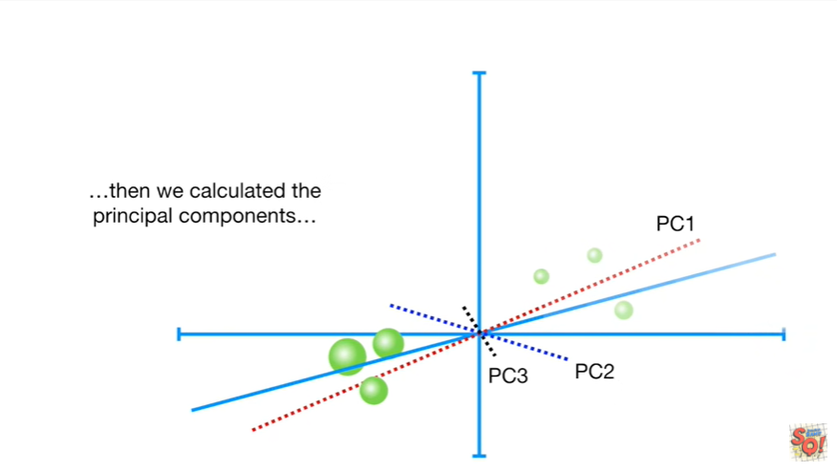

then we calculated the principal components

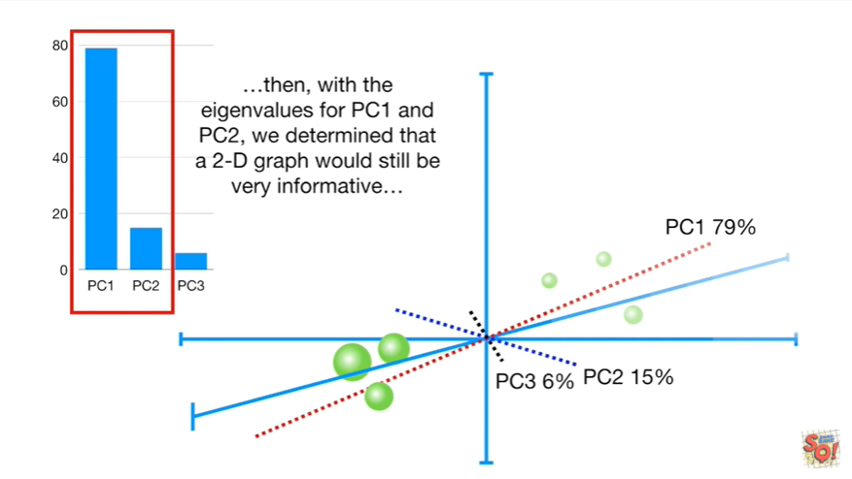

then with the eigenvalues for pc1 & pc2 we determined that a 2d graph would still be very informative.

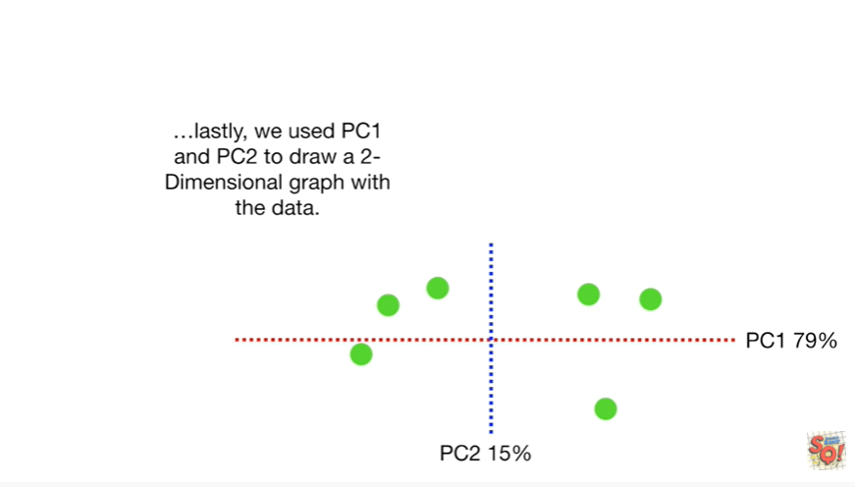

lastly we used pc1 & pc2 to draw two dimensional graph with the data.

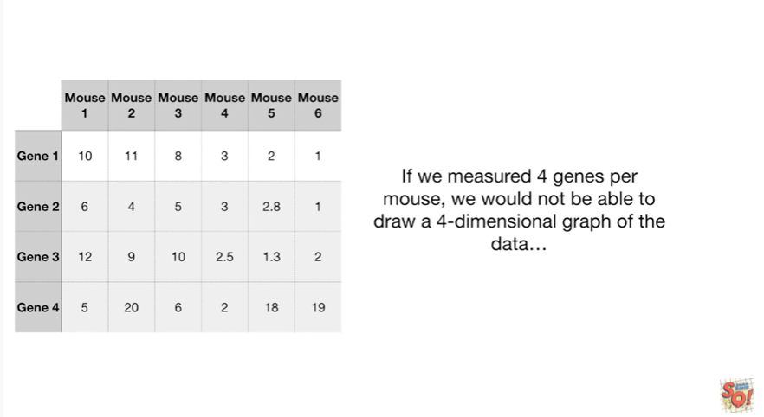

If we measured for jeans per mouse we would not be able to draw a four dimensional graph of the data.

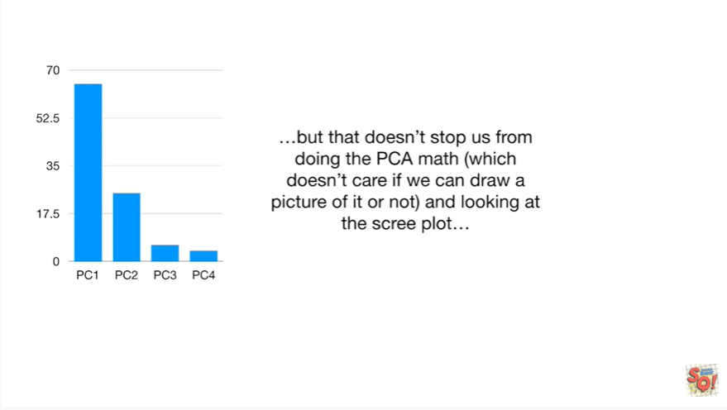

but that doesn't stop us from doing the pca math which doesn't care if we can draw a picture of it or not and looking at the scree plot

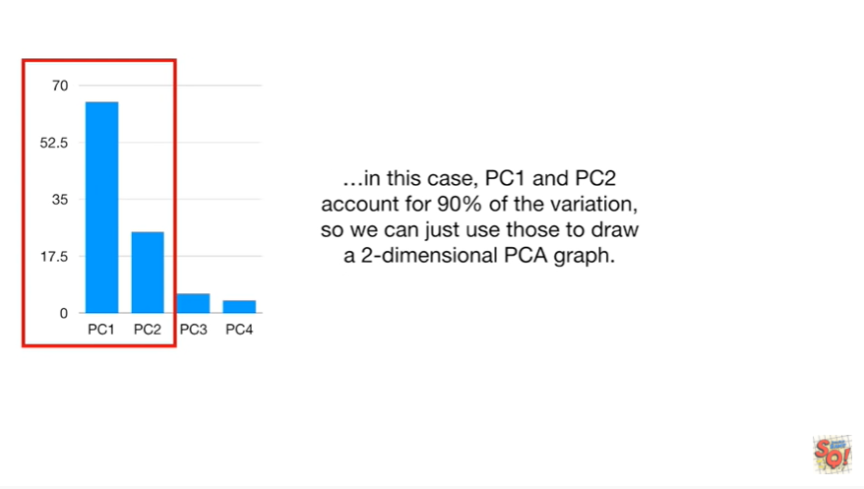

in this case pc1 & pc2 account for 90% of the variation so we can just use those to draw two dimensional pca graph.

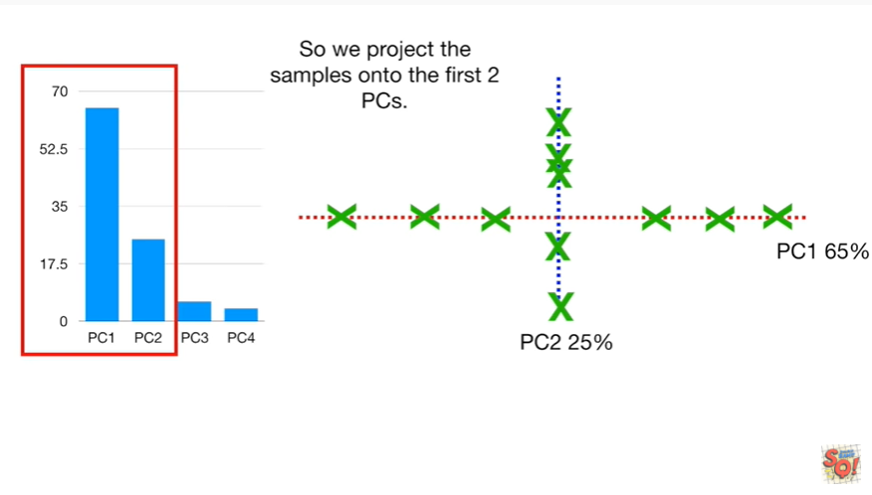

So we project the samples onto the first two pcs.

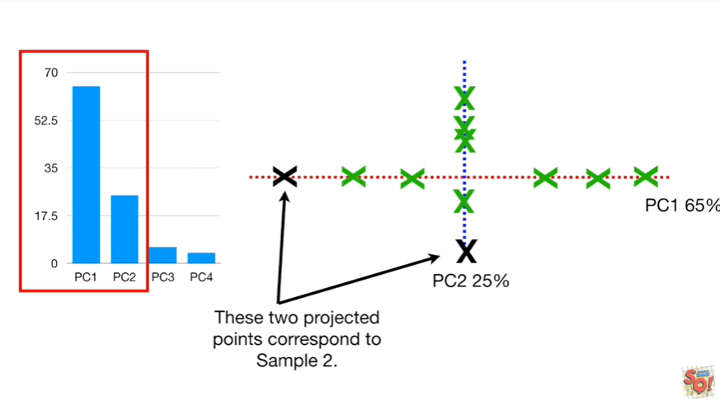

These two projected points correspond to sample two.

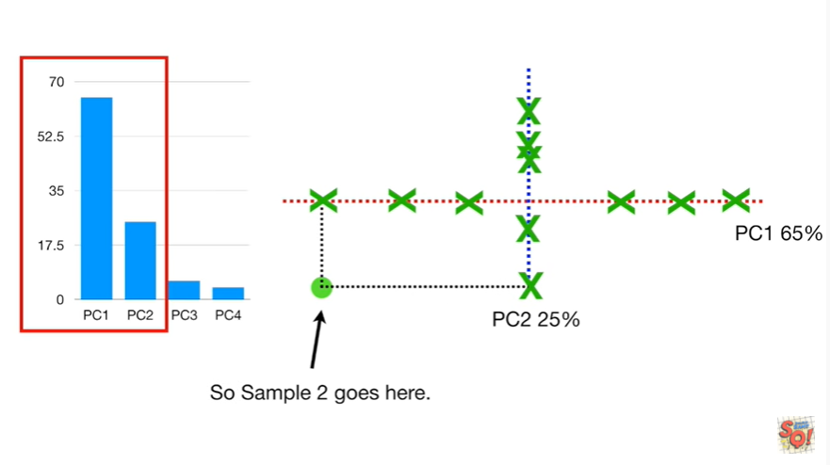

So sample two goes here.

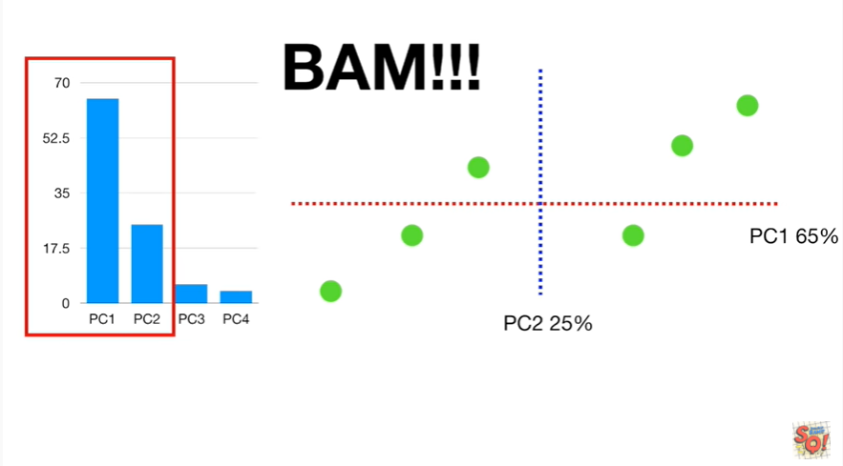

BAM !!!

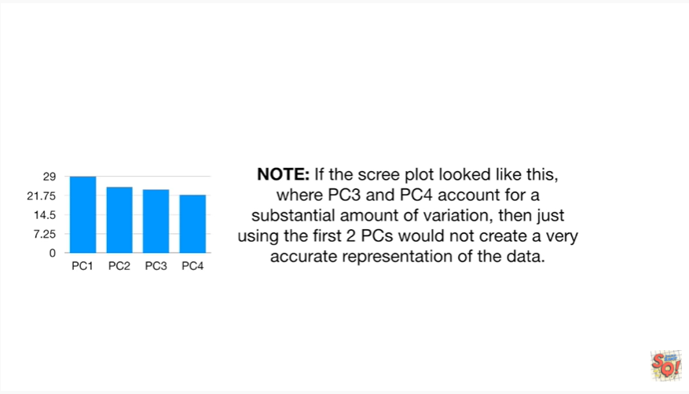

Note : if the scree plot looked like this where PC 3 and PC four account for a substantial amount of variation then just using the first two pcs would not create a very accurate representation of the data.

Wha-wha.

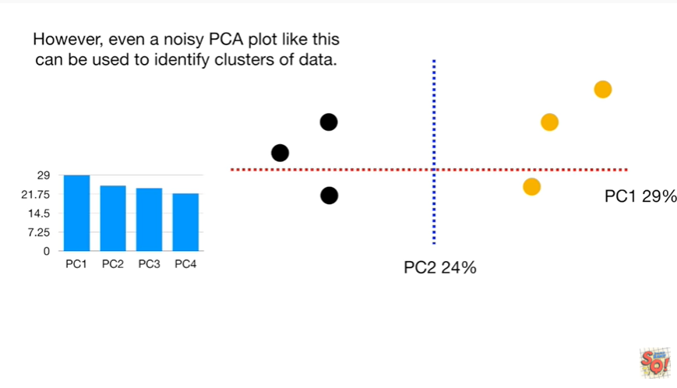

However even a noisy PCA plot like this can be used to identify clusters of data.

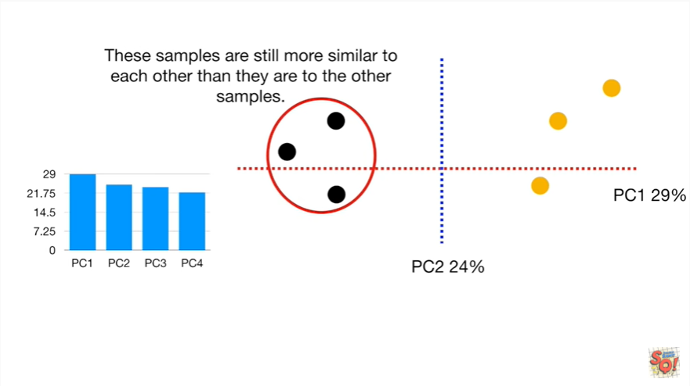

These samples are still more similar to each other than they are to the other samples.

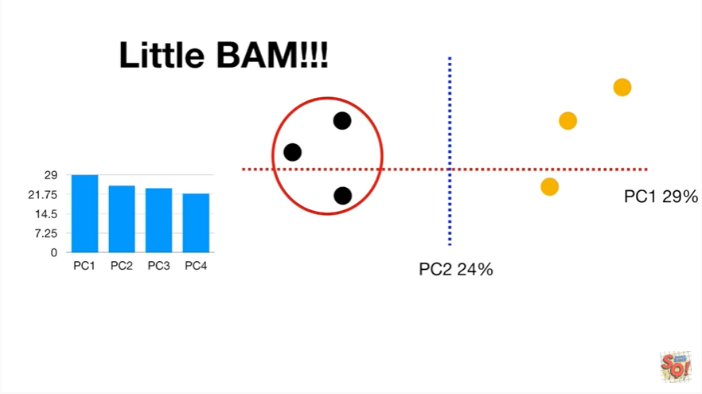

Little bam !!!